

BUS USER SUPPORT SYSTEM

DETAIL DESIGN DOCUMENT

Class Design

**Project Code: BUSS**

**Document Code: BUSS_Class_Design_v1.1_EN**

**Ha Noi, 26/06/2015**

Record of change

*A - Added M - Modified D – Deleted

|  |  |  |  |  |
| --- | --- | --- | --- | --- |
| **Effective Date** | **Changed Items** | **A* M, D** | **Change Description** | **New Version** |
| 26/06/2015 | Add new | A | Add this document | v1.0 |
| 20/08/2015 | Update | M | Update this document | v1.1 |
|  |  |  |  |  |

SIGNATURE PAGE

**ORIGINATOR:** Nguyen Thanh Nam 26/06/2015

Team Leader

**REVIEWERS:** Trinh Thi Tuyet Mai 26/06/2015

Developer

**APPROVAL:** Nguyen Van Sang 30/06/2015

Supervisor

TABLE OF CONTENTS

1 Introduction 6

**1.1** Purpose 6

**1.2** Definitions*,* Acronyms and Abbreviations 6

2 Packages 7

**2.1** ActivityPackage 7

2.1.1 Bus group 7

2.1.2 Path group 34

2.1.3 Favorites group 74

2.1.4 Reminder group 84

2.1.5 Other 94

**2.2** AdapterPackage 99

2.2.1 Class diagram 99

2.2.2 BusListAdapter 101

2.2.3 BusNearMeAdapter 104

2.2.4 BusRouteAdapter 106

2.2.5 FavoriteBusAdapter 108

2.2.6 FavoritePlaceAdapter 110

2.2.7 FindPathFavoriteAdapter 113

2.2.8 FindPathHistoryAdapter 115

2.2.9 ImageAdapter 117

2.2.10 MenuAdapter 118

2.2.11 PathDetailByListAdapter 120

2.2.12 PathDeatilListIconAdapter 121

2.2.13 PathFoundAdapter 123

2.2.14 PlaceAutoCompleteAdapter 124

2.2.15 TrackAdapter 126

**2.3** Common Package 126

2.3.1 Class diagram 126

2.3.2 Bus 130

2.3.3 BusRoute 134

2.3.4 BusStop 141

2.3.5 BusViewHolder 145

2.3.6 CompareByLeastExc 146

2.3.7 CompareByLeastWalking 146

2.3.8 CompareByShortest 147

2.3.9 DrawerMenuItem 147

2.3.10 FavoritePlace 148

2.3.11 History 153

2.3.12 HorizontalListView 156

2.3.13 JsonParser 162

2.3.14 Path 164

2.3.15 Place 168

2.3.16 Reminder 171

2.3.17 Step 176

2.3.18 Tracker 181

2.3.19 DirectionReceiver 185

2.3.20 DirectionAlarmReceiver 185

2.3.21 ReminderService 186

2.3.22 ReminderReceiver 187

2.3.23 TrackReceiver 187

2.3.24 TrackAlarmReceiver 188

**2.4** dao Package 189

2.4.1 Class diagram 189

2.4.2 DataBaseHelper 190

**2.5** wsclient Package 200

2.5.1 Class diagram 200

2.5.2 BusMapUtils 200

2.5.3 MapUtils 202

3 Functions 206

**3.1** Bus function group 206

3.1.1 Class diagram 206

3.1.2 Sequence diagram 206

**3.2** Path function group 211

3.2.1 Class diagram 211

3.2.2 Sequence diagram 212

**3.3** Favorites function group 217

3.3.1 Class diagram 217

3.3.2 Sequence diagram 217

**3.4** Reminder function group 222

3.4.1 Class diagram 222

3.4.2 Sequence diagram 223

**3.5** Other function 226

3.5.1 Class diagram 226

3.5.2 Sequence diagram 227

4 Layer architecture pattern 234

# Introduction

## Purpose

Bus user support system class design document contains descriptions of all classes of the Bus user support system. It includes:

* Class diagrams that describe the static relation of all classes in the system.

## Definitions*,* Acronyms and Abbreviations

|  |  |  |
| --- | --- | --- |
| Abbreviations | Description | Comment |
| BUSS | Bus User Support System |  |

# Packages

|  |  |  |  |
| --- | --- | --- | --- |
| No | Package | Language | Description |
| 1. 01 | activity | Java | Store all activities |
|  | adapter | Java | Store all adapters for activities |
|  | common | Java | Store all common class/object |
|  | dao | Java | Store all class which provide access to data |
|  | wsclient | Java | Store all class which work with web service |
|  | libs | Java | Store all libraries |
|  | res | XML | Store all resources (layout files, images, strings, values, colors, menu….) |

## ActivityPackage

### Bus group

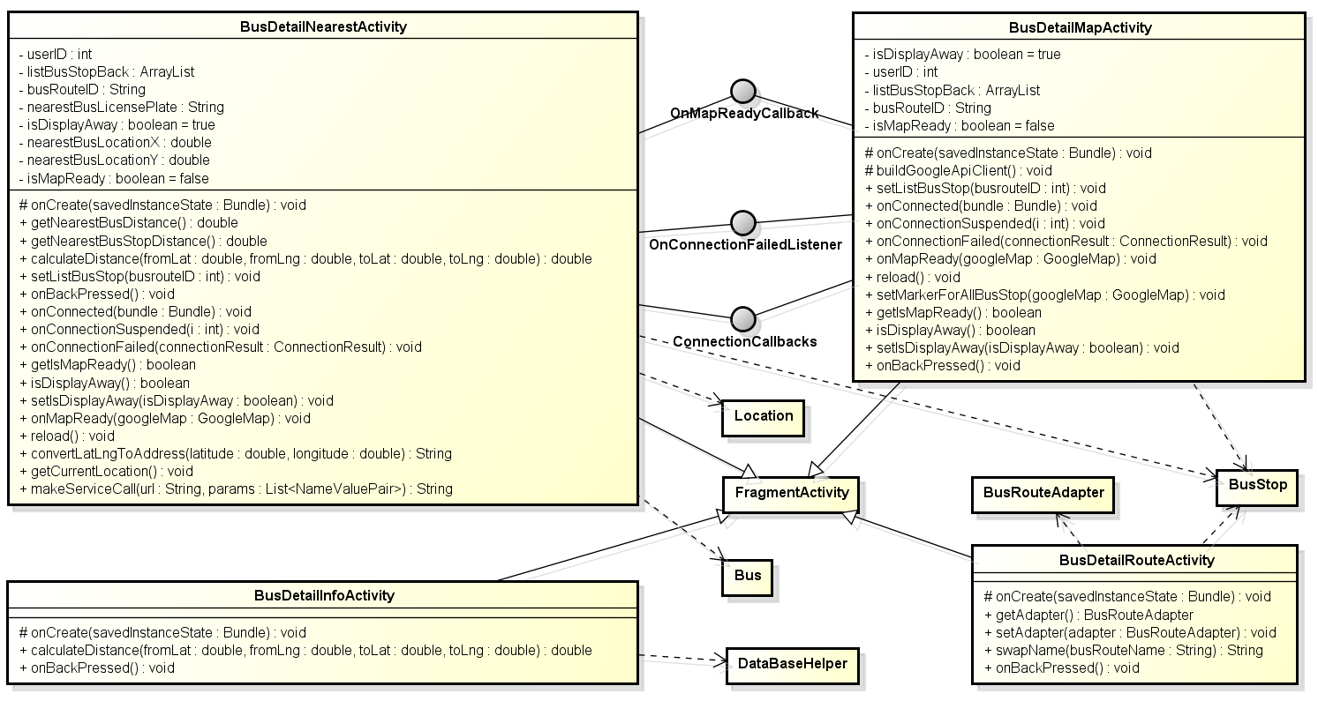

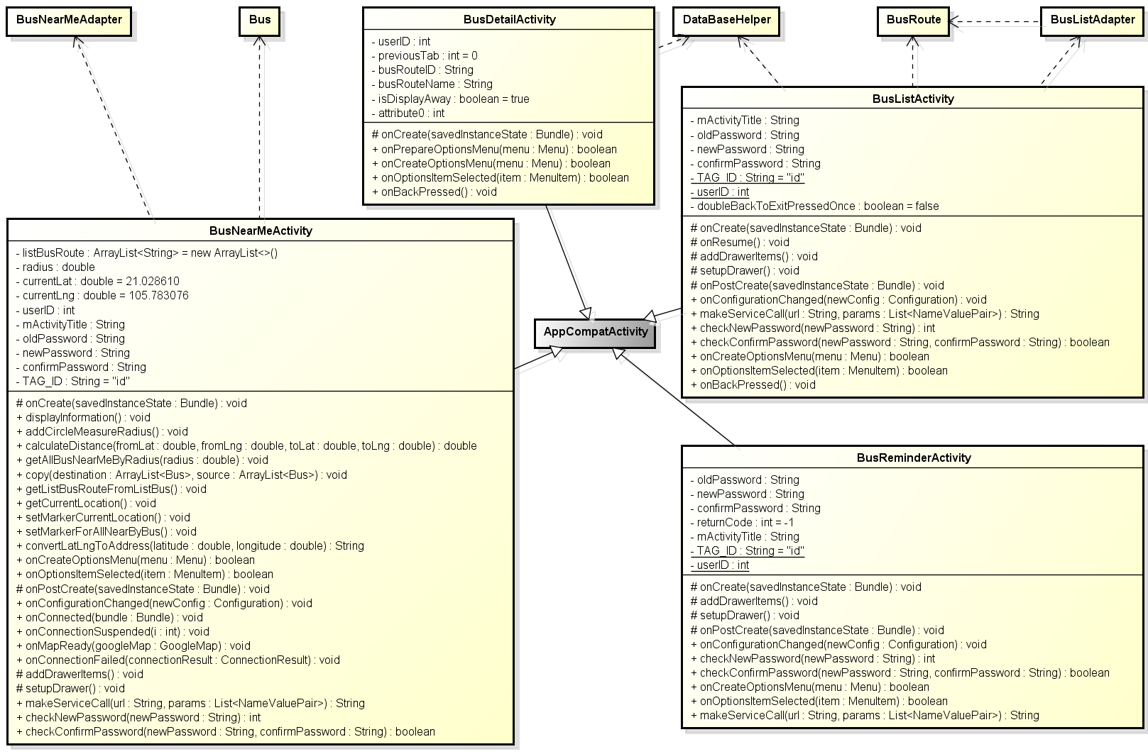

**Figure 1: Class diagram activity package – bus group**

|  |  |  |
| --- | --- | --- |
| No | Class Name | Description |
| 1 | AddFavoritePlaceActivity | Provide activity add favorite place |
| 2 | AddReminderActivity | Provide activity add reminder |
| 3 | BusDetailActivity | Provide activity bus detail |
| 4 | BusDetailInfoActivity | Provide activity bus detail tab info |
| 5 | BusDetailMapActivity | Provide activity bus detail tab map |
| 6 | BusDetailNearestActivity | Provide activity bus detail tab nearest |
| 7 | BusDetailRouteActivity | Provide activity bus detail tab route |
| 8 | BusListActivity | Provide activity bus list |
| 9 | BusNearMeActivity | Provide activity bus near me |
| 10 | DirectionActivity | Provide activity direction – navigation |
| 11 | EditFavoritePlaceActivity | Provide activity edit favorite place |
| 12 | FavoritesActivity | Provide activity favorites |
| 13 | FavoriteBusesActivity | Provide activity favorite tab bus |
| 14 | FavoritePlacesActivity | Provide activity favorite tab place |
| 15 | FindPathActivity | Provide activity find path |
| 16 | FindPathFavoriteActivity | Provide activity find path tab favorite |
| 17 | FindPathHistoryActivity | Provide activity find path tab history |
| 18 | FindPathMapActivity | Provide activity find path tab map |
| 19 | FindPlaceActivity | Provide activity find place |
| 20 | LoginActivity | Provide activity login |
| 21 | PathDetailByListActivity | Provide activity path detail by list |
| 22 | PathDetailByMapActivity | Provide activity path detail by map |
| 23 | PathFoundActivity | Provide activity path found |
| 24 | SettingsActivity | Provide activity settings |
| 25 | SignUpActivity | Provide activity sign up |
| 26 | TrackActivity | Provide activity track |

#### 2.1.1.1 BusDetailActivity

##### Attributes

|  |  |  |  |  |  |
| --- | --- | --- | --- | --- | --- |
| No | Attribute | Type | Default | Note | Description |
| 1 | userID | int |  | private |  |
| 2 | previousTab | int | 0 | private |  |
| 3 | busRouteID | String |  | private |  |
| 4 | busRouteName | String |  | private |  |
| 5 | isDisplayAway | boolean | true | private |  |

##### Methods

|  |  |  |
| --- | --- | --- |
| No | Method | Description |
| 1 | onCreate() | Called when activity create |
| 2 | onPrepareOptionsMenu() | Called when prepare option menu |
| 3 | onCreateOptionsMenu () | Called when create option menu |
| 4 | onOptionsItemSelected() | Called when option menu is selected |
| 5 | onBackPressed() | Called when back button is pressed |

**onCreate**

|  |  |  |  |  |  |
| --- | --- | --- | --- | --- | --- |
| No | Parameter name | Type | I/O | Default | Description |
| 1 | savedInstanceState | Bundle | In |  |  |

**onPrepareOptionsMenu**

|  |  |  |  |  |  |
| --- | --- | --- | --- | --- | --- |
| No | Parameter name | Type | I/O | Default | Description |
| 1 |  | Boolean | Out |  |  |
| 2 | menu | Menu | In |  |  |

**onCreateOptionsMenu**

|  |  |  |  |  |  |
| --- | --- | --- | --- | --- | --- |
| No | Parameter name | Type | I/O | Default | Description |
| 1 |  | Boolean | Out |  |  |
| 2 | menu | Menu | In |  |  |

**onOptionsItemSelected**

|  |  |  |  |  |  |
| --- | --- | --- | --- | --- | --- |
| No | Parameter name | Type | I/O | Default | Description |
| 1 |  | Boolean | Out |  |  |
| 2 | item | MenuItem | In |  |  |

#### 2.1.1.2 BusDetailInfoActivity

##### Attributes

N/A

##### Methods

|  |  |  |
| --- | --- | --- |
| No | Method | Description |
| 1 | onCreate() | Called when activity create |
| 2 | calculateDistance() | Call to calculate distance between two LatLng point |
| 3 | onBackPressed() | Called when back button is pressed |

|  |  |  |  |
| --- | --- | --- | --- |
|  | | | |
| * **Return:** * **Visibility:** * **Purpose:** | | | |
| Parameters | | | |
| No. | Parameter | Type | Description |

|  |  |  |  |
| --- | --- | --- | --- |
|  |  |  |  |

|  |  |  |  |
| --- | --- | --- | --- |
| onCreate() | | | |
| * **Return:** void * **Visibility:** protected * **Purpose:** create activity | | | |
| Parameters | | | |
| No. | Parameter | Type | Description |

|  |  |  |  |
| --- | --- | --- | --- |
| 1 | saveInstanceState | Bundle |  |

|  |  |  |  |
| --- | --- | --- | --- |
| calculateDistance() | | | |
| * **Return:** double * **Visibility:** public * **Purpose:** calculate distance between two latlng | | | |
| Parameters | | | |
| No. | Parameter | Type | Description |

|  |  |  |  |
| --- | --- | --- | --- |
| 1 | fromLat | Double | From point’s latitude |
| 2 | toLat | Double | From point’s longitude |
| 3 | fromLng | Double | To point’s latitude |
| 4 | toLng | Double | To point’s longitude |

|  |
| --- |
| onBackPressed() |
| * **Return:** void * **Visibility:** public * **Purpose:** handle when back button is pressed |

#### 2.1.1.3 BusDetailMapActivity

##### Attributes

|  |  |  |  |  |  |
| --- | --- | --- | --- | --- | --- |
| No | Attribute | Type | Default | Note | Description |
| 1 | isDisplayAway | boolean | True | private |  |
| 2 | userID | int | 0 | private |  |
| 3 | listBusStopBack | ArrayList<BusStop> |  | private |  |
| 4 | busRouteID | String |  | private |  |
| 5 | isMapReady | boolean | false | private |  |

##### Methods

|  |
| --- |
| buildGoogleApiClient() |
| * **Return:** void * **Visibility:** protected * **Purpose:** build api client |
| Parameters |

|  |  |  |  |
| --- | --- | --- | --- |
| onCreate() | | | |
| * **Return:** void * **Visibility:** protected * **Purpose:** create activity | | | |
| Parameters | | | |
| No. | Parameter | Type | Description |

|  |  |  |  |
| --- | --- | --- | --- |
| 1 | saveInstanceState | Bundle |  |

|  |  |  |  |
| --- | --- | --- | --- |
| setListBusStop() | | | |
| * **Return:** void * **Visibility:** public * **Purpose:** set list bus stop | | | |
| Parameters | | | |
| No. | Parameter | Type | Description |

|  |  |  |  |
| --- | --- | --- | --- |
| 1 | busrouteID | Int | Bus route id |

|  |
| --- |
| onBackPressed() |
| * **Return:** void * **Visibility:** public * **Purpose:** handle when back button is pressed |

|  |
| --- |
| onConnected() |
| * **Return:** void * **Visibility:** public * **Purpose:** called when connected |

|  |  |  |  |
| --- | --- | --- | --- |
| onConnectionSuspended() | | | |
| * **Return:** void * **Visibility:** public * **Purpose:** called when connection suspended | | | |
| Parameters | | | |
| No. | Parameter | Type | Description |

|  |  |  |  |
| --- | --- | --- | --- |
| 1 | i | Int |  |

|  |  |  |  |
| --- | --- | --- | --- |
| onConnectionFailed() | | | |
| * **Return:** void * **Visibility:** public * **Purpose:** called when connect failed | | | |
| Parameters | | | |
| No. | Parameter | Type | Description |

|  |  |  |  |
| --- | --- | --- | --- |
| 1 | connectionResult | ConnectionResult | Bus route id |

|  |
| --- |
| onMapReady() |
| * **Return:** void * **Visibility:** public * **Purpose:** called when map ready |

|  |
| --- |
| reload() |
| * **Return:** void * **Visibility:** public * **Purpose:** called when activity reload |

|  |  |  |  |
| --- | --- | --- | --- |
| setMarkerForAllBusStop() | | | |
| * **Return:** void * **Visibility:** public * **Purpose:** called when app content reconnect | | | |
| Parameters | | | |
| No. | Parameter | Type | Description |

|  |  |  |  |
| --- | --- | --- | --- |
| 1 | busrouteID | Int | Bus route id |
| 2 | googleMap | GoogleMap | Map to handle things |

|  |
| --- |
| getIsMapReady() |
| * **Return:** void * **Visibility:** public * **Purpose:** called when app content reconnect |

|  |
| --- |
| isDisplayAway() |
| * **Return:** void * **Visibility:** public * **Purpose:** called when app content reconnect |

|  |  |  |  |
| --- | --- | --- | --- |
| setIsDisplayAway() | | | |
| * **Return:** void * **Visibility:** public * **Purpose:** called when app content reconnect | | | |
| Parameters | | | |
| No. | Parameter | Type | Description |

|  |  |  |  |
| --- | --- | --- | --- |
| 1 | isDisplayAway | Int | Parameter indicate is display away or not |

|  |
| --- |
| onBackPressed() |
| * **Return:** void * **Visibility:** public * **Purpose:** handle when back button is pressed |

#### 2.1.1.4 BusDetailNearestActivity

##### Attributes

|  |  |  |  |  |  |
| --- | --- | --- | --- | --- | --- |
| No | Attribute | Type | Default | Note | Description |
| 1 | isDisplayAway | boolean | True | private |  |
| 2 | nearestBusLicensePlate | String |  | private |  |
| 3 | listBusStopBack | ArrayList<BusStop> |  | private |  |
| 4 | busRouteID | String |  | private |  |
| 5 | isMapReady | boolean | false | private |  |
| 6 | nearestBusLocationX | Double |  | private |  |
| 7 | nearestBusLocationY | double |  | private |  |
| 8 | userID | Int | 0 | private |  |

##### Methods

|  |
| --- |
| getNearestBusDistance() |
| * **Return:** double * **Visibility:** public * **Purpose:** get nearest bus distance |
| Parameters |

|  |
| --- |
| getNearestBusStopDistance() |
| * **Return:** double * **Visibility:** public * **Purpose:** get nearest bus stop distance |
| Parameters |

|  |  |  |  |
| --- | --- | --- | --- |
| setListBusStop() | | | |
| * **Return:** void * **Visibility:** public * **Purpose:** set list bus stop | | | |
| Parameters | | | |
| No. | Parameter | Type | Description |

|  |  |  |  |
| --- | --- | --- | --- |
| 1 | busrouteID | Int | Bus route id |

|  |  |  |  |
| --- | --- | --- | --- |
| calculateDistance() | | | |
| * **Return:** double * **Visibility:** public * **Purpose:** calculate distance between two latlng | | | |
| Parameters | | | |
| No. | Parameter | Type | Description |

|  |  |  |  |
| --- | --- | --- | --- |
| 1 | fromLat | Double | From point’s latitude |
| 2 | toLat | Double | From point’s longitude |
| 3 | fromLng | Double | To point’s latitude |
| 4 | toLng | Double | To point’s longitude |

|  |
| --- |
| reload() |
| * **Return:** void * **Visibility:** public * **Purpose:** called when activity reload |

|  |  |  |  |
| --- | --- | --- | --- |
| onCreate() | | | |
| * **Return:** void * **Visibility:** protected * **Purpose:** create activity | | | |
| Parameters | | | |
| No. | Parameter | Type | Description |

|  |  |  |  |
| --- | --- | --- | --- |
| 1 | saveInstanceState | Bundle |  |

|  |
| --- |
| onConnected() |
| * **Return:** void * **Visibility:** public * **Purpose:** called when connected |

|  |  |  |  |
| --- | --- | --- | --- |
| onConnectionSuspended() | | | |
| * **Return:** void * **Visibility:** public * **Purpose:** called when connection suspended | | | |
| Parameters | | | |
| No. | Parameter | Type | Description |

|  |  |  |  |
| --- | --- | --- | --- |
| 1 | i | Int |  |

|  |  |  |  |
| --- | --- | --- | --- |
| onConnectionFailed() | | | |
| * **Return:** void * **Visibility:** public * **Purpose:** called when connect failed | | | |
| Parameters | | | |
| No. | Parameter | Type | Description |

|  |  |  |  |
| --- | --- | --- | --- |
| 1 | connectionResult | ConnectionResult | Bus route id |

|  |
| --- |
| onMapReady() |
| * **Return:** void * **Visibility:** public * **Purpose:** called when map ready |

|  |
| --- |
| getIsMapReady() |
| * **Return:** void * **Visibility:** public * **Purpose:** called when app content reconnect |

|  |
| --- |
| isDisplayAway() |
| * **Return:** void * **Visibility:** public * **Purpose:** called when app content reconnect |

|  |  |  |  |
| --- | --- | --- | --- |
| setIsDisplayAway() | | | |
| * **Return:** void * **Visibility:** public * **Purpose:** called when app content reconnect | | | |
| Parameters | | | |
| No. | Parameter | Type | Description |

|  |  |  |  |
| --- | --- | --- | --- |
| 1 | isDisplayAway | Int | Parameter indicate is display away or not |

|  |
| --- |
| onBackPressed() |
| * **Return:** void * **Visibility:** public * **Purpose:** handle when back button is pressed |

|  |
| --- |
| getCurrentLocation() |
| * **Return:** void * **Visibility:** public * **Purpose:** called to get current location |
| Parameters |

|  |  |  |  |
| --- | --- | --- | --- |
| convertLatLngToAddress() | | | |
| * **Return:** String * **Visibility:** public * **Purpose:** called to convert latlng to address | | | |
| Parameters | | | |
| No. | Parameter | Type | Description |

|  |  |  |  |
| --- | --- | --- | --- |
| 1 | Lat | Double |  |
| 2 | Lng | Double |  |

|  |  |  |  |
| --- | --- | --- | --- |
| makeServiceCall() | | | |
| * **Return:** String * **Visibility:** public * **Purpose:** called to convert latlng to address | | | |
| Parameters | | | |
| No. | Parameter | Type | Description |

|  |  |  |  |
| --- | --- | --- | --- |
| 1 | url | String |  |
| 2 | params | List<NameValuePair> |  |

#### 2.1.1.5 BusDetailRouteActivity

##### Attributes

N/A

##### Methods

|  |  |  |  |
| --- | --- | --- | --- |
| onCreate() | | | |
| * **Return:** void * **Visibility:** protected * **Purpose:** create activity | | | |
| Parameters | | | |
| **No.** | **Parameter** | **Type** | **Description** |
| 1 | saveInstanceState | Bundle |  |

|  |
| --- |
| getAdapter() |
| * **Return:** BusRouteAdapter * **Visibility:** public * **Purpose:** get adapter |

|  |  |  |  |
| --- | --- | --- | --- |
| setAdapter() | | | |
| * **Return:** void * **Visibility:** protected * **Purpose:** set adapter | | | |
| Parameters | | | |
| **No.** | **Parameter** | **Type** | **Description** |
| 1 | adapter | BusRouteAdapter | Adapter of BusRoute |

|  |  |  |  |
| --- | --- | --- | --- |
| swapName() | | | |
| * **Return:** String * **Visibility:** public * **Purpose:** swap bus direction | | | |
| Parameters | | | |
| **No.** | **Parameter** | **Type** | **Description** |
| 1 | busRouteName | String | Bus route name |

|  |
| --- |
| onBackPressed() |
| * **Return:** void * **Visibility:** public * **Purpose:** Handle onBackPressed event |

#### 2.1.1.6 BusListActivity

##### Attributes

|  |  |  |  |  |  |
| --- | --- | --- | --- | --- | --- |
| No | Attribute | Type | Default | Note | Description |
| 1 | mActivityTitle | String |  | private |  |
| 2 | oldPassword | String |  | private |  |
| 3 | newPassword | String |  | private |  |
| 4 | confirmPassword | String |  | private |  |
| 5 | TAG_ID | String | id | private |  |
| 6 | userID | int |  | private |  |
| 7 | doubleBackToExitPressedOnce | boolean | false | private |  |

##### Methods

|  |  |  |  |
| --- | --- | --- | --- |
| onCreate() | | | |
| * **Return:** void * **Visibility:** protected * **Purpose:** create activity | | | |
| Parameters | | | |
| **No.** | **Parameter** | **Type** | **Description** |
| 1 | saveInstanceState | Bundle | Save instance state |

|  |
| --- |
| onResume() |
| * **Return:** void * **Visibility:** protected * **Purpose:** call when activity is on resume |

|  |
| --- |
| addDrawerItems() |
| * **Return:** void * **Visibility:** protected * **Purpose:** add drawer item |

|  |
| --- |
| setupDrawer() |
| * **Return:** void * **Visibility:** protected * **Purpose:** setup drawer |

|  |  |  |  |
| --- | --- | --- | --- |
| onPostCreate() | | | |
| * **Return:** void * **Visibility:** protected * **Purpose:** call before starting activity | | | |
| Parameters | | | |
| **No.** | **Parameter** | **Type** | **Description** |
| 1 | savedInstanceState | Bundle | Save instance state |

|  |  |  |  |
| --- | --- | --- | --- |
| onConfigurationChanged() | | | |
| * **Return:** void * **Visibility:** public * **Purpose:** call when configuration was changed | | | |
| Parameters | | | |
| **No.** | **Parameter** | **Type** | **Description** |
| 1 | newConfig | Configuration |  |

|  |  |  |  |
| --- | --- | --- | --- |
| makeServiceCall() | | | |
| * **Return:** String * **Visibility:** public * **Purpose:** | | | |
| Parameters | | | |
| **No.** | **Parameter** | **Type** | **Description** |
| 1 | url | String |  |
| 2 | params | List<NameValuePair> |  |

|  |  |  |  |
| --- | --- | --- | --- |
| checkNewPassword() | | | |
| * **Return:** int * **Visibility:** public * **Purpose:** check new password field | | | |
| Parameters | | | |
| **No.** | **Parameter** | **Type** | **Description** |
| 1 | newPassword | String |  |

|  |  |  |  |
| --- | --- | --- | --- |
| checkConfirmPassword() | | | |
| * **Return:** boolean * **Visibility:** public * **Purpose:** check confirm password field | | | |
| Parameters | | | |
| **No.** | **Parameter** | **Type** | **Description** |
| 1 | newPassword | String |  |
| 2 | confirmPassword | String |  |

|  |  |  |  |
| --- | --- | --- | --- |
| onCreateOptionsMenu() | | | |
| * **Return:** boolean * **Visibility:** public * **Purpose:** call when create menu | | | |
| Parameters | | | |
| **No.** | **Parameter** | **Type** | **Description** |
| 1 | item | MenuItem |  |

|  |  |  |  |
| --- | --- | --- | --- |
| onOptionsItemSelected() | | | |
| * **Return:** double * **Visibility:** public * **Purpose:** get nearest bus distance | | | |
| Parameters | | | |
| **No.** | **Parameter** | **Type** | **Description** |
|  |  |  |  |

|  |
| --- |
| onBackPressed() |
| * **Return:** void * **Visibility:** public * **Purpose:** Handle onBackPressed event |

#### 2.1.1.7 BusNearMeActivity

##### Attribute

|  |  |  |  |  |  |
| --- | --- | --- | --- | --- | --- |
| **No** | **Attribute** | **Type** | **Default** | **Note** | **Description** |
| 1 | listBusRoute | ArrayList<String> | new ArrayList<>() | private |  |
| 2 | radius | double |  | private |  |
| 3 | currentLat | double | 21.028610 | private |  |
| 4 | currentLng | double | 105.783076 | private |  |
| 5 | userID | int |  | private |  |
| 6 | mActivityTitle | String |  | private |  |
| 7 | oldPassword | String |  | private |  |
| 8 | newPassword | String |  | private |  |
| 9 | confirmPassword | String |  | private |  |
| 10 | TAG_ID | String | id | private |  |

##### Methods

|  |  |  |  |
| --- | --- | --- | --- |
| onCreate() | | | |
| * Return: void * Visibility: protected * Purpose: create activity | | | |
| Parameters | | | |
| No. | Parameter | Type | Description |
| 1 | saveInstanceState | Bundle | Save instance state |

|  |
| --- |
| **displayInformation()** |
| * **Return:** void * **Visibility:** public * **Purpose:** |

|  |
| --- |
| **addCircleMeasureRadius()** |
| * **Return:** void * **Visibility:** public * **Purpose:** |

|  |  |  |  |
| --- | --- | --- | --- |
| calculateDistance() | | | |
| * Return: double * Visibility: public * Purpose: | | | |
| Parameters | | | |
| No. | Parameter | Type | Description |
| 1 | fromLat | double |  |
| 2 | fromLng | double |  |
| 3 | toLat | double |  |
| 4 | toLng | double |  |

|  |  |  |  |
| --- | --- | --- | --- |
| getAllBusNearMeByRadius() | | | |
| * Return: void * Visibility: public * Purpose: | | | |
| Parameters | | | |
| No. | Parameter | Type | Description |
| 1 | radius | double |  |

|  |  |  |  |
| --- | --- | --- | --- |
| copy() | | | |
| * Return: void * Visibility: public * Purpose: | | | |
| Parameters | | | |
| No. | Parameter | Type | Description |
| 1 | destination | ArrayList<Bus> |  |
| 2 | source | ArrayList<Bus> |  |

|  |
| --- |
| **getListBusRouteFromListBus()** |
| * **Return:** void * **Visibility:** public * **Purpose:** |

|  |
| --- |
| **getCurrentLocation()** |
| * **Return:** void * **Visibility:** public * **Purpose:** |

|  |
| --- |
| **setMarkerCurrentLocation()** |
| * **Return:** void * **Visibility:** public * **Purpose:** |

|  |
| --- |
| **setMarkerForAllNearByBus()** |
| * **Return:** void * **Visibility:** public * **Purpose:** |

|  |  |  |  |
| --- | --- | --- | --- |
| convertLatLngToAddress() | | | |
| * Return: String * Visibility: public * Purpose: | | | |
| Parameters | | | |
| No. | Parameter | Type | Description |
| 1 | latitude | double |  |
| 2 | longitude | double |  |

|  |  |  |  |
| --- | --- | --- | --- |
| onCreateOptionsMenu() | | | |
| * Return: boolean * Visibility: public * Purpose: | | | |
| Parameters | | | |
| No. | Parameter | Type | Description |
| 1 | menu | Menu |  |

|  |  |  |  |
| --- | --- | --- | --- |
| onOptionsItemSelected() | | | |
| * Return: boolean * Visibility: public * Purpose: | | | |
| Parameters | | | |
| No. | Parameter | Type | Description |
| 1 | item | MenuItem |  |

|  |  |  |  |
| --- | --- | --- | --- |
| onPostCreate() | | | |
| * Return: void * Visibility: protected * Purpose: | | | |
| Parameters | | | |
| No. | Parameter | Type | Description |
| 1 | saveInstanceState | Bundle | Save instance state |

|  |  |  |  |
| --- | --- | --- | --- |
| onConfigurationChanged() | | | |
| * Return: void * Visibility: public * Purpose: | | | |
| Parameters | | | |
| No. | Parameter | Type | Description |
| 1 | newConfig | Configuration |  |

|  |  |  |  |
| --- | --- | --- | --- |
| onConnected() | | | |
| * Return: void * Visibility: public * Purpose: | | | |
| Parameters | | | |
| No. | Parameter | Type | Description |
| 1 | bundle | Bundle |  |

|  |  |  |  |
| --- | --- | --- | --- |
| onConnectionSuspended() | | | |
| * Return: void * Visibility: public * Purpose: | | | |
| Parameters | | | |
| No. | Parameter | Type | Description |
| 1 | i | int |  |

|  |  |  |  |
| --- | --- | --- | --- |
| onMapReady() | | | |
| * Return: void * Visibility: public * Purpose: | | | |
| Parameters | | | |
| No. | Parameter | Type | Description |
| 1 | googleMap | GoogleMap |  |

|  |  |  |  |
| --- | --- | --- | --- |
| onConnectionFailed() | | | |
| * Return: void * Visibility: public * Purpose: | | | |
| Parameters | | | |
| No. | Parameter | Type | Description |
| 1 | connectionResult | ConnectionResult |  |

|  |
| --- |
| **addDrawerItems()** |
| * **Return:** void * **Visibility:** protected * **Purpose:** |

|  |
| --- |
| **setupDrawer()** |
| * **Return:** void * **Visibility:** protected * **Purpose:** |

|  |  |  |  |
| --- | --- | --- | --- |
| makeServiceCall() | | | |
| * Return: String * Visibility: public * Purpose: | | | |
| Parameters | | | |
| No. | Parameter | Type | Description |
| 1 | url | String |  |
| 2 | param | List<NameValuePair> |  |

|  |  |  |  |
| --- | --- | --- | --- |
| checkNewPassword() | | | |
| * Return: int * Visibility: public * Purpose: | | | |
| Parameters | | | |
| No. | Parameter | Type | Description |
| 1 | newPassword | String |  |

|  |  |  |  |
| --- | --- | --- | --- |
| checkConfirmPassword() | | | |
| * Return: boolean * Visibility: public * Purpose: | | | |
| Parameters | | | |
| No. | Parameter | Type | Description |
| 1 | newPassword | String |  |
| 2 | confirmPassword | String |  |

### Path group

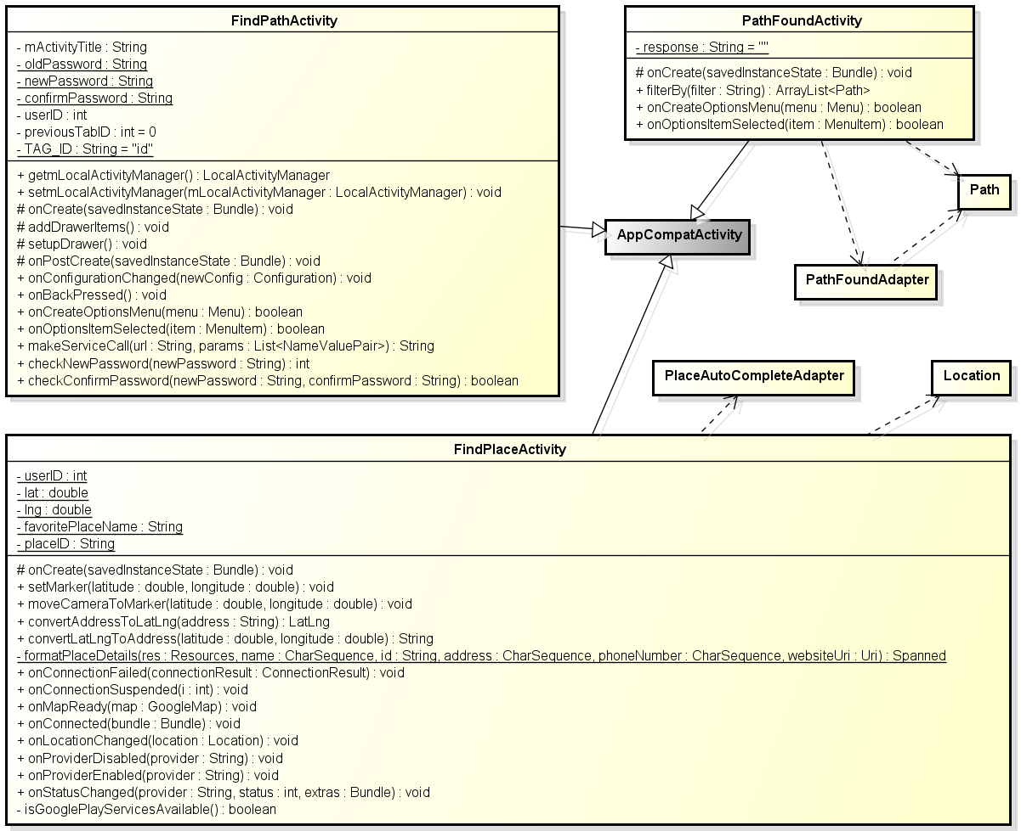

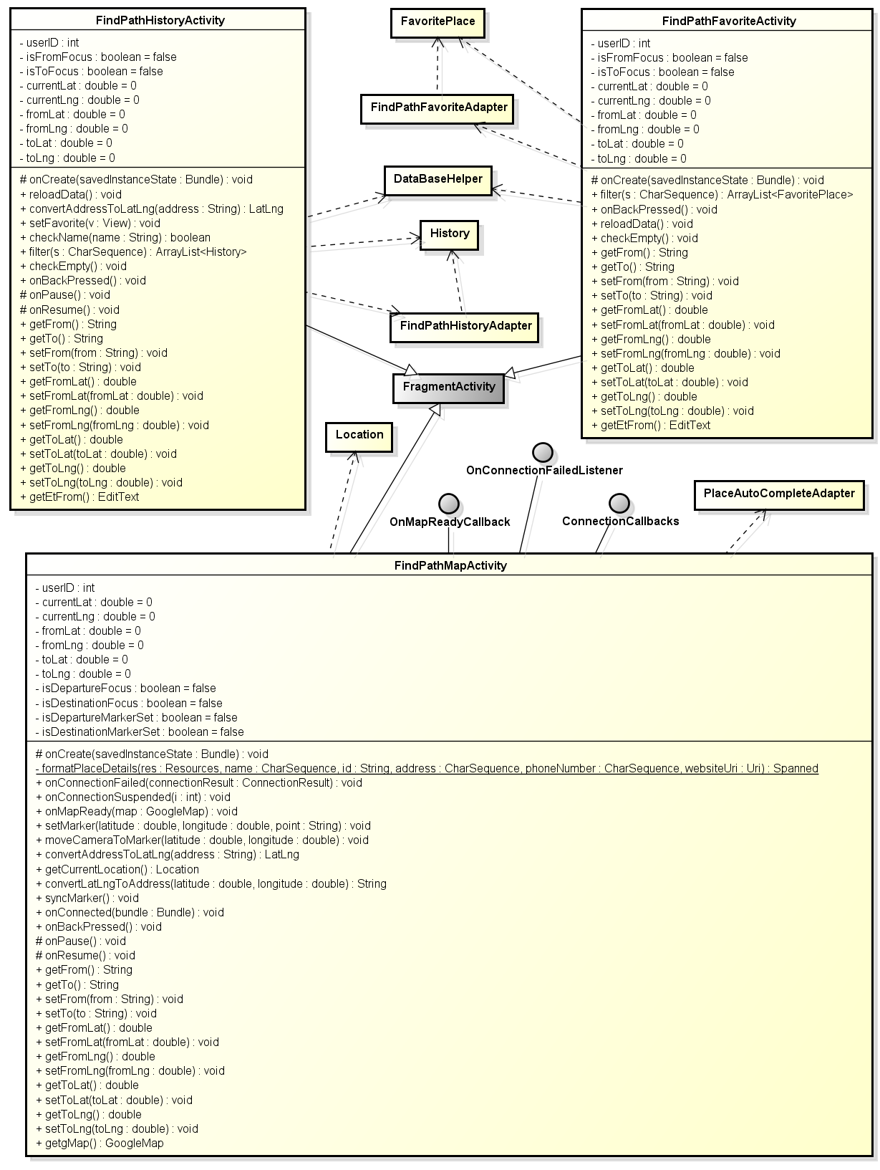

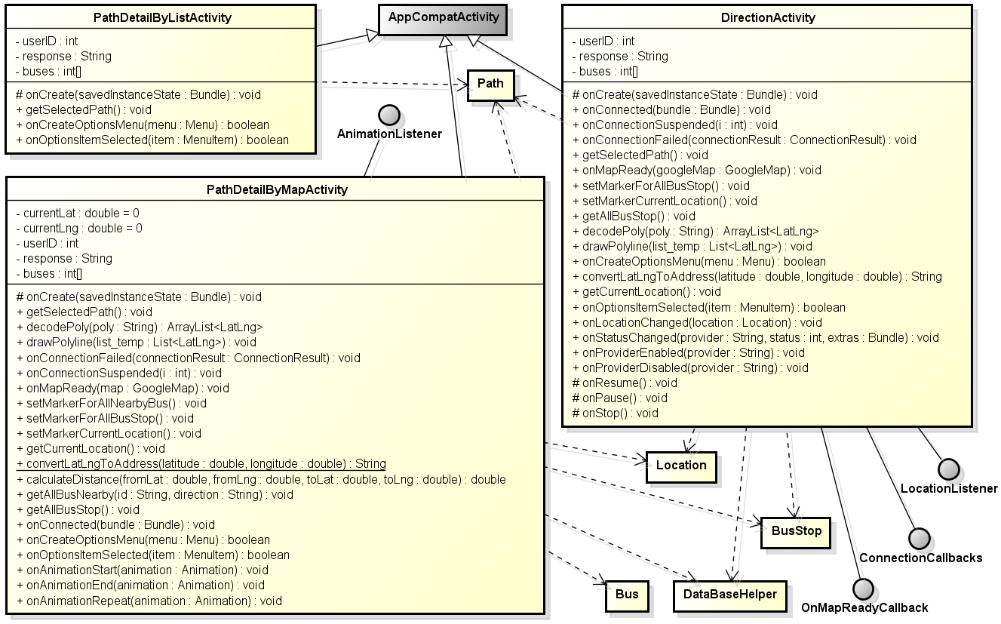

#### 2.1.2.1 FindPathActivity

##### Attributes

|  |  |  |  |  |  |
| --- | --- | --- | --- | --- | --- |
| **No** | **Attribute** | **Type** | **Default** | **Note** | **Description** |
| 1 | mActivityTitle | String |  | private |  |
| 2 | oldPassword | String |  | private |  |
| 3 | newPassword | String |  | private |  |
| 4 | confirmPassword | String |  | private |  |
| 5 | userID | int |  | private |  |
| 6 | previousTabID | int | 0 | private |  |
| 7 | TAG_ID | String | id | private |  |

##### Methods

|  |
| --- |
| getmLocalActivityManager() |
| * Return: LocalActivityManager * Visibility: public * Purpose: |

|  |  |  |  |
| --- | --- | --- | --- |
| setmLocalActivityManager() | | | |
| * Return: void * Visibility: public * Purpose: | | | |
| Parameters | | | |
| No. | Parameter | Type | Description |
| 1 | mLocalActivityManager | LocalActivityManager |  |

|  |  |  |  |
| --- | --- | --- | --- |
| onCreate() | | | |
| * Return: void * Visibility: protected * Purpose: create activity | | | |
| Parameters | | | |
| No. | Parameter | Type | Description |
| 1 | saveInstanceState | Bundle | Save instance state |

|  |
| --- |
| addDrawerItems() |
| * Return: void * Visibility: protected * Purpose: |

|  |
| --- |
| setupDrawer() |
| * Return: void * Visibility: protected * Purpose: |

|  |  |  |  |
| --- | --- | --- | --- |
| onPostCreate() | | | |
| * Return: void * Visibility: protected * Purpose: | | | |
| Parameters | | | |
| No. | Parameter | Type | Description |
| 1 | saveInstanceState | Bundle | Save instance state |

|  |  |  |  |
| --- | --- | --- | --- |
| onConfigurationChanged() | | | |
| * Return: void * Visibility: public * Purpose: | | | |
| Parameters | | | |
| No. | Parameter | Type | Description |
| 1 | newConfig | Configuration |  |

|  |
| --- |
| onBackPressed() |
| * Return: void * Visibility: public * Purpose: |

|  |  |  |  |
| --- | --- | --- | --- |
| onCreateOptionsMenu() | | | |
| * Return: boolean * Visibility: public * Purpose: | | | |
| Parameters | | | |
| No. | Parameter | Type | Description |
| 1 | menu | Menu |  |

|  |  |  |  |
| --- | --- | --- | --- |
| onOptionsItemSelected() | | | |
| * Return: boolean * Visibility: public * Purpose: | | | |
| Parameters | | | |
| No. | Parameter | Type | Description |
| 1 | item | MenuItem |  |

|  |  |  |  |
| --- | --- | --- | --- |
| makeServiceCall() | | | |
| * Return: String * Visibility: public * Purpose: | | | |
| Parameters | | | |
| No. | Parameter | Type | Description |
| 1 | url | String |  |
| 2 | params | List<NameValuePair> |  |

|  |  |  |  |
| --- | --- | --- | --- |
| checkNewPassword() | | | |
| * Return: int * Visibility: public * Purpose: | | | |
| Parameters | | | |
| No. | Parameter | Type | Description |
| 1 | newPassword | String |  |

|  |  |  |  |
| --- | --- | --- | --- |
| checkConfirmPassword() | | | |
| * Return: boolean * Visibility: public * Purpose: | | | |
| Parameters | | | |
| No. | Parameter | Type | Description |
| 1 | newPassword | String |  |
| 2 | confirmPassword | String |  |

#### 2.1.2.2 FindPathMapActivity

##### Attributes

|  |  |  |  |  |  |
| --- | --- | --- | --- | --- | --- |
| **No** | **Attribute** | **Type** | **Default** | **Note** | **Description** |
| 1 | userID | Int |  | private |  |
| 2 | currentLat | Double |  | private |  |
| 3 | currentLng | Double |  | private |  |
| 4 | fromLat | Double |  | private |  |
| 5 | fromLng | Double |  | private |  |
| 6 | toLat | Double |  | private |  |
| 7 | toLng | Double |  | private |  |
| 8 | isDepartureFocus | Boolean |  | Private |  |
| 9 | isDestinationFocus | Boolean |  | Private |  |
| 10 | isDepartureMarkerSet | Boolean |  | Private |  |
| 11 | isDestinationMarkerSet | Boolean |  | Private |  |

##### Methods

|  |  |  |  |
| --- | --- | --- | --- |
| onCreate() | | | |
| * Return: void * Visibility: protected * Purpose: create activity | | | |
| Parameters | | | |
| No. | Parameter | Type | Description |
| 1 | saveInstanceState | Bundle | Save instance state |

|  |  |  |  |
| --- | --- | --- | --- |
| onConnectionFailed() | | | |
| * Return: void * Visibility: public * Purpose: create activity | | | |
| Parameters | | | |
| No. | Parameter | Type | Description |
| 1 | connectionResult | ConnectionResult |  |
| onConnectionSuspended() | | | |
| * Return: void * Visibility: public * Purpose: create activity | | | |
| Parameters | | | |
| No. | Parameter | Type | Description |
| 1 | I | Int |  |

|  |  |  |  |
| --- | --- | --- | --- |
| onMapReady() | | | |
| * Return: void * Visibility: public * Purpose: create activity | | | |
| Parameters | | | |
| No. | Parameter | Type | Description |
| 1 | Map | GoogleMap |  |

|  |  |  |  |
| --- | --- | --- | --- |
| setMarker() | | | |
| * Return: void * Visibility: public * Purpose: create activity | | | |
| Parameters | | | |
| No. | Parameter | Type | Description |
| 1 | Latitude | Double |  |
| 2 | Longitude | Double |  |
| 3 | Point | String |  |

|  |  |  |  |
| --- | --- | --- | --- |
| moveCameraToMarker() | | | |
| * Return: void * Visibility: public * Purpose: create activity | | | |
| Parameters | | | |
| No. | Parameter | Type | Description |
| 1 | Latitude | Double |  |
| 2 | Longitude | Double |  |

|  |  |  |  |
| --- | --- | --- | --- |
| convertAddressToLatLng() | | | |
| * Return: LatLng * Visibility: public * Purpose: create activity | | | |
| Parameters | | | |
| No. | Parameter | Type | Description |
| 1 | Address | String |  |

|  |  |  |  |
| --- | --- | --- | --- |
| getCurrentLocation() | | | |
| * Return: Location * Visibility: public * Purpose: create activity | | | |
| Parameters | | | |
| No. | Parameter | Type | Description |

|  |  |  |  |
| --- | --- | --- | --- |
| convertLatLngToAddress () | | | |
| * Return: String * Visibility: public * Purpose: create activity | | | |
| Parameters | | | |
| No. | Parameter | Type | Description |
| 1 | Latitude | Double |  |
| 2 | Longitude | Double |  |

|  |  |  |  |
| --- | --- | --- | --- |
| syncMarker() | | | |
| * Return: void * Visibility: public * Purpose: create activity | | | |
| Parameters | | | |
| No. | Parameter | Type | Description |

|  |  |  |  |
| --- | --- | --- | --- |
| onConnected() | | | |
| * Return: void * Visibility: public * Purpose: create activity | | | |
| Parameters | | | |
| No. | Parameter | Type | Description |
| 1 | bundle | Bundle |  |

|  |  |  |  |
| --- | --- | --- | --- |
| onBackPressed() | | | |
| * Return: void * Visibility: public * Purpose: create activity | | | |
| Parameters | | | |
| No. | Parameter | Type | Description |

|  |  |  |  |
| --- | --- | --- | --- |
| onPause() | | | |
| * Return: void * Visibility: protected * Purpose: create activity | | | |
| Parameters | | | |
| No. | Parameter | Type | Description |

|  |  |  |  |
| --- | --- | --- | --- |
| onResume() | | | |
| * Return: void * Visibility: protected * Purpose: create activity | | | |
| Parameters | | | |
| No. | Parameter | Type | Description |

|  |  |  |  |
| --- | --- | --- | --- |
| getFrom() | | | |
| * Return: String * Visibility: public * Purpose: create activity | | | |
| Parameters | | | |
| No. | Parameter | Type | Description |

|  |  |  |  |
| --- | --- | --- | --- |
| getTo() | | | |
| * Return: String * Visibility: public * Purpose: create activity | | | |
| Parameters | | | |
| No. | Parameter | Type | Description |

|  |  |  |  |
| --- | --- | --- | --- |
| setFrom() | | | |
| * Return: void * Visibility: public * Purpose: create activity | | | |
| Parameters | | | |
| No. | Parameter | Type | Description |
| 1 | from | String |  |

|  |  |  |  |
| --- | --- | --- | --- |
| setTo() | | | |
| * Return: void * Visibility: public * Purpose: create activity | | | |
| Parameters | | | |
| No. | Parameter | Type | Description |
| 1 | to | String |  |

|  |  |  |  |
| --- | --- | --- | --- |
| getFromLat() | | | |
| * Return: double * Visibility: public * Purpose: create activity | | | |
| Parameters | | | |
| No. | Parameter | Type | Description |

|  |  |  |  |
| --- | --- | --- | --- |
| setFromLat() | | | |
| * Return: void * Visibility: public * Purpose: create activity | | | |
| Parameters | | | |
| No. | Parameter | Type | Description |
| 1 | fromLat | double |  |

|  |  |  |  |
| --- | --- | --- | --- |
| getFromLng() | | | |
| * Return: double * Visibility: public * Purpose: create activity | | | |
| Parameters | | | |
| No. | Parameter | Type | Description |

|  |  |  |  |
| --- | --- | --- | --- |
| setFromLng() | | | |
| * Return: void * Visibility: public * Purpose: create activity | | | |
| Parameters | | | |
| No. | Parameter | Type | Description |
| 1 | fromLng | double |  |

|  |  |  |  |
| --- | --- | --- | --- |
| getToLat() | | | |
| * Return: double * Visibility: public * Purpose: create activity | | | |
| Parameters | | | |
| No. | Parameter | Type | Description |

|  |  |  |  |
| --- | --- | --- | --- |
| setToLat() | | | |
| * Return: void * Visibility: public * Purpose: create activity | | | |
| Parameters | | | |
| No. | Parameter | Type | Description |
| 1 | toLat | double |  |

|  |  |  |  |
| --- | --- | --- | --- |
| getToLng() | | | |
| * Return: double * Visibility: public * Purpose: create activity | | | |
| Parameters | | | |
| No. | Parameter | Type | Description |

|  |  |  |  |
| --- | --- | --- | --- |
| setToLng() | | | |
| * Return: void * Visibility: public * Purpose: create activity | | | |
| Parameters | | | |
| No. | Parameter | Type | Description |
| 1 | toLng | double |  |

|  |  |  |  |
| --- | --- | --- | --- |
| getgMap() | | | |
| * Return: GoogleMap * Visibility: public * Purpose: create activity | | | |
| Parameters | | | |
| No. | Parameter | Type | Description |

|  |  |  |  |
| --- | --- | --- | --- |
| formatPlaceDetails() | | | |
| * Return: static * Visibility: private * Purpose: create activity | | | |
| Parameters | | | |
| No. | Parameter | Type | Description |
| 1 | saveInstanceState | private |  |
| 2 | Res | Resources |  |
| 3 | Name | CharSequence |  |
| 4 | Id | String |  |
| 5 | Address | CharSequence |  |
| 6 | phoneNumber | CharSequence |  |
| 7 | websiteUri | Uri |  |

#### 2.1.2.3 FindPathHistoryActivity

##### Attributes

|  |  |  |  |  |  |
| --- | --- | --- | --- | --- | --- |
| **No** | **Attribute** | **Type** | **Default** | **Note** | **Description** |
| 1 | userID | int |  | private |  |
| 2 | isFromFocus | boolean | false | private |  |
| 3 | isToFocus | boolean | false | private |  |
| 4 | currentLat | double | 0 | private |  |
| 5 | currentLng | double | 0 | private |  |
| 6 | fromLat | double | 0 | private |  |
| 7 | fromLng | double | 0 | private |  |
| 8 | toLat | double | 0 | private |  |
| 9 | toLng | double | 0 | private |  |

##### Methods

|  |  |  |  |
| --- | --- | --- | --- |
| onCreate() | | | |
| * Return: void * Visibility: protected * Purpose: create activity | | | |
| Parameters | | | |
| No. | Parameter | Type | Description |
| 1 | saveInstanceState | Bundle | Save instance state |

|  |
| --- |
| **reloadData()** |
| * **Return:** void * **Visibility:** public * **Purpose:** |

|  |  |  |  |
| --- | --- | --- | --- |
| convertAddressToLatLng() | | | |
| * Return: LatLng * Visibility: public * Purpose: | | | |
| Parameters | | | |
| No. | Parameter | Type | Description |
| 1 | address | String |  |

|  |  |  |  |
| --- | --- | --- | --- |
| setFavorite() | | | |
| * Return: void * Visibility: public * Purpose: | | | |
| Parameters | | | |
| No. | Parameter | Type | Description |
| 1 | v | View |  |

|  |  |  |  |
| --- | --- | --- | --- |
| checkName() | | | |
| * Return: boolean * Visibility: public * Purpose: | | | |
| Parameters | | | |
| No. | Parameter | Type | Description |
| 1 | name | String |  |

|  |  |  |  |
| --- | --- | --- | --- |
| filter() | | | |
| * Return: ArrayList<History> * Visibility: public * Purpose: | | | |
| Parameters | | | |
| No. | Parameter | Type | Description |
| 1 | s | CharSequence |  |

|  |
| --- |
| **checkEmpty()** |
| * **Return:** void * **Visibility:** public * **Purpose:** |

|  |
| --- |
| **onBackPressed()** |
| * **Return:** void * **Visibility:** public * **Purpose:** |

|  |
| --- |
| **onPause()** |
| * **Return:** void * **Visibility:** protected * **Purpose:** |

|  |
| --- |
| **onResume()** |
| * **Return:** void * **Visibility:** protected * **Purpose:** call when activity is on resume |

|  |
| --- |
| **getFrom()** |
| * **Return:** String * **Visibility:** public * **Purpose:** |

|  |
| --- |
| **getTo()** |
| * **Return:** String * **Visibility:** public * **Purpose:** |

|  |  |  |  |
| --- | --- | --- | --- |
| setFrom() | | | |
| * Return: void * Visibility: public * Purpose: | | | |
| Parameters | | | |
| No. | Parameter | Type | Description |
| 1 | from | String |  |

|  |  |  |  |
| --- | --- | --- | --- |
| setTo() | | | |
| * Return: void * Visibility: public * Purpose: | | | |
| Parameters | | | |
| No. | Parameter | Type | Description |
| 1 | to | String |  |

|  |
| --- |
| **getFromLat()** |
| * **Return:** double * **Visibility:** public * **Purpose:** |

|  |  |  |  |
| --- | --- | --- | --- |
| setFromLat() | | | |
| * Return: void * Visibility: public * Purpose: | | | |
| Parameters | | | |
| No. | Parameter | Type | Description |
| 1 | fromLat | double |  |

|  |
| --- |
| **getFromLng()** |
| * **Return:** double * **Visibility:** public * **Purpose:** |

|  |  |  |  |
| --- | --- | --- | --- |
| setFromLng() | | | |
| * Return: void * Visibility: public * Purpose: | | | |
| Parameters | | | |
| No. | Parameter | Type | Description |
| 1 | fromLng | double |  |

|  |
| --- |
| **getToLat()** |
| * **Return:** double * **Visibility:** public * **Purpose:** |

|  |  |  |  |
| --- | --- | --- | --- |
| setToLat() | | | |
| * Return: void * Visibility: public * Purpose: | | | |
| Parameters | | | |
| No. | Parameter | Type | Description |
| 1 | toLat | double |  |

|  |
| --- |
| **getToLng()** |
| * **Return:** double * **Visibility:** public * **Purpose:** |

|  |  |  |  |
| --- | --- | --- | --- |
| setToLng() | | | |
| * Return: void * Visibility: public * Purpose: | | | |
| Parameters | | | |
| No. | Parameter | Type | Description |
| 1 | toLng | double |  |

|  |
| --- |
| **getEtFrom()** |
| * **Return:** EditText * **Visibility:** public * **Purpose:** |

#### 2.1.2.4 FindPathFavoriteActivity

##### Attributes

##### Methods

|  |  |  |  |
| --- | --- | --- | --- |
| onCreate() | | | |
| * Return: void * Visibility: protected * Purpose: create activity | | | |
| Parameters | | | |
| No. | Parameter | Type | Description |
| 1 | saveInstanceState | Bundle | Save instance state |

|  |  |  |  |
| --- | --- | --- | --- |
| filter() | | | |
| * Return: ArrayList<FavoritePlace> * Visibility: public * Purpose: | | | |
| Parameters | | | |
| No. | Parameter | Type | Description |
| 1 | s | CharSequence |  |

|  |
| --- |
| **onBackPressed()** |
| * **Return:** void * **Visibility:** public * **Purpose:** |

|  |
| --- |
| **reloadData()** |
| * **Return:** void * **Visibility:** public * **Purpose:** |

|  |
| --- |
| **checkEmpty()** |
| * **Return:** void * **Visibility:** public * **Purpose:** |

|  |
| --- |
| **getFrom()** |
| * **Return:** String * **Visibility:** public * **Purpose:** |

|  |
| --- |
| **getTo()** |
| * **Return:** String * **Visibility:** public * **Purpose:** |

|  |  |  |  |
| --- | --- | --- | --- |
| setFrom() | | | |
| * Return: void * Visibility: public * Purpose: | | | |
| Parameters | | | |
| No. | Parameter | Type | Description |
| 1 | from | String |  |

|  |  |  |  |
| --- | --- | --- | --- |
| setTo() | | | |
| * Return: void * Visibility: public * Purpose: | | | |
| Parameters | | | |
| No. | Parameter | Type | Description |
| 1 | to | String |  |

|  |
| --- |
| **getFromLat()** |
| * **Return:** double * **Visibility:** public * **Purpose:** |

|  |  |  |  |
| --- | --- | --- | --- |
| setFromLat() | | | |
| * Return: void * Visibility: public * Purpose: | | | |
| Parameters | | | |
| No. | Parameter | Type | Description |
| 1 | fromLat | double |  |

|  |
| --- |
| **getFromLng()** |
| * **Return:** double * **Visibility:** public * **Purpose:** |

|  |  |  |  |
| --- | --- | --- | --- |
| setFromLng() | | | |
| * Return: void * Visibility: public * Purpose: | | | |
| Parameters | | | |
| No. | Parameter | Type | Description |
| 1 | fromLng | double |  |

|  |
| --- |
| **getToLat()** |
| * **Return:** double * **Visibility:** public * **Purpose:** |

|  |  |  |  |
| --- | --- | --- | --- |
| setToLat() | | | |
| * Return: void * Visibility: public * Purpose: | | | |
| Parameters | | | |
| No. | Parameter | Type | Description |
| 1 | toLat | double |  |

|  |
| --- |
| **getToLng()** |
| * **Return:** double * **Visibility:** public * **Purpose:** |

|  |  |  |  |
| --- | --- | --- | --- |
| setToLng() | | | |
| * Return: void * Visibility: public * Purpose: | | | |
| Parameters | | | |
| No. | Parameter | Type | Description |
| 1 | toLng | double |  |

|  |
| --- |
| **getEtFrom()** |
| * **Return:** EditText * **Visibility:** public * **Purpose:** |

#### 2.1.2.5 FindPlaceActivity

##### Attributes

|  |  |  |  |  |  |
| --- | --- | --- | --- | --- | --- |
| **No** | **Attribute** | **Type** | **Default** | **Note** | **Description** |
| 1 | userID | Int |  | private |  |
| 2 | lat | Double |  | private |  |
| 3 | lng | Double |  | private |  |
| 4 | favoritePlaceName | String |  | private |  |
| 5 | placeID | String |  | private |  |

##### Methods

|  |  |  |  |
| --- | --- | --- | --- |
| onCreate() | | | |
| * Return: void * Visibility: protected * Purpose: create activity | | | |
| Parameters | | | |
| No. | Parameter | Type | Description |
| 1 | saveInstanceState | Bundle | Save instance state |

|  |  |  |  |
| --- | --- | --- | --- |
| setMarker() | | | |
| * Return: void * Visibility: public * Purpose: create activity | | | |
| Parameters | | | |
| No. | Parameter | Type | Description |
| 1 | latitude | double | Save instance state |
| 2 | longitude | double |  |

|  |  |  |  |
| --- | --- | --- | --- |
| moveCameraToMarker() | | | |
| * Return: void * Visibility: public * Purpose: create activity | | | |
| Parameters | | | |
| No. | Parameter | Type | Description |
| 1 | latitude | double | Save instance state |
| 2 | longitude | double |  |

|  |  |  |  |
| --- | --- | --- | --- |
| convertAddressToLatLng() | | | |
| * Return: LatLng * Visibility: public * Purpose: create activity | | | |
| Parameters | | | |
| No. | Parameter | Type | Description |
| 1 | address | String | Save instance state |

|  |  |  |  |
| --- | --- | --- | --- |
| convertLatLngToAddress () | | | |
| * Return: String * Visibility: public * Purpose: create activity | | | |
| Parameters | | | |
| No. | Parameter | Type | Description |
| 1 | latitude | Double | Save instance state |
| 2 | longitude | Double |  |

|  |  |  |  |
| --- | --- | --- | --- |
| formatPlaceDetails() | | | |
| * Return: static * Visibility: private * Purpose: create activity | | | |
| Parameters | | | |
| No. | Parameter | Type | Description |
| 1 | res | Resources |  |
| 2 | Name | CharSequence |  |
| 3 | Id | String |  |
| 4 | Address | CharSequence |  |
| 5 | phoneNumber | CharSequence |  |
| 6 | websiteUri | Uri |  |

|  |  |  |  |
| --- | --- | --- | --- |
| onConnectionFailed () | | | |
| * Return: void * Visibility: public * Purpose: create activity | | | |
| Parameters | | | |
| No. | Parameter | Type | Description |
| 1 | connectionResult | ConnectionResult | Called when the Activity could not connect to Google Play services and the auto manager  could resolve the error automatically.  In this case the API is not available and notify the user.    @param connectionResult can be inspected to determine the cause of the failure |

|  |  |  |  |
| --- | --- | --- | --- |
| onConnectionSuspended() | | | |
| * Return: void * Visibility: public * Purpose: create activity | | | |
| Parameters | | | |
| No. | Parameter | Type | Description |
| 1 | I | Int |  |

|  |  |  |  |
| --- | --- | --- | --- |
| onMapReady() | | | |
| * Return: void * Visibility: public * Purpose: create activity | | | |
| Parameters | | | |
| No. | Parameter | Type | Description |
| 1 | Map | GoogleMap |  |

|  |  |  |  |
| --- | --- | --- | --- |
| onConnected() | | | |
| * Return: void * Visibility: public * Purpose: create activity | | | |
| Parameters | | | |
| No. | Parameter | Type | Description |
| 1 | Bundle | Bundle |  |

|  |  |  |  |
| --- | --- | --- | --- |
| onLocationChanged() | | | |
| * Return: void * Visibility: public * Purpose: create activity | | | |
| Parameters | | | |
| No. | Parameter | Type | Description |
| 1 | Location | Location |  |

|  |  |  |  |
| --- | --- | --- | --- |
| onProviderDisable() | | | |
| * Return: void * Visibility: public * Purpose: create activity | | | |
| Parameters | | | |
| No. | Parameter | Type | Description |
| 1 | Provider | String |  |

|  |  |  |  |
| --- | --- | --- | --- |
| onProviderEnable() | | | |
| * Return: void * Visibility: public * Purpose: create activity | | | |
| Parameters | | | |
| No. | Parameter | Type | Description |
| 1 | Provider | String |  |

|  |  |  |  |
| --- | --- | --- | --- |
| onStatusChanged() | | | |
| * Return: void * Visibility: public * Purpose: create activity | | | |
| Parameters | | | |
| No. | Parameter | Type | Description |
| 1 | Provider | String |  |
| 2 | Status | Int |  |
| 3 | Extras | Bundle |  |

|  |
| --- |
| **isGooglePlayServicesAvailable()** |
| * **Return:** boolean * **Visibility:** protected * **Purpose:** call when activity is on resume |

#### 2.1.2.6 PathFoundActivity

##### Attributes

|  |  |  |  |  |  |
| --- | --- | --- | --- | --- | --- |
| **No** | **Attribute** | **Type** | **Default** | **Note** | **Description** |
| 1 | response | String |  | private | [Initial Value]  "" |

##### Methods

|  |  |  |  |
| --- | --- | --- | --- |
| onCreate() | | | |
| * Return: void * Visibility: protected * Purpose: create activity | | | |
| Parameters | | | |
| No. | Parameter | Type | Description |
| 1 | saveInstanceState | Bundle | Save instance state |

|  |  |  |  |
| --- | --- | --- | --- |
| filterBy() | | | |
| * Return: ArrayList<Path> * Visibility: public * Purpose: create activity | | | |
| Parameters | | | |
| No. | Parameter | Type | Description |
| 1 | filter | String |  |
| onCreateOptionsMenu() | | | |
| * Return: boolean * Visibility: public * Purpose: create activity | | | |
| Parameters | | | |
| No. | Parameter | Type | Description |
| 1 | menu | Menu |  |

|  |  |  |  |
| --- | --- | --- | --- |
| onOptionsItemSelected() | | | |
| * Return: boolean * Visibility: public * Purpose: create activity | | | |
| Parameters | | | |
| No. | Parameter | Type | Description |
| 1 | item | MenuItem |  |

#### 2.1.2.7 PathDetailByListActivity

##### Attributes

|  |  |  |  |  |  |
| --- | --- | --- | --- | --- | --- |
| **No** | **Attribute** | **Type** | **Default** | **Note** | **Description** |
| 1 | userID | Int |  | private |  |
| 2 | Response | String |  | private |  |
| 3 | Buses | int[] |  | private |  |

##### Methods

|  |  |  |  |
| --- | --- | --- | --- |
| onCreate() | | | |
| * Return: void * Visibility: protected * Purpose: create activity | | | |
| Parameters | | | |
| No. | Parameter | Type | Description |
| 1 | saveInstanceState | Bundle | Save instance state |

|  |  |  |  |
| --- | --- | --- | --- |
| onCreateOptionsMenu() | | | |
| * Return: boolean * Visibility: public * Purpose: create activity | | | |
| Parameters | | | |
| No. | Parameter | Type | Description |
| 1 | menu | Menu |  |

|  |  |  |  |
| --- | --- | --- | --- |
| onOptionsItemSelected() | | | |
| * Return: boolean * Visibility: public * Purpose: create activity | | | |
| Parameters | | | |
| No. | Parameter | Type | Description |
| 1 | item | MenuItem |  |

|  |
| --- |
| **getSelectedPath ()** |
| * **Return:** void * **Visibility:** public * **Purpose:** |

#### 2.1.2.8 PathDetailByMapActivity

##### Attributes

|  |  |  |  |  |  |
| --- | --- | --- | --- | --- | --- |
| **No** | **Attribute** | **Type** | **Default** | **Note** | **Description** |
| 1 | currentLat | double |  | private | [Initial Value]  0 |
| 2 | currentLng | double |  | private | [Initial Value]  0 |
| 3 | userID | int |  | private |  |
| 4 | response | String |  | private |  |
| 5 | buses | int[] |  | private |  |

##### Methods

|  |  |  |  |
| --- | --- | --- | --- |
| onCreate() | | | |
| * Return: void * Visibility: protected * Purpose: create activity | | | |
| Parameters | | | |
| No. | Parameter | Type | Description |
| 1 | saveInstanceState | Bundle | Save instance state |

|  |
| --- |
| getSelectedPath() |
| * **Return:** void * **Visibility:** public * **Purpose:** |

|  |  |  |  |
| --- | --- | --- | --- |
| decodePoly() | | | |
| * Return: ArrayList<LatLng> * Visibility: public * Purpose: | | | |
| Parameters | | | |
| No. | Parameter | Type | Description |
| 1 | poly | String |  |

|  |  |  |  |
| --- | --- | --- | --- |
| drawPolyline() | | | |
| * Return: void * Visibility: public * Purpose: | | | |
| Parameters | | | |
| No. | Parameter | Type | Description |
| 1 | list_temp | List<LatLng> |  |

|  |  |  |  |
| --- | --- | --- | --- |
| onConnectionFailed() | | | |
| * Return: void * Visibility: public * Purpose: | | | |
| Parameters | | | |
| No. | Parameter | Type | Description |
| 1 | connectionResult | ConnectionResult | Called when the Activity could not connect to Google Play services and the auto manager  could resolve the error automatically.  In this case the API is not available and notify the user.    @param connectionResult can be inspected to determine the cause of the failure |

|  |  |  |  |
| --- | --- | --- | --- |
| onConnectionSuspended() | | | |
| * Return: void * Visibility: public * Purpose: | | | |
| Parameters | | | |
| No. | Parameter | Type | Description |
| 1 | I | Int |  |

|  |  |  |  |
| --- | --- | --- | --- |
| onMapReady() | | | |
| * Return: void * Visibility: public * Purpose: | | | |
| Parameters | | | |
| No. | Parameter | Type | Description |
| 1 | Map | GoogleMap |  |

|  |
| --- |
| **setMarkerForAllNearbyBus()** |
| * **Return:** void * **Visibility:** public * **Purpose:** |

|  |
| --- |
| **setMarkerForAllBusStop()** |
| * **Return:** void * **Visibility:** public * **Purpose:** |

|  |
| --- |
| **setMarkerCurrentLocation()** |
| * **Return:** void * **Visibility:** public * **Purpose:** |

|  |
| --- |
| **getCurrentLocation()** |
| * **Return:** void * **Visibility:** public * **Purpose:** |

|  |  |  |  |
| --- | --- | --- | --- |
| convertLatLngToAddress() | | | |
| * Return: String * Visibility: public * Purpose: | | | |
| Parameters | | | |
| No. | Parameter | Type | Description |
| 1 | latitude | Double |  |
| 2 | longitude | double |  |

|  |  |  |  |
| --- | --- | --- | --- |
| CalculateDistance() | | | |
| * Return: double * Visibility: public * Purpose: | | | |
| Parameters | | | |
| No. | Parameter | Type | Description |
| 1 | fromLat | Double |  |
| 2 | fromLng | Double |  |
| 3 | toLat | Double |  |
| 4 | toLng | Double |  |

|  |  |  |  |
| --- | --- | --- | --- |
| getAllBusNearby() | | | |
| * Return: void * Visibility: public * Purpose: | | | |
| Parameters | | | |
| No. | Parameter | Type | Description |
| 1 | id | String |  |
| 2 | direction | String |  |

|  |
| --- |
| **getAllBusStop()** |
| * **Return:** void * **Visibility:** public * **Purpose:** |

|  |  |  |  |
| --- | --- | --- | --- |
| onConnected() | | | |
| * Return: void * Visibility: public * Purpose: | | | |
| Parameters | | | |
| No. | Parameter | Type | Description |
| 1 | bundle | Bundle |  |

|  |  |  |  |
| --- | --- | --- | --- |
| onCreateOptionsMenu() | | | |
| * Return: boolean * Visibility: public * Purpose: | | | |
| Parameters | | | |
| No. | Parameter | Type | Description |
| 1 | menu | Menu |  |

|  |  |  |  |
| --- | --- | --- | --- |
| onOptionsItemSelected() | | | |
| * Return: boolean * Visibility: public * Purpose: | | | |
| Parameters | | | |
| No. | Parameter | Type | Description |
| 1 | item | MenuItem |  |

|  |  |  |  |
| --- | --- | --- | --- |
| onAnimationStart() | | | |
| * Return: void * Visibility: public * Purpose: | | | |
| Parameters | | | |
| No. | Parameter | Type | Description |
| 1 | animation | Animation |  |

|  |  |  |  |
| --- | --- | --- | --- |
| onAnimationEnd() | | | |
| * Return: void * Visibility: public * Purpose: | | | |
| Parameters | | | |
| No. | Parameter | Type | Description |
| 1 | animation | Animation |  |

|  |  |  |  |
| --- | --- | --- | --- |
| onAnimationRepeat() | | | |
| * Return: void * Visibility: public * Purpose: | | | |
| Parameters | | | |
| No. | Parameter | Type | Description |
| 1 | animation | Animation |  |

#### 2.1.2.9 DirectionActivity

##### Attributes

##### Methods

### Favorites group

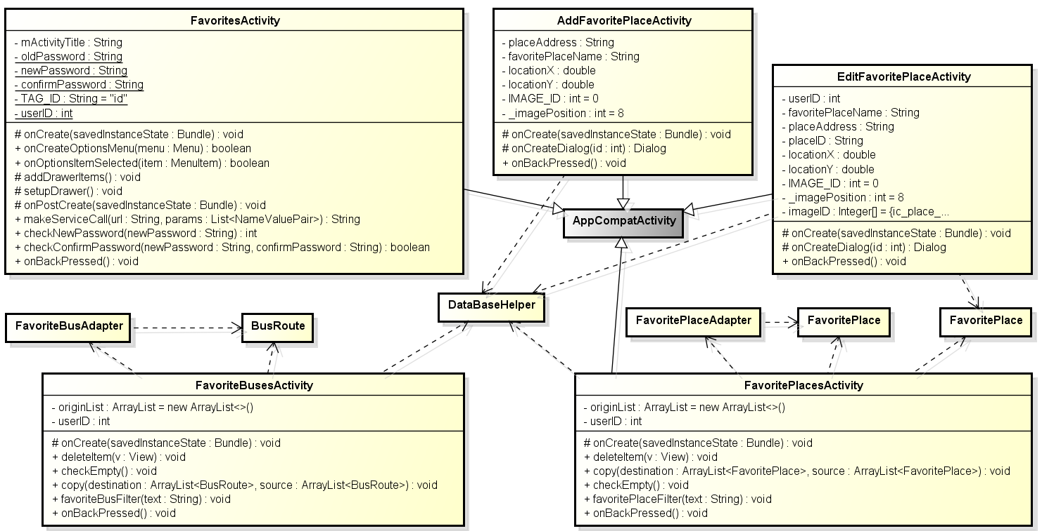

#### 2.1.3.1 FavoritesActivity

##### Attributes

|  |  |  |  |  |  |
| --- | --- | --- | --- | --- | --- |
| **No** | **Attribute** | **Type** | **Default** | **Note** | **Description** |
| 1 | mActivityTitle | String |  | private |  |
| 2 | oldPassword | String |  | private |  |
| 3 | newPassword | String |  | private |  |
| 4 | confirmPassword | String |  | private |  |
| 5 | TAG_ID | String | id | private |  |
| 6 | userID | int |  | private |  |

##### Methods

|  |  |  |  |
| --- | --- | --- | --- |
| onCreate() | | | |
| * Return: void * Visibility: protected * Purpose: create activity | | | |
| Parameters | | | |
| No. | Parameter | Type | Description |
| 1 | saveInstanceState | Bundle | Save instance state |

|  |  |  |  |
| --- | --- | --- | --- |
| onCreateOptionsMenu() | | | |
| * Return: boolean * Visibility: public * Purpose: | | | |
| Parameters | | | |
| No. | Parameter | Type | Description |
| 1 | menu | Menu |  |

|  |  |  |  |
| --- | --- | --- | --- |
| onOptionsItemSelected() | | | |
| * Return: boolean * Visibility: public * Purpose: | | | |
| Parameters | | | |
| No. | Parameter | Type | Description |
| 1 | item | MenuItem |  |

|  |
| --- |
| **addDrawerItems()** |
| * **Return:** void * **Visibility:** protected * **Purpose:** |

|  |
| --- |
| **setupDrawer()** |
| * **Return:** void * **Visibility:** protected * **Purpose:** |

|  |  |  |  |
| --- | --- | --- | --- |
| onPostCreate() | | | |
| * Return: void * Visibility: protected * Purpose: | | | |
| Parameters | | | |
| No. | Parameter | Type | Description |
| 1 | saveInstanceState | Bundle | Save instance state |

|  |  |  |  |
| --- | --- | --- | --- |
| makeServiceCall() | | | |
| * Return: String * Visibility: public * Purpose: | | | |
| Parameters | | | |
| No. | Parameter | Type | Description |
| 1 | url | String |  |
| 2 | params | List<NameValuePair> |  |

|  |  |  |  |
| --- | --- | --- | --- |
| checkNewPassword() | | | |
| * Return: int * Visibility: public * Purpose: | | | |
| Parameters | | | |
| No. | Parameter | Type | Description |
| 1 | newPassword | String |  |

|  |  |  |  |
| --- | --- | --- | --- |
| checkConfirmPassword() | | | |
| * Return: boolean * Visibility: public * Purpose: | | | |
| Parameters | | | |
| No. | Parameter | Type | Description |
| 1 | newPassword | String |  |
| 2 | confirmPassword | String |  |

|  |
| --- |
| **onBackPressed()** |
| * **Return:** void * **Visibility:** public * **Purpose:** |

#### 2.1.3.2 FavoriteBusesActivity

##### Attributes

|  |  |  |  |  |  |
| --- | --- | --- | --- | --- | --- |
| **No** | **Attribute** | **Type** | **Default** | **Note** | **Description** |
| 1 | originList | ArrayList | new ArrayList<>() | private |  |
| 2 | userID | int |  | private |  |

##### Methods

|  |  |  |  |
| --- | --- | --- | --- |
| onCreate() | | | |
| * Return: void * Visibility: protected * Purpose: create activity | | | |
| Parameters | | | |
| No. | Parameter | Type | Description |
| 1 | saveInstanceState | Bundle | Save instance state |

|  |  |  |  |
| --- | --- | --- | --- |
| deleteItem() | | | |
| * Return: void * Visibility: public * Purpose: | | | |
| Parameters | | | |
| No. | Parameter | Type | Description |
| 1 | v | View |  |

|  |
| --- |
| **checkEmpty()** |
| * **Return:** void * **Visibility:** public * **Purpose:** |

|  |  |  |  |
| --- | --- | --- | --- |
| copy() | | | |
| * Return: void * Visibility: public * Purpose: | | | |
| Parameters | | | |
| No. | Parameter | Type | Description |
| 1 | destination | ArrayList<Bus> |  |
| 2 | source | ArrayList<Bus> |  |

|  |  |  |  |
| --- | --- | --- | --- |
| favoriteBusFilter() | | | |
| * Return: void * Visibility: public * Purpose: | | | |
| Parameters | | | |
| No. | Parameter | Type | Description |
| 1 | text | String |  |

|  |
| --- |
| **onBackPressed()** |
| * **Return:** void * **Visibility:** public * **Purpose:** |

#### 2.1.3.3 FavoritePlacesActivity

##### Attributes

|  |  |  |  |  |  |
| --- | --- | --- | --- | --- | --- |
| **No** | **Attribute** | **Type** | **Default** | **Note** | **Description** |
| 1 | originList | ArrayList | new ArrayList<>() | private |  |
| 2 | userID | int |  | private |  |

##### Methods

|  |  |  |  |
| --- | --- | --- | --- |
| onCreate() | | | |
| * Return: void * Visibility: protected * Purpose: create activity | | | |
| Parameters | | | |
| No. | Parameter | Type | Description |
| 1 | saveInstanceState | Bundle | Save instance state |

|  |  |  |  |
| --- | --- | --- | --- |
| deleteItem() | | | |
| * Return: void * Visibility: public * Purpose: | | | |
| Parameters | | | |
| No. | Parameter | Type | Description |
| 1 | v | View |  |

|  |
| --- |
| checkEmpty() |
| * **Return:** void * **Visibility:** public * **Purpose:** |

|  |  |  |  |
| --- | --- | --- | --- |
| copy() | | | |
| * Return: void * Visibility: public * Purpose: | | | |
| Parameters | | | |
| No. | Parameter | Type | Description |
| 1 | destination | ArrayList<Bus> |  |
| 2 | source | ArrayList<Bus> |  |

|  |  |  |  |
| --- | --- | --- | --- |
| favoriteBusFilter() | | | |
| * Return: void * Visibility: public * Purpose: | | | |
| Parameters | | | |
| No. | Parameter | Type | Description |
| 1 | text | String |  |

|  |
| --- |
| onBackPressed() |
| * **Return:** void * **Visibility:** public * **Purpose:** handle back press |

#### 2.1.3.4 AddFavoritePlaceActivity class

##### Attributes

|  |  |  |  |  |  |
| --- | --- | --- | --- | --- | --- |
| **No** | **Attribute** | **Type** | **Default** | **Note** | **Description** |
| 1 | placeAddress | String |  | private |  |
| 2 | favoritePlaceName | String |  | private |  |
| 3 | locationX | double |  | private |  |
| 4 | locationY | double |  | private |  |
| 5 | IMAGE_ID | int | 0 | private |  |
| 6 | _imagePosition | int | 8 | private |  |

##### Methods

|  |  |  |  |
| --- | --- | --- | --- |
| onCreate() | | | |
| * Return: void * Visibility: protected * Purpose: create activity | | | |
| Parameters | | | |
| No. | Parameter | Type | Description |
| 1 | saveInstanceState | Bundle | Save instance state |

|  |  |  |  |
| --- | --- | --- | --- |
| onCreateDialog() | | | |
| * Return: void * Visibility: protected * Purpose: create activity | | | |
| Parameters | | | |
| No. | Parameter | Type | Description |
| 1 | id | Dialog | dialog id |

|  |
| --- |
| onBackPressed() |
| * Return: void * Visibility: public * Purpose: handle back press |

#### 2.1.3.5 EditFavoritePlaceActivity

##### Attributes

|  |  |  |  |
| --- | --- | --- | --- |
| onCreate() | | | |
| * Return: void * Visibility: protected * Purpose: create activity | | | |
| Parameters | | | |
| No. | Parameter | Type | Description |
| 1 | saveInstanceState | Bundle | Save instance state |

##### Methods

|  |  |  |  |
| --- | --- | --- | --- |
| onCreate() | | | |
| * Return: void * Visibility: protected * Purpose: create activity | | | |
| Parameters | | | |
| No. | Parameter | Type | Description |
| 1 | saveInstanceState | Bundle | Save instance state |

|  |  |  |  |
| --- | --- | --- | --- |
| onCreateDialog() | | | |
| * Return: void * Visibility: protected * Purpose: create activity | | | |
| Parameters | | | |
| No. | Parameter | Type | Description |
| 1 | id | Dialog | dialog id |

|  |
| --- |
| onBackPressed() |
| * Return: void * Visibility: public * Purpose: handle back press |

### Reminder group

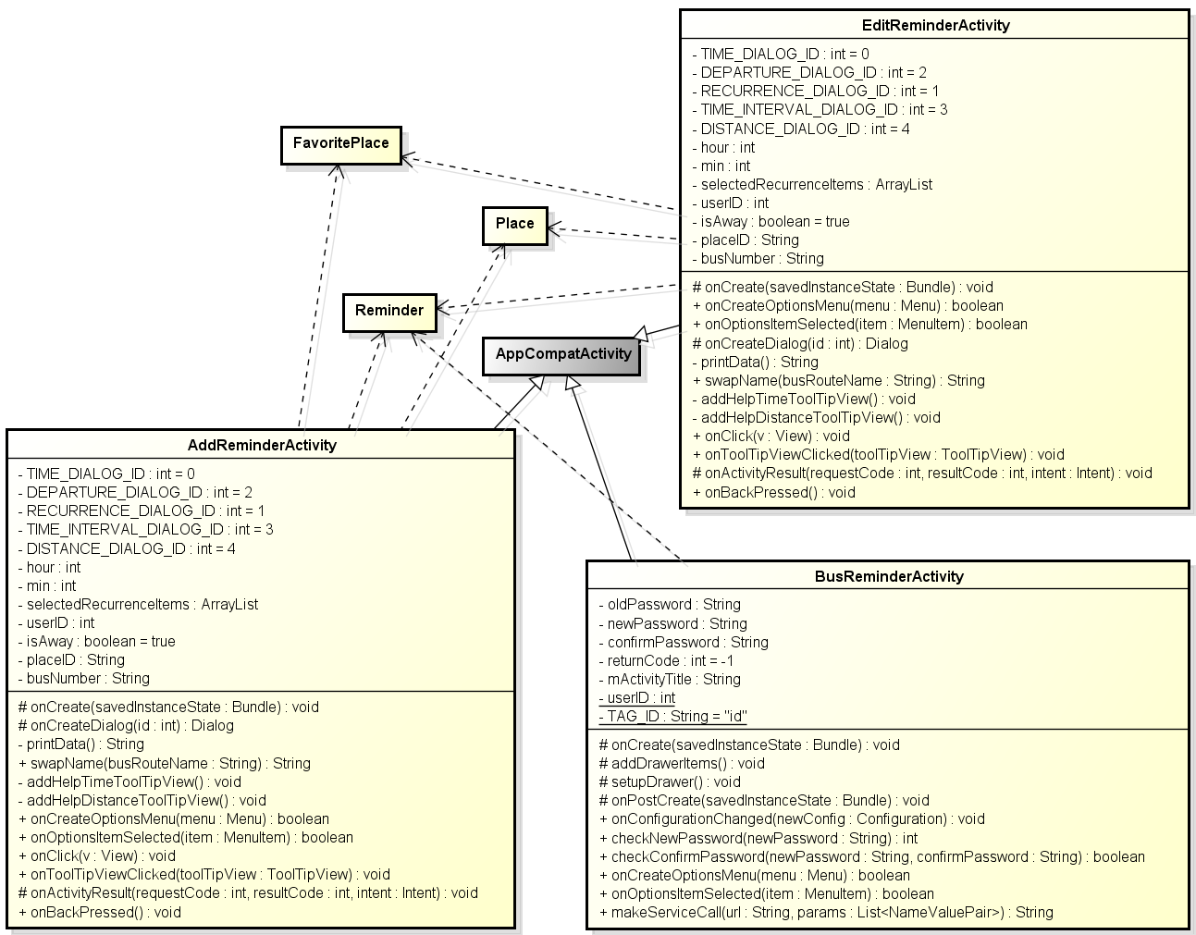

#### 2.1.4.1 BusReminderActivity

##### Attributes

|  |  |  |  |  |  |
| --- | --- | --- | --- | --- | --- |
| **No** | **Attribute** | **Type** | **Default** | **Note** | **Description** |
| 1 | oldPassword | String |  | private |  |
| 2 | newPassword | String |  | private |  |
| 3 | confirmPassword | String |  | private |  |
| 4 | returnCode | int | -1 | private |  |
| 5 | TAG_ID | String | id | private |  |
| 6 | userID | int |  | private |  |
| 7 | mActivityTitle | String |  | private |  |

##### Methods

|  |  |  |  |
| --- | --- | --- | --- |
| onCreate() | | | |
| * Return: void * Visibility: protected * Purpose: create activity | | | |
| Parameters | | | |
| No. | Parameter | Type | Description |
| 1 | saveInstanceState | Bundle | Save instance state |

|  |
| --- |
| addDrawerItems() |
| * Return: void * Visibility: protected * Purpose: |

|  |
| --- |
| setupDrawer() |
| * Return: void * Visibility: protected * Purpose: |

|  |  |  |  |
| --- | --- | --- | --- |
| onPostCreate() | | | |
| * Return: void * Visibility: protected * Purpose: | | | |
| Parameters | | | |
| No. | Parameter | Type | Description |
| 1 | saveInstanceState | Bundle | Save instance state |

|  |  |  |  |
| --- | --- | --- | --- |
| onConfigurationChanged() | | | |
| * Return: void * Visibility: public * Purpose: | | | |
| Parameters | | | |
| No. | Parameter | Type | Description |
| 1 | newConfig | Configuration |  |

|  |  |  |  |
| --- | --- | --- | --- |
| onCreateOptionsMenu() | | | |
| * Return: boolean * Visibility: public * Purpose: | | | |
| Parameters | | | |
| No. | Parameter | Type | Description |
| 1 | menu | Menu |  |

|  |  |  |  |
| --- | --- | --- | --- |
| onOptionsItemSelected() | | | |
| * Return: boolean * Visibility: public * Purpose: | | | |
| Parameters | | | |
| No. | Parameter | Type | Description |
| 1 | item | MenuItem |  |

|  |  |  |  |
| --- | --- | --- | --- |
| makeServiceCall() | | | |
| * Return: String * Visibility: public * Purpose: | | | |
| Parameters | | | |
| No. | Parameter | Type | Description |
| 1 | url | String |  |
| 2 | params | List<NameValuePair> |  |

|  |  |  |  |
| --- | --- | --- | --- |
| checkNewPassword() | | | |
| * Return: int * Visibility: public * Purpose: | | | |
| Parameters | | | |
| No. | Parameter | Type | Description |
| 1 | newPassword | String |  |

|  |  |  |  |
| --- | --- | --- | --- |
| checkConfirmPassword() | | | |
| * Return: boolean * Visibility: public * Purpose: | | | |
| Parameters | | | |
| No. | Parameter | Type | Description |
| 1 | newPassword | String |  |
| 2 | confirmPassword | String |  |

#### 2.1.4.2 AddReminderActivity

##### Attributes

|  |  |  |  |  |  |
| --- | --- | --- | --- | --- | --- |
| **No** | **Attribute** | **Type** | **Default** | **Note** | **Description** |
| 1 | TIME_DIALOG_ID | int | 0 | private |  |
| 2 | DEPARTURTE_DIALOG | int | 2 | private |  |
| 3 | RECURRENCE_DIALOG | int | 1 | private |  |
| 4 | TIME_INTERVAL_DIALOG | int | 3 | private |  |
| 5 | DISTANCE_DIALOG | int | 4 | private |  |
| 6 | hour | int |  | private |  |
| 7 | min | int |  | private |  |
| 8 | selectedRecurrenceItem | ArrayList |  | private |  |
| 9 | userID | int |  | private |  |
| 10 | isAway | Boolean | true | private |  |
| 11 | placeID | String |  | private |  |
| 12 | busNumber | String |  | private |  |

##### Methods

|  |  |  |  |
| --- | --- | --- | --- |
| onCreate() | | | |
| * Return: void * Visibility: protected * Purpose: create activity | | | |
| Parameters | | | |
| No. | Parameter | Type | Description |
| 1 | saveInstanceState | Bundle | Save instance state |

|  |  |  |  |
| --- | --- | --- | --- |
| onCreateDialog() | | | |
| * Return: void * Visibility: protected * Purpose: create dialog | | | |
| Parameters | | | |
| No. | Parameter | Type | Description |
| 1 | Dialog | int | Dialog id |

|  |
| --- |
| printData () |
| * Return: String * Visibility: protected * Purpose: create activity |

|  |  |  |  |
| --- | --- | --- | --- |
| swapName() | | | |
| * Return: String * Visibility: public * Purpose: swap name | | | |
| Parameters | | | |
| No. | Parameter | Type | Description |
| 1 | busRouteName | String | bus route name |

|  |
| --- |
| addHelpTimeTooltipView() |
| * Return: void * Visibility: public * Purpose: add tooltip view for help time |

|  |
| --- |
| addHelpDistanceTooltipView() |
| * Return: void * Visibility: public * Purpose: add tooltip view for help distance |

|  |  |  |  |
| --- | --- | --- | --- |
| onCreateOptionsMenu() | | | |
| * Return: boolean * Visibility: protected * Purpose: create menu | | | |
| Parameters | | | |
| No. | Parameter | Type | Description |
| 1 | menu | Menu | menu |

|  |  |  |  |
| --- | --- | --- | --- |
| onOptionsItemSelected() | | | |
| * Return: boolean * Visibility: protected * Purpose: handle menu item select | | | |
| Parameters | | | |
| No. | Parameter | Type | Description |
| 1 | menuItem | MenuItem | menu item |

|  |  |  |  |
| --- | --- | --- | --- |
| onClick() | | | |
| * Return: void * Visibility: protected * Purpose: handle item click | | | |
| Parameters | | | |
| No. | Parameter | Type | Description |
| 1 | v | View | view |

|  |  |  |  |
| --- | --- | --- | --- |
| onToolTipViewClicked() | | | |
| * Return: boolean * Visibility: protected * Purpose: handle tool tip view click | | | |
| Parameters | | | |
| No. | Parameter | Type | Description |
| 1 | toolTipView | ToolTipView | tool tip view |

|  |  |  |  |
| --- | --- | --- | --- |
| onActivityResult(requestCode : int, resultCode : int, intent : Intent) : void () | | | |
| * Return: void * Visibility: protected * Purpose: create activity | | | |
| Parameters | | | |
| No. | Parameter | Type | Description |
| 1 | requestCode | int | request code |
| 2 | resultCode | int | result code |
| 3 | intent | Intent | intent |

|  |
| --- |
| onBackPressed() |
| * Return: void * Visibility: public * Purpose: |

#### 2.1.4.3 EditReminderActivity

##### Attributes

|  |  |  |  |  |  |
| --- | --- | --- | --- | --- | --- |
| **No** | **Attribute** | **Type** | **Default** | **Note** | **Description** |
| 1 | TIME_DIALOG_ID | int | 0 | private |  |
| 2 | DEPARTURTE_DIALOG | int | 2 | private |  |
| 3 | RECURRENCE_DIALOG | int | 1 | private |  |
| 4 | TIME_INTERVAL_DIALOG | int | 3 | private |  |
| 5 | DISTANCE_DIALOG | int | 4 | private |  |
| 6 | hour | int |  | private |  |
| 7 | min | int |  | private |  |
| 8 | selectedRecurrenceItem | ArrayList |  | private |  |
| 9 | userID | int |  | private |  |
| 10 | isAway | Boolean | true | private |  |
| 11 | placeID | String |  | private |  |
| 12 | busNumber | String |  | private |  |

##### Methods

|  |  |  |  |
| --- | --- | --- | --- |
| onCreate() | | | |
| * Return: void * Visibility: protected * Purpose: create activity | | | |
| Parameters | | | |
| No. | Parameter | Type | Description |
| 1 | saveInstanceState | Bundle | Save instance state |

|  |  |  |  |
| --- | --- | --- | --- |
| onCreateDialog() | | | |
| * Return: void * Visibility: protected * Purpose: create dialog | | | |
| Parameters | | | |
| No. | Parameter | Type | Description |
| 1 | Dialog | int | Dialog id |

|  |
| --- |
| printData () |
| * Return: String * Visibility: protected * Purpose: create activity |

|  |  |  |  |
| --- | --- | --- | --- |
| swapName() | | | |
| * Return: String * Visibility: public * Purpose: swap name | | | |
| Parameters | | | |
| No. | Parameter | Type | Description |
| 1 | busRouteName | String | bus route name |

|  |
| --- |
| addHelpTimeTooltipView() |
| * Return: void * Visibility: public * Purpose: add tooltip view for help time |

|  |
| --- |
| addHelpDistanceTooltipView() |
| * Return: void * Visibility: public * Purpose: add tooltip view for help distance |

|  |  |  |  |
| --- | --- | --- | --- |
| onCreateOptionsMenu() | | | |
| * Return: boolean * Visibility: protected * Purpose: create menu | | | |
| Parameters | | | |
| No. | Parameter | Type | Description |
| 1 | menu | Menu | menu |

|  |  |  |  |
| --- | --- | --- | --- |
| onOptionsItemSelected() | | | |
| * Return: boolean * Visibility: protected * Purpose: handle menu item select | | | |
| Parameters | | | |
| No. | Parameter | Type | Description |
| 1 | menuItem | MenuItem | menu item |

|  |  |  |  |
| --- | --- | --- | --- |
| onClick() | | | |
| * Return: void * Visibility: protected * Purpose: handle item click | | | |
| Parameters | | | |
| No. | Parameter | Type | Description |
| 1 | v | View | view |

|  |  |  |  |
| --- | --- | --- | --- |
| onToolTipViewClicked() | | | |
| * Return: boolean * Visibility: protected * Purpose: handle tool tip view click | | | |
| Parameters | | | |
| No. | Parameter | Type | Description |
| 1 | toolTipView | ToolTipView | tool tip view |

|  |  |  |  |
| --- | --- | --- | --- |
| onActivityResult(requestCode : int, resultCode : int, intent : Intent) : void () | | | |
| * Return: void * Visibility: protected * Purpose: create activity | | | |
| Parameters | | | |
| No. | Parameter | Type | Description |
| 1 | requestCode | int | request code |
| 2 | resultCode | int | result code |
| 3 | intent | Intent | intent |

|  |
| --- |
| onBackPressed() |
| * Return: void * Visibility: public * Purpose: |

### Other

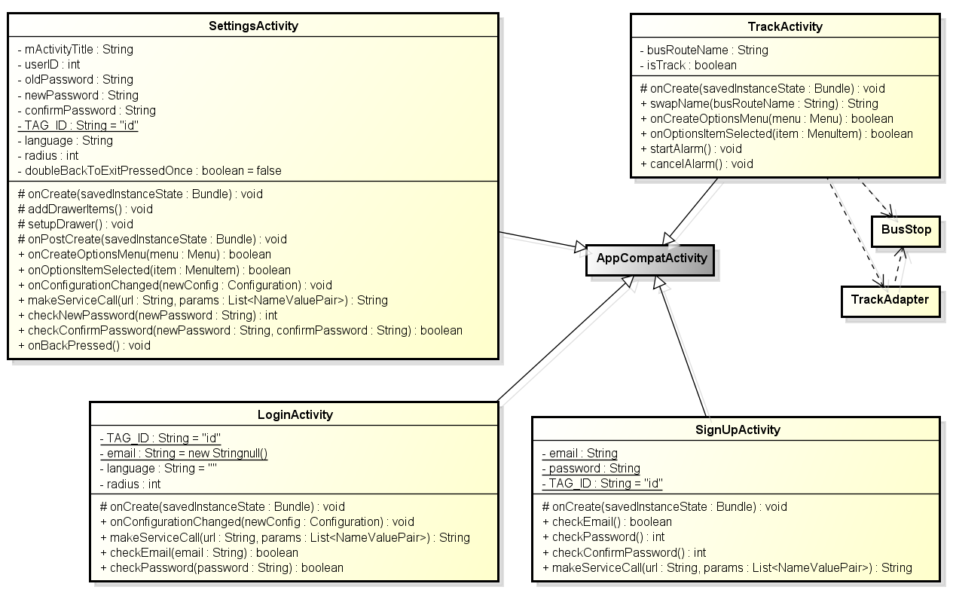

#### 2.1.5.1 LoginActivity

##### Attributes

|  |  |  |  |  |  |
| --- | --- | --- | --- | --- | --- |
| **No** | **Attribute** | **Type** | **Default** | **Note** | **Description** |
| 1 | TAG_ID | String |  | private |  |
| 2 | email | String |  | private |  |
| 3 | language | String |  | private |  |
| 4 | radius | Int |  | private |  |

##### Methods

|  |  |  |  |
| --- | --- | --- | --- |
| onCreate() | | | |
| * Return: void * Visibility: protected * Purpose: create activity | | | |
| Parameters | | | |
| No. | Parameter | Type | Description |
| 1 | saveInstanceState | Bundle | Save instance state |

|  |  |  |  |
| --- | --- | --- | --- |
| onConfigurationChanged() | | | |
| * Return: void * Visibility: public * Purpose: create activity | | | |
| Parameters | | | |
| No. | Parameter | Type | Description |
| 1 | newConfig | Configuration |  |

|  |  |  |  |
| --- | --- | --- | --- |
| makeServiceCall() | | | |
| * Return: String * Visibility: public * Purpose: create activity | | | |
| Parameters | | | |
| No. | Parameter | Type | Description |
| 1 | url | String |  |
| 2 | params | List<NameValuePair> |  |

|  |  |  |  |
| --- | --- | --- | --- |
| checkEmail() | | | |
| * Return: boolean * Visibility: public * Purpose: create activity | | | |
| Parameters | | | |
| No. | Parameter | Type | Description |
| 1 | email | String |  |

|  |  |  |  |
| --- | --- | --- | --- |
| checkPassword() | | | |
| * Return: boolean * Visibility: public * Purpose: create activity | | | |
| Parameters | | | |
| No. | Parameter | Type | Description |
| 1 | password | String |  |

#### 2.1.5.2 SignUpActivity

##### Attributes

|  |  |  |  |  |  |
| --- | --- | --- | --- | --- | --- |
| **No** | **Attribute** | **Type** | **Default** | **Note** | **Description** |
| 1 | email | String |  | private |  |
| 2 | password | String |  | private |  |
| 3 | TAG_ID | String | id | private |  |

##### Methods

|  |  |  |  |
| --- | --- | --- | --- |
| onCreate() | | | |
| * Return: void * Visibility: protected * Purpose: create activity | | | |
| Parameters | | | |
| No. | Parameter | Type | Description |
| 1 | saveInstanceState | Bundle | Save instance state |

|  |
| --- |
| **checkEmail()** |
| * **Return:** boolean * **Visibility:** public * **Purpose:** |

|  |
| --- |
| **checkPassword()** |
| * **Return:** int * **Visibility:** public * **Purpose:** |

|  |
| --- |
| **checkConfirmPassword()** |
| * **Return:** int * **Visibility:** public * **Purpose:** |

|  |  |  |  |
| --- | --- | --- | --- |
| makeServiceCall() | | | |
| * Return: String * Visibility: public * Purpose: | | | |
| Parameters | | | |
| No. | Parameter | Type | Description |
| 1 | url | String |  |
| 2 | params | List<NameValuePair> |  |

#### 2.1.5.3 SettingsActivity

##### Attributes

|  |  |  |  |  |  |
| --- | --- | --- | --- | --- | --- |
| **No** | **Attribute** | **Type** | **Default** | **Note** | **Description** |
| 1 | _id | Int |  | private |  |
| 2 | password | String |  | private |  |
| 3 | TAG_ID | String | id | private |  |

##### Methods

|  |  |  |  |
| --- | --- | --- | --- |
| doInBackground() | | | |
| * Return: void * Visibility: protected * Purpose: create activity | | | |
| Parameters | | | |
| No. | Parameter | Type | Description |
| 1 | arg0 | Void |  |

#### 2.1.5.4 TrackActivity

##### Attributes

##### Methods

## AdapterPackage

### Class diagram

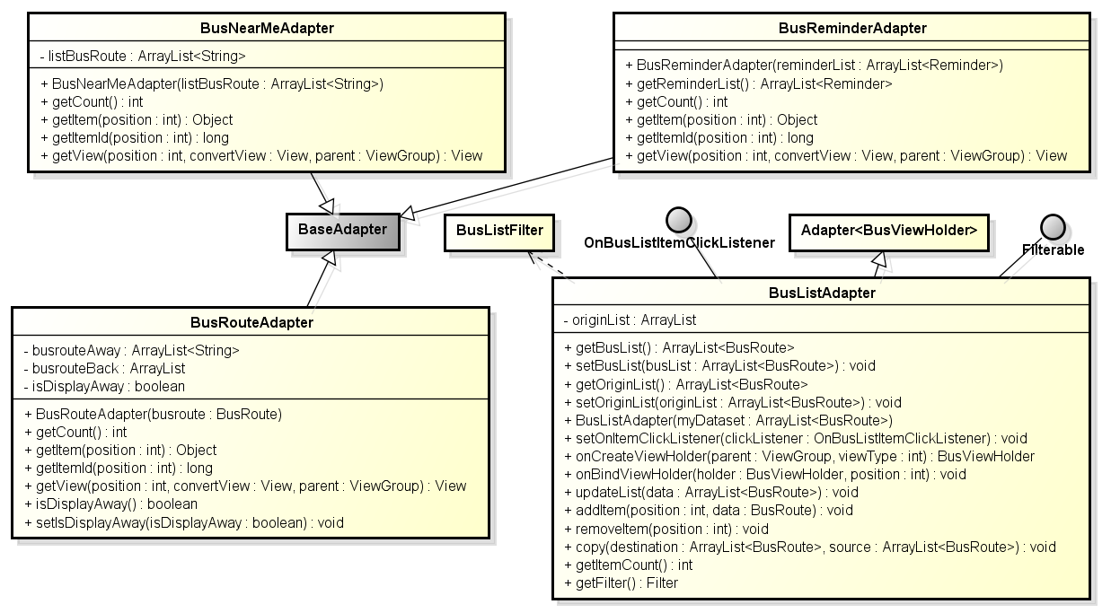

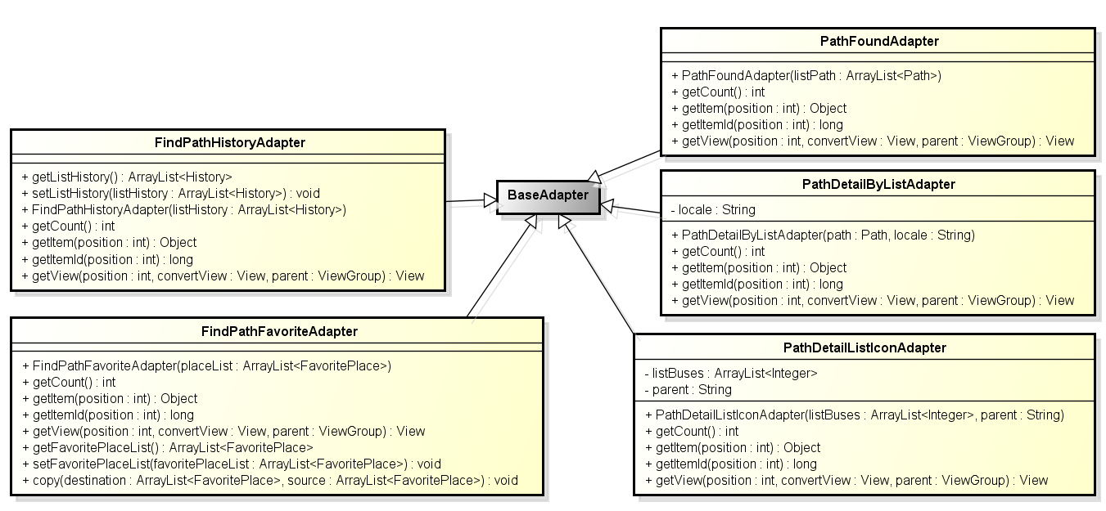

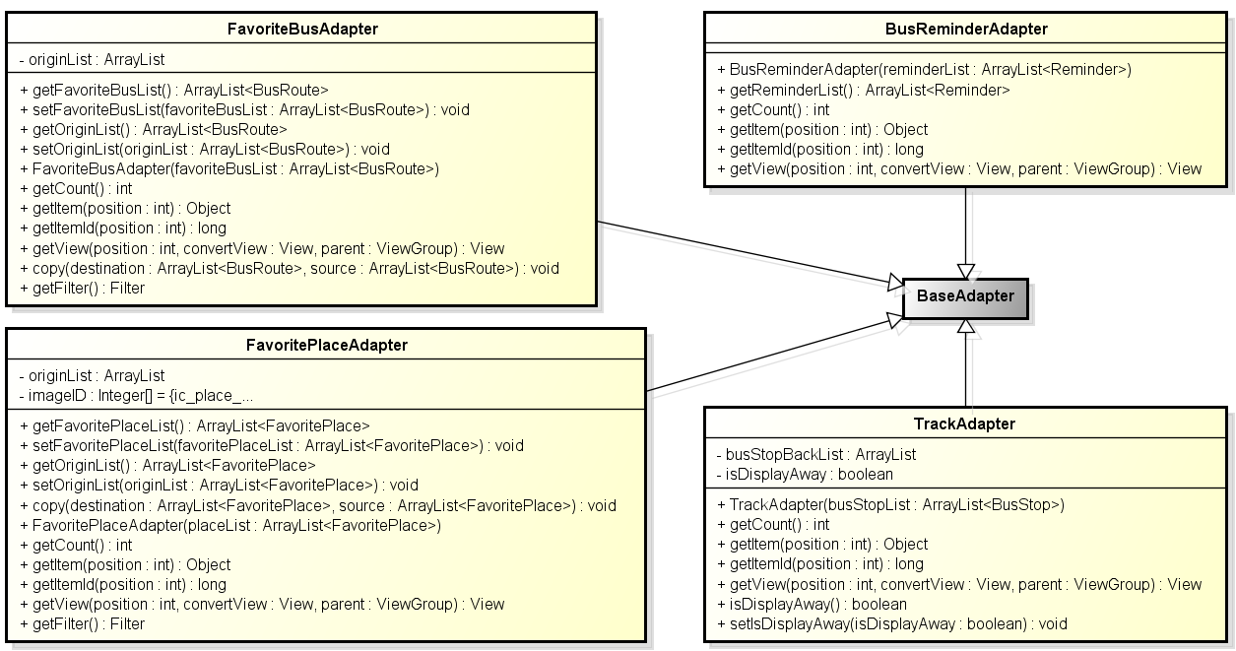

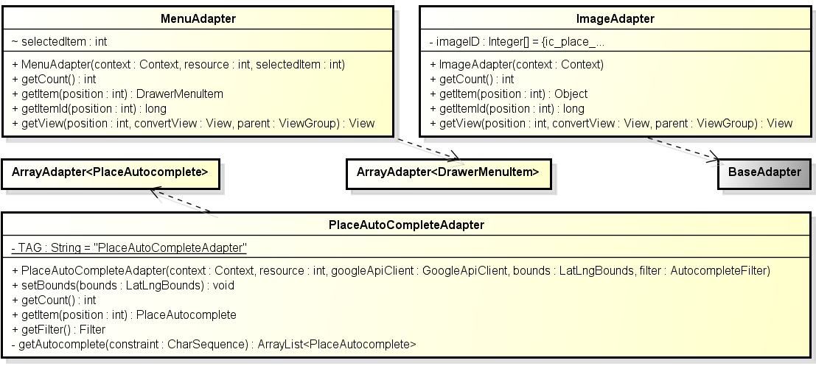

**Figure 2: Class diagram adapter package**

|  |  |  |
| --- | --- | --- |
| No | Class Name | Description |
| 1 | BusListAdapter |  |
| 2 | BusNearMeAdapter |  |
| 3 | BusReminderAdapter |  |
| 4 | BusRouteAdapter |  |
| 5 | FavoriteBusAdapter |  |
| 6 | FavoritePlaceAdapter |  |
| 7 | FindPathFavoriteAdapter |  |
| 8 | FindPathHistoryAdapter |  |
| 9 | ImageAdapter |  |
| 10 | MenuAdapter |  |
| 11 | PathDetailByListAdapter |  |
| 12 | PathDetailListIconAdapter |  |
| 13 | PathFoundAdapter |  |
| 14 | PlaceAutoCompleteAdapter |  |
| 15 | TrackAdapter |  |

### BusListAdapter

#### **Attributes**

|  |  |  |  |  |  |
| --- | --- | --- | --- | --- | --- |
| **No** | **Attribute** | **Type** | **Default** | **Note** | **Description** |
| 1 | originList | ArrayList |  | private |  |

#### **Methods**

|  |
| --- |
| **getBusList()** |
| * **Return:** ArrayList<BusRoute> * **Visibility:** public * **Purpose:** |

|  |  |  |  |
| --- | --- | --- | --- |
| setBusList() | | | |
| * Return: void * Visibility: public * Purpose: | | | |
| Parameters | | | |
| No. | Parameter | Type | Description |
| 1 | busList | ArrayList<BusRoute> |  |

|  |
| --- |
| **getOriginList()** |
| * **Return:** ArrayList<BusRoute> * **Visibility:** public * **Purpose:** |

|  |  |  |  |
| --- | --- | --- | --- |
| setOriginList() | | | |
| * Return: void * Visibility: public * Purpose: | | | |
| Parameters | | | |
| No. | Parameter | Type | Description |
| 1 | originList | ArrayList<BusRoute> |  |

|  |
| --- |
| **BusListAdapter()** |
| * **Return:** * **Visibility:** public * **Purpose:** |

|  |  |  |  |
| --- | --- | --- | --- |
| setOnItemClickListener() | | | |
| * Return: void * Visibility: public * Purpose: | | | |
| Parameters | | | |
| No. | Parameter | Type | Description |
| 1 | clickListener | OnBusListItemClickListener |  |

|  |  |  |  |
| --- | --- | --- | --- |
| onCreateViewHolder() | | | |
| * Return: BusViewHolder * Visibility: public * Purpose: | | | |
| Parameters | | | |
| No. | Parameter | Type | Description |
| 1 | parent | ViewGroup |  |
| 2 | viewType | int |  |

|  |  |  |  |
| --- | --- | --- | --- |
| onBindViewHolder() | | | |
| * Return: void * Visibility: public * Purpose: | | | |
| Parameters | | | |
| No. | Parameter | Type | Description |
| 1 | holder | BusViewHolder |  |
| 2 | position | int |  |

|  |  |  |  |
| --- | --- | --- | --- |
| updateList() | | | |
| * Return: void * Visibility: public * Purpose: | | | |
| Parameters | | | |
| No. | Parameter | Type | Description |
| 1 | data | ArrayList<BusRoute> |  |

|  |  |  |  |
| --- | --- | --- | --- |
| addItem() | | | |
| * Return: void * Visibility: public * Purpose: | | | |
| Parameters | | | |
| No. | Parameter | Type | Description |
| 1 | position | int |  |
| 2 | data | BusRoute |  |

|  |  |  |  |
| --- | --- | --- | --- |
| removeItem() | | | |
| * Return: void * Visibility: public * Purpose: | | | |
| Parameters | | | |
| No. | Parameter | Type | Description |
| 1 | position | int |  |

|  |  |  |  |
| --- | --- | --- | --- |
| copy() | | | |
| * Return: void * Visibility: public * Purpose: | | | |
| Parameters | | | |
| No. | Parameter | Type | Description |
| 1 | destination | ArrayList<BusRoute> |  |
| 2 | source | ArrayList<BusRoute> |  |

|  |
| --- |
| **getItemCount()** |
| * **Return:** int * **Visibility:** public * **Purpose:** |

|  |
| --- |
| **getFilter()** |
| * **Return:** Filter * **Visibility:** public * **Purpose:** |

### BusNearMeAdapter

#### **Attributes**

|  |  |  |  |  |  |
| --- | --- | --- | --- | --- | --- |
| **No** | **Attribute** | **Type** | **Default** | **Note** | **Description** |
| 1 | listBusRoute | ArrayList<String> |  | private |  |

#### **Methods**

|  |
| --- |
| **BusNearMeAdapter()** |
| * **Return:** * **Visibility:** public * **Purpose:** |

|  |
| --- |
| **getCount()** |
| * **Return:** int * **Visibility:** public * **Purpose:** |

|  |  |  |  |
| --- | --- | --- | --- |
| getItem() | | | |
| * Return: Object * Visibility: public * Purpose: | | | |
| Parameters | | | |
| No. | Parameter | Type | Description |
| 1 | position | int |  |

|  |  |  |  |
| --- | --- | --- | --- |
| getItemId() | | | |
| * Return: long * Visibility: public * Purpose: | | | |
| Parameters | | | |
| No. | Parameter | Type | Description |
| 1 | position | int |  |

|  |  |  |  |
| --- | --- | --- | --- |
| getView() | | | |
| * Return: View * Visibility: public * Purpose: | | | |
| Parameters | | | |
| No. | Parameter | Type | Description |
| 1 | position | int |  |
| 2 | convertView | View |  |
| 3 | parent | ViewGroup |  |

### BusRouteAdapter

#### **Attributes**

|  |  |  |  |  |  |
| --- | --- | --- | --- | --- | --- |
| **No** | **Attribute** | **Type** | **Default** | **Note** | **Description** |
| 1 | busrouteAway | ArrayList<String> |  | private |  |
| 2 | busrouteBack | ArrayList |  | private |  |
| 3 | isDisplayAway | boolean |  | private |  |

#### **Methods**

|  |
| --- |
| **BusRouteAdapter()** |
| * **Return:** * **Visibility:** public * **Purpose:** |

|  |
| --- |
| **getCount()** |
| * **Return:** int * **Visibility:** public * **Purpose:** |

|  |  |  |  |
| --- | --- | --- | --- |
| getItem() | | | |
| * Return: Object * Visibility: public * Purpose: | | | |
| Parameters | | | |
| No. | Parameter | Type | Description |
| 1 | position | int |  |

|  |  |  |  |
| --- | --- | --- | --- |
| getItemId() | | | |
| * Return: long * Visibility: public * Purpose: | | | |
| Parameters | | | |
| No. | Parameter | Type | Description |
| 1 | position | int |  |

|  |  |  |  |
| --- | --- | --- | --- |
| getView() | | | |
| * Return: View * Visibility: public * Purpose: | | | |
| Parameters | | | |
| No. | Parameter | Type | Description |
| 1 | position | int |  |
| 2 | convertView | View |  |
| 3 | parent | ViewGroup |  |

|  |
| --- |
| **isDisplayAway()** |
| * **Return:** boolean * **Visibility:** public * **Purpose:** |

|  |  |  |  |
| --- | --- | --- | --- |
| setlsDisplayAway() | | | |
| * Return: void * Visibility: public * Purpose: | | | |
| Parameters | | | |
| No. | Parameter | Type | Description |
| 1 | isDisplayAway | boolean |  |

### FavoriteBusAdapter

#### **Attributes**

|  |  |  |  |  |  |
| --- | --- | --- | --- | --- | --- |
| **No** | **Attribute** | **Type** | **Default** | **Note** | **Description** |
| 1 | originList | ArrayList |  | private |  |

#### **Methods**

|  |
| --- |
| **getFavoriteBusList()** |
| * **Return:** ArrayList<BusRoute> * **Visibility:** public * **Purpose:** |

|  |  |  |  |
| --- | --- | --- | --- |
| setFavoriteBusList() | | | |
| * Return: void * Visibility: public * Purpose: | | | |
| Parameters | | | |
| No. | Parameter | Type | Description |
| 1 | favoriteBusList | ArrayList<BusRoute> |  |

|  |
| --- |
| **getOriginList()** |
| * **Return:** ArrayList<BusRoute> * **Visibility:** public * **Purpose:** |

|  |  |  |  |
| --- | --- | --- | --- |
| setOriginList() | | | |
| * Return: void * Visibility: public * Purpose: | | | |
| Parameters | | | |
| No. | Parameter | Type | Description |
| 1 | originList | ArrayList<BusRoute> |  |

|  |
| --- |
| **FavoriteBusAdapter()** |
| * **Return:** * **Visibility:** public * **Purpose:** |

|  |
| --- |
| **getCount()** |
| * **Return:** int * **Visibility:** public * **Purpose:** |

|  |  |  |  |
| --- | --- | --- | --- |
| getItem() | | | |
| * Return: Object * Visibility: public * Purpose: | | | |
| Parameters | | | |
| No. | Parameter | Type | Description |
| 1 | position | int |  |

|  |  |  |  |
| --- | --- | --- | --- |
| getItemId() | | | |
| * Return: long * Visibility: public * Purpose: | | | |
| Parameters | | | |
| No. | Parameter | Type | Description |
| 1 | position | int |  |

|  |  |  |  |
| --- | --- | --- | --- |
| getView() | | | |
| * Return: View * Visibility: public * Purpose: | | | |
| Parameters | | | |
| No. | Parameter | Type | Description |
| 1 | position | int |  |
| 2 | convertView | View |  |
| 3 | parent | ViewGroup |  |

|  |  |  |  |
| --- | --- | --- | --- |
| copy() | | | |
| * Return: void * Visibility: public * Purpose: | | | |
| Parameters | | | |
| No. | Parameter | Type | Description |
| 1 | destination | ArrayList<BusRoute> |  |
| 2 | source | ArrayList<BusRoute> |  |

|  |
| --- |
| **getFilter()** |
| * **Return:** Filter * **Visibility:** public * **Purpose:** |

### FavoritePlaceAdapter

#### **Attributes**

|  |  |  |  |  |  |
| --- | --- | --- | --- | --- | --- |
| **No** | **Attribute** | **Type** | **Default** | **Note** | **Description** |
| 1 | originList | ArrayList |  | private |  |
| 2 | imageID | Integer[] | {ic_place_cafe,ic_place_home,ic_place_hospital,ic_place_library,ic_place_restaurant,ic_place_school,ic_place_store,ic_place_work,ic_action_location_on} | private |  |

#### **Methods**

|  |
| --- |
| **getFavoritePlaceList()** |
| * **Return:** ArrayList<FavoritePlace> * **Visibility:** public * **Purpose:** |

|  |  |  |  |
| --- | --- | --- | --- |
| setFavoritePlaceList() | | | |
| * Return: void * Visibility: public * Purpose: | | | |
| Parameters | | | |
| No. | Parameter | Type | Description |
| 1 | favoritePlaceList | ArrayList<FavoritePlace> |  |

|  |
| --- |
| **getOriginList()** |
| * **Return:** ArrayList<FavoritePlace> * **Visibility:** public * **Purpose:** |

|  |  |  |  |
| --- | --- | --- | --- |
| setOriginList() | | | |
| * Return: void * Visibility: public * Purpose: | | | |
| Parameters | | | |
| No. | Parameter | Type | Description |
| 1 | originList | ArrayList<FavoritePlace> |  |

|  |  |  |  |
| --- | --- | --- | --- |
| copy() | | | |
| * Return: void * Visibility: public * Purpose: | | | |
| Parameters | | | |
| No. | Parameter | Type | Description |
| 1 | destination | ArrayList<FavoritePlace> |  |
| 2 | source | ArrayList<FavoritePlace> |  |

|  |
| --- |
| **FavoritePlaceAdapter()** |
| * **Return:** * **Visibility:** public * **Purpose:** |

|  |
| --- |
| **getCount()** |
| * **Return:** int * **Visibility:** public * **Purpose:** |

|  |  |  |  |
| --- | --- | --- | --- |
| getItem() | | | |
| * Return: Object * Visibility: public * Purpose: | | | |
| Parameters | | | |
| No. | Parameter | Type | Description |
| 1 | position | int |  |

|  |  |  |  |
| --- | --- | --- | --- |
| getItemId() | | | |
| * Return: long * Visibility: public * Purpose: | | | |
| Parameters | | | |
| No. | Parameter | Type | Description |
| 1 | position | int |  |

|  |  |  |  |
| --- | --- | --- | --- |
| getView() | | | |
| * Return: View * Visibility: public * Purpose: | | | |
| Parameters | | | |
| No. | Parameter | Type | Description |
| 1 | position | int |  |
| 2 | convertView | View |  |
| 3 | parent | ViewGroup |  |

|  |
| --- |
| **getFilter()** |
| * **Return:** Filter * **Visibility:** public * **Purpose:** |

### FindPathFavoriteAdapter

#### **Attributes**

N/A

#### **Methods**

|  |
| --- |
| **FindPathFavoriteAdapter()** |
| * **Return:** * **Visibility:** public * **Purpose:** |

|  |
| --- |
| **getCount()** |
| * **Return:** int * **Visibility:** public * **Purpose:** |

|  |  |  |  |
| --- | --- | --- | --- |
| getItem() | | | |
| * Return: Object * Visibility: public * Purpose: | | | |
| Parameters | | | |
| No. | Parameter | Type | Description |
| 1 | position | int |  |

|  |  |  |  |
| --- | --- | --- | --- |
| getItemId() | | | |
| * Return: long * Visibility: public * Purpose: | | | |
| Parameters | | | |
| No. | Parameter | Type | Description |
| 1 | position | int |  |

|  |  |  |  |
| --- | --- | --- | --- |
| getView() | | | |
| * Return: View * Visibility: public * Purpose: | | | |
| Parameters | | | |
| No. | Parameter | Type | Description |
| 1 | position | int |  |
| 2 | convertView | View |  |
| 3 | parent | ViewGroup |  |

|  |
| --- |
| **getFavoritePlaceList()** |
| * **Return:** ArrayList<FavoritePlace> * **Visibility:** public * **Purpose:** |

|  |  |  |  |
| --- | --- | --- | --- |
| setFavoritePlaceList() | | | |
| * Return: void * Visibility: public * Purpose: | | | |
| Parameters | | | |
| No. | Parameter | Type | Description |
| 1 | favoritePlaceList | ArrayList<FavoritePlace> |  |

|  |  |  |  |
| --- | --- | --- | --- |
| copy() | | | |
| * Return: void * Visibility: public * Purpose: | | | |
| Parameters | | | |
| No. | Parameter | Type | Description |
| 1 | destination | ArrayList<FavoritePlace> |  |
| 2 | source | ArrayList<FavoritePlace> |  |

### FindPathHistoryAdapter

#### **Attributes**

N/A

#### **Methods**

|  |
| --- |
| **getListHistory()** |
| * **Return:** ArrayList<History> * **Visibility:** public * **Purpose:** |

|  |  |  |  |
| --- | --- | --- | --- |
| setListHistory() | | | |
| * Return: void * Visibility: public * Purpose: | | | |
| Parameters | | | |
| No. | Parameter | Type | Description |
| 1 | listHistory | ArrayList<History> |  |

|  |
| --- |
| **FindPathHistoryAdapter()** |
| * **Return:** * **Visibility:** public * **Purpose:** |

|  |
| --- |
| **getCount()** |
| * **Return:** int * **Visibility:** public * **Purpose:** |

|  |  |  |  |
| --- | --- | --- | --- |
| getItem() | | | |
| * Return: Object * Visibility: public * Purpose: | | | |
| Parameters | | | |
| No. | Parameter | Type | Description |
| 1 | position | int |  |

|  |  |  |  |
| --- | --- | --- | --- |
| getItemId() | | | |
| * Return: long * Visibility: public * Purpose: | | | |
| Parameters | | | |
| No. | Parameter | Type | Description |
| 1 | position | int |  |

|  |  |  |  |
| --- | --- | --- | --- |
| getView() | | | |
| * Return: View * Visibility: public * Purpose: | | | |
| Parameters | | | |
| No. | Parameter | Type | Description |
| 1 | position | int |  |
| 2 | convertView | View |  |
| 3 | parent | ViewGroup |  |

### ImageAdapter

#### **Attributes**

|  |  |  |  |  |  |
| --- | --- | --- | --- | --- | --- |
| **No** | **Attribute** | **Type** | **Default** | **Note** | **Description** |
| 1 | imageID | Integer[] | {ic_place_cafe,ic_place_home,ic_place_hospital,ic_place_library,ic_place_restaurant,ic_place_school,ic_place_store,ic_place_work,ic_action_location_on} | private |  |

#### **Methods**

|  |
| --- |
| **ImageAdapter()** |
| * **Return:** ArrayList<FavoritePlace> * **Visibility:** public * **Purpose:** |

|  |
| --- |
| **getCount()** |
| * **Return:** int * **Visibility:** public * **Purpose:** |

|  |  |  |  |
| --- | --- | --- | --- |
| getItem() | | | |
| * Return: Object * Visibility: public * Purpose: | | | |
| Parameters | | | |
| No. | Parameter | Type | Description |
| 1 | position | int |  |

|  |  |  |  |
| --- | --- | --- | --- |
| getItemId() | | | |
| * Return: long * Visibility: public * Purpose: | | | |
| Parameters | | | |
| No. | Parameter | Type | Description |
| 1 | position | int |  |

|  |  |  |  |
| --- | --- | --- | --- |
| getView() | | | |
| * Return: View * Visibility: public * Purpose: | | | |
| Parameters | | | |
| No. | Parameter | Type | Description |
| 1 | position | int |  |
| 2 | convertView | View |  |
| 3 | parent | ViewGroup |  |

### MenuAdapter

#### **Attributes**

|  |  |  |  |  |  |
| --- | --- | --- | --- | --- | --- |
| **No** | **Attribute** | **Type** | **Default** | **Note** | **Description** |
| 1 | selectedItem | int |  | package |  |

#### **Methods**

|  |  |  |  |
| --- | --- | --- | --- |
| MenuAdapter() | | | |
| * Return: * Visibility: public * Purpose: | | | |
| Parameters | | | |
| No. | Parameter | Type | Description |
| 1 | resource | int |  |
| 2 | selectedItem | int |  |

|  |
| --- |
| **getCount()** |
| * **Return:** int * **Visibility:** public * **Purpose:** |

|  |  |  |  |
| --- | --- | --- | --- |
| getItem() | | | |
| * Return: Object * Visibility: public * Purpose: | | | |
| Parameters | | | |
| No. | Parameter | Type | Description |
| 1 | position | int |  |

|  |  |  |  |
| --- | --- | --- | --- |
| getItemId() | | | |
| * Return: long * Visibility: public * Purpose: | | | |
| Parameters | | | |
| No. | Parameter | Type | Description |
| 1 | position | int |  |

|  |  |  |  |
| --- | --- | --- | --- |
| getView() | | | |
| * Return: View * Visibility: public * Purpose: | | | |
| Parameters | | | |
| No. | Parameter | Type | Description |
| 1 | position | int |  |
| 2 | convertView | View |  |
| 3 | parent | ViewGroup |  |

### PathDetailByListAdapter

#### **Attributes**

|  |  |  |  |  |  |
| --- | --- | --- | --- | --- | --- |
| **No** | **Attribute** | **Type** | **Default** | **Note** | **Description** |
| 1 | locale | String |  | private |  |

#### **Methods**

|  |  |  |  |
| --- | --- | --- | --- |
| PathDetailByListAdapter() | | | |
| * Return: * Visibility: public * Purpose: | | | |
| Parameters | | | |
| No. | Parameter | Type | Description |
| 1 | locale | String |  |

|  |
| --- |
| **getCount()** |
| * **Return:** int * **Visibility:** public * **Purpose:** |

|  |  |  |  |
| --- | --- | --- | --- |
| getItem() | | | |
| * Return: Object * Visibility: public * Purpose: | | | |
| Parameters | | | |
| No. | Parameter | Type | Description |
| 1 | position | int |  |

|  |  |  |  |
| --- | --- | --- | --- |
| getItemId() | | | |
| * Return: long * Visibility: public * Purpose: | | | |
| Parameters | | | |
| No. | Parameter | Type | Description |
| 1 | position | int |  |

|  |  |  |  |
| --- | --- | --- | --- |
| getView() | | | |
| * Return: View * Visibility: public * Purpose: | | | |
| Parameters | | | |
| No. | Parameter | Type | Description |
| 1 | position | int |  |
| 2 | convertView | View |  |
| 3 | parent | ViewGroup |  |

### PathDeatilListIconAdapter

#### **Attributes**

|  |  |  |  |  |  |
| --- | --- | --- | --- | --- | --- |
| **No** | **Attribute** | **Type** | **Default** | **Note** | **Description** |
| 1 | listBuses | ArrayList<Integer> |  | private |  |
| 2 | parent | String |  | private |  |

#### **Methods**

|  |  |  |  |
| --- | --- | --- | --- |
| PathDetailListIconAdapter() | | | |
| * Return: * Visibility: public * Purpose: | | | |
| Parameters | | | |
| No. | Parameter | Type | Description |
| 1 | parent | String |  |

|  |
| --- |
| **getCount()** |
| * **Return:** int * **Visibility:** public * **Purpose:** |

|  |  |  |  |
| --- | --- | --- | --- |
| getItem() | | | |
| * Return: Object * Visibility: public * Purpose: | | | |
| Parameters | | | |
| No. | Parameter | Type | Description |
| 1 | position | int |  |

|  |  |  |  |
| --- | --- | --- | --- |
| getItemId() | | | |
| * Return: long * Visibility: public * Purpose: | | | |
| Parameters | | | |
| No. | Parameter | Type | Description |
| 1 | position | int |  |

|  |  |  |  |
| --- | --- | --- | --- |
| getView() | | | |
| * Return: View * Visibility: public * Purpose: | | | |
| Parameters | | | |
| No. | Parameter | Type | Description |
| 1 | position | int |  |
| 2 | convertView | View |  |
| 3 | parent | ViewGroup |  |

### PathFoundAdapter

#### **Attributes**

N/A

#### **Methods**

|  |
| --- |
| PathFoundAdapter() |
| * Return: * Visibility: public * Purpose: |

|  |
| --- |
| **getCount()** |
| * **Return:** int * **Visibility:** public * **Purpose:** |

|  |  |  |  |
| --- | --- | --- | --- |
| getItem() | | | |
| * Return: Object * Visibility: public * Purpose: | | | |
| Parameters | | | |
| No. | Parameter | Type | Description |
| 1 | position | int |  |

|  |  |  |  |
| --- | --- | --- | --- |
| getItemId() | | | |
| * Return: long * Visibility: public * Purpose: | | | |
| Parameters | | | |
| No. | Parameter | Type | Description |
| 1 | position | int |  |

|  |  |  |  |
| --- | --- | --- | --- |
| getView() | | | |
| * Return: View * Visibility: public * Purpose: | | | |
| Parameters | | | |
| No. | Parameter | Type | Description |
| 1 | position | int |  |
| 2 | convertView | View |  |
| 3 | parent | ViewGroup |  |

### PlaceAutoCompleteAdapter

#### **Attributes**

|  |  |  |  |  |  |
| --- | --- | --- | --- | --- | --- |
| **No** | **Attribute** | **Type** | **Default** | **Note** | **Description** |
| 1 | TAG | String | PlaceAutoCompleteAdapter | private |  |

#### **Methods**

|  |  |  |  |
| --- | --- | --- | --- |
| PlaceAutoCompleteAdapter() | | | |
| * Return: * Visibility: public * Purpose: | | | |
| Parameters | | | |
| No. | Parameter | Type | Description |
| 1 | resource | int |  |
| 2 | googleApiClient | GoogleApiClient |  |
| 3 | bounds | LatLngBounds |  |
| 4 | filter | AutocompleteFilter |  |

|  |  |  |  |
| --- | --- | --- | --- |
| setBounds() | | | |
| * Return: void * Visibility: public * Purpose: Sets the bounds for all subsequent queries | | | |
| Parameters | | | |
| No. | Parameter | Type | Description |
| 1 | bounds | LatLngBounds |  |

|  |
| --- |
| getCount() |
| * Return: int * Visibility: public * Purpose: Returns the number of results received in the last autocomplete query |

|  |  |  |  |
| --- | --- | --- | --- |
| getItem() | | | |
| * Return: PlaceAutocomplete * Visibility: public * Purpose: Returns an item from the last autocomplete query | | | |
| Parameters | | | |
| No. | Parameter | Type | Description |
| 1 | position | int |  |

|  |
| --- |
| **getFilter()** |
| * **Return:** Filter * **Visibility:** public * **Purpose:** Returns the filter for the current set of autocomplete results |

|  |  |  |  |
| --- | --- | --- | --- |
| getAutocomplete() | | | |
| * Return: ArrayList<PlaceAutocomplete> * Visibility: public * Purpose: | | | |
| Parameters | | | |
| No. | Parameter | Type | Description |
| 1 | constraint | CharSequence |  |

### TrackAdapter

#### **Attributes**

|  |  |  |  |  |  |
| --- | --- | --- | --- | --- | --- |
| **No** | **Attribute** | **Type** | **Default** | **Note** | **Description** |
| 1 | busStopBackList | ArrayList |  | private |  |
| 2 | isDisplayAway | boolean |  | private |  |

## Common Package

### Class diagram

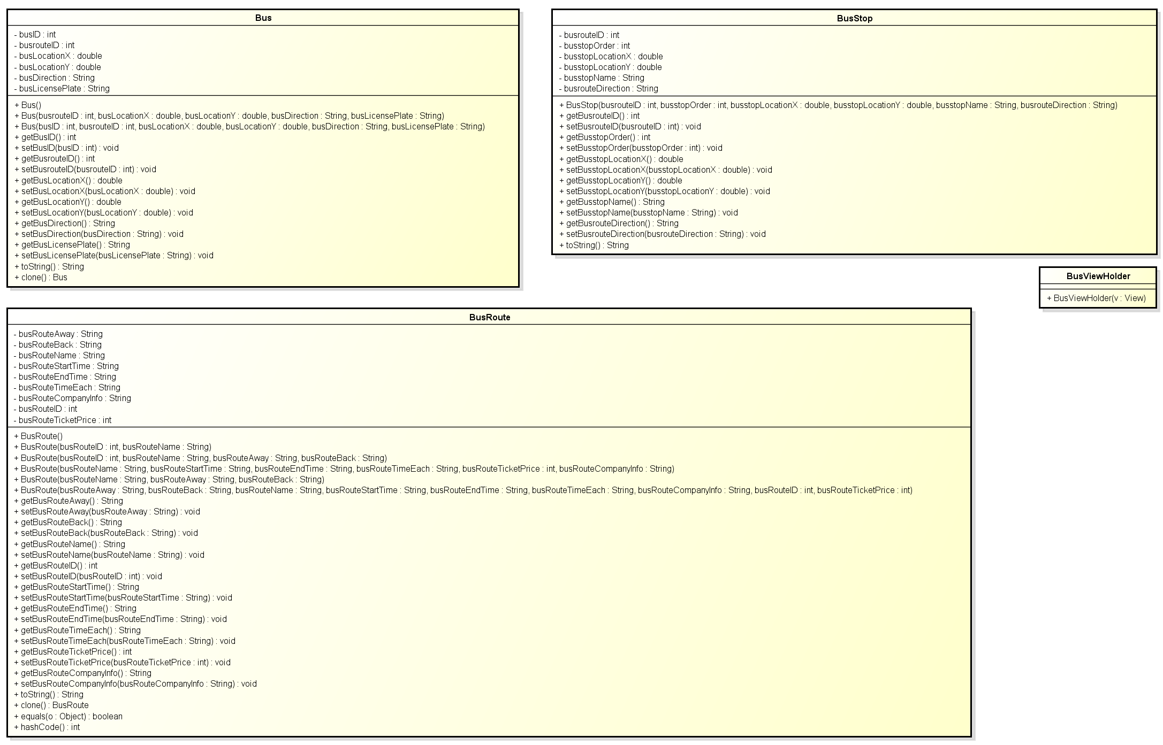

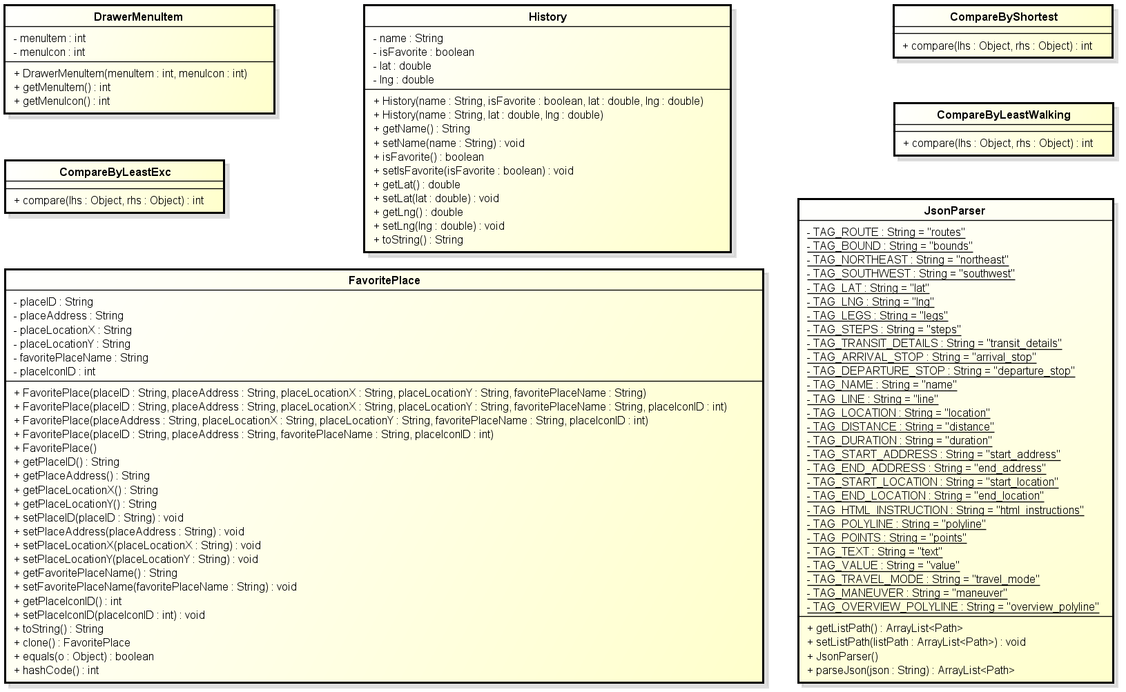

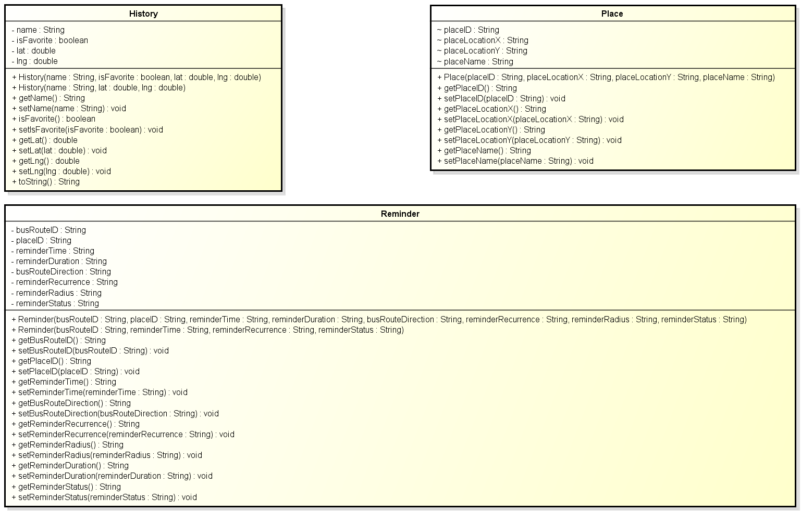

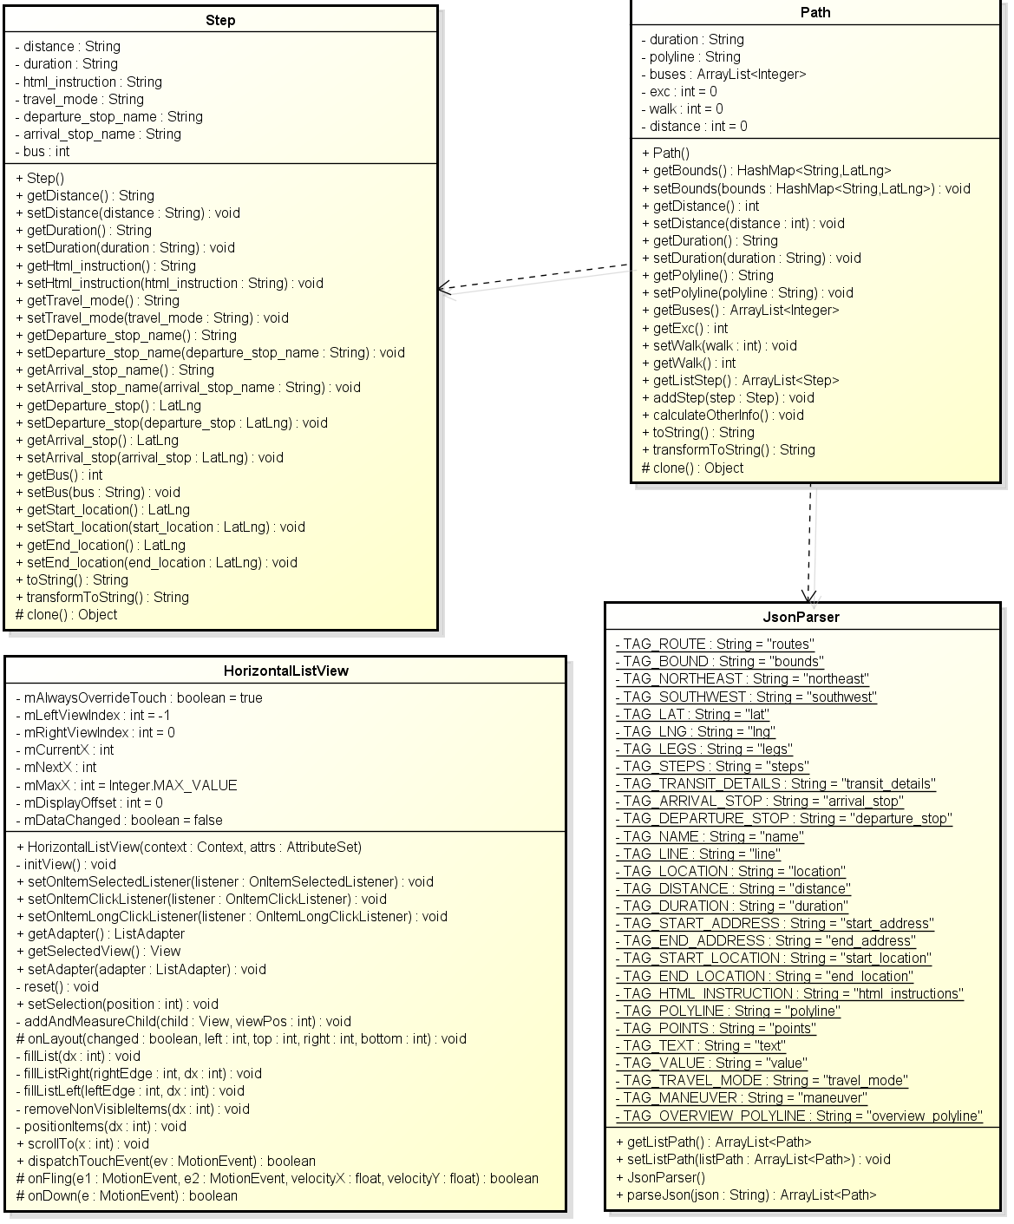

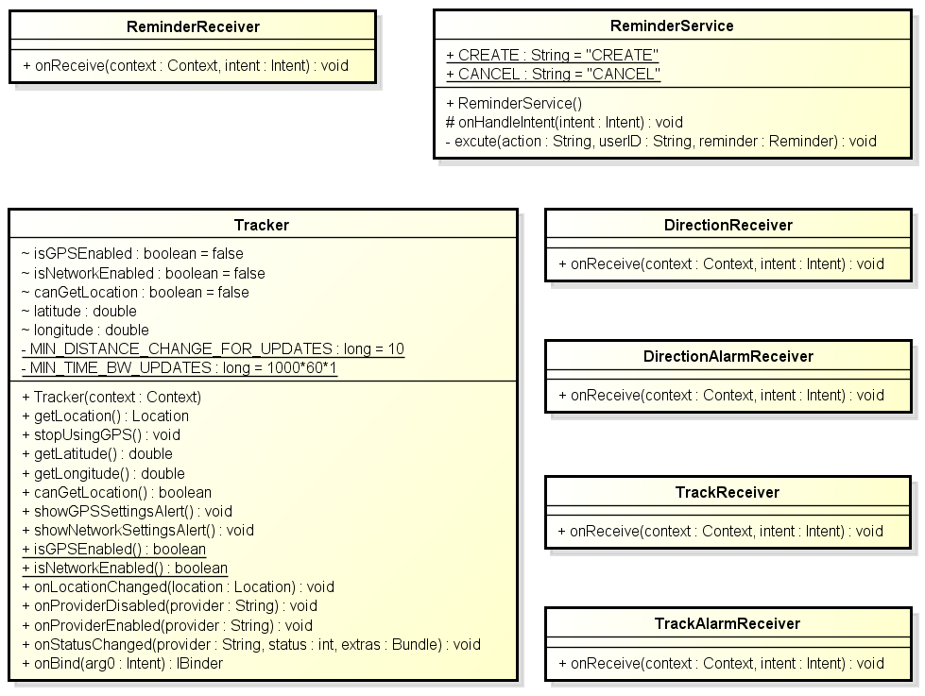

**Figure 3: Class diagram Common package**

|  |  |  |
| --- | --- | --- |
| No | Class Name | Description |
| 1 | Bus | bus |
| 2 | BusRoute | bus route |
| 3 | BusStop | bus stop |
| 4 | BusViewHolder | bus view holder |
| 5 | CompareByLeastExc | compare by least exc |
| 6 | CompareByLeastWalking | compare by least walking |
| 7 | CompareByShortest | compare by shortest |
| 8 | DrawerMenuItem | drawer menu item |
| 9 | FavoritePlace | favorite place |
| 10 | History | history |
| 11 | HorizontalListView | horizontal list view |
| 12 | JsonParser | json parser |
| 13 | Path | path |
| 14 | Place | place |
| 15 | Reminder | reminder |
| 16 | Step | step |
| 17 | Tracker | tracker |
| 18 | DirectionReceiver | direction receiver |
| 19 | DirectionAlarmReceiver | direction alarm receiver |
| 20 | ReminderReceiver | reminder receiver |
| 21 | ReminderService | reminder service |
| 22 | TrackReceiver | track receiver |
| 23 | TrackAlarmReceiver | track alarm receiver |

### Bus

#### **Attributes**

|  |  |  |  |  |  |
| --- | --- | --- | --- | --- | --- |
| **No** | **Attribute** | **Type** | **Default** | **Note** | **Description** |
| 1 | busID | Int |  | Private |  |
| 2 | busrouteID | Int |  | Private |  |
| 3 | busLocationX | Double |  | Private |  |
| 4 | busLocationY | Double |  | Private |  |
| 5 | busDirection | String |  | Private |  |
| 6 | busLicensePlate | String |  | Private |  |

#### **Methods**

|  |
| --- |
| **Bus()** |
| * **Return:** * **Visibility:** public * **Purpose:** |

|  |  |  |  |
| --- | --- | --- | --- |
| Bus() | | | |
| * Return: * Visibility: public * Purpose: | | | |
| Parameters | | | |
| No. | Parameter | Type | Description |
| 1 | busrouteID | Int |  |
| 2 | busLocationX | Double |  |
| 3 | busLocationY | Double |  |
| 4 | busDirection | String |  |
| 5 | busLicensePlate | String |  |

|  |
| --- |
| **getBusID()** |
| * **Return:** int * **Visibility:** public * **Purpose:** |

|  |  |  |  |
| --- | --- | --- | --- |
| setBusID() | | | |
| * Return: void * Visibility: public * Purpose: | | | |
| Parameters | | | |
| No. | Parameter | Type | Description |
| 1 | busID | Int |  |

|  |
| --- |
| **getBusrouteID()** |
| * **Return:** int * **Visibility:** public * **Purpose:** |

|  |  |  |  |
| --- | --- | --- | --- |
| setBusrouteID() | | | |
| * Return: void * Visibility: public * Purpose: | | | |
| Parameters | | | |
| No. | Parameter | Type | Description |
| 1 | busrouteID | Int |  |

|  |
| --- |
| **getBusLocationX()** |
| * **Return:** double * **Visibility:** public * **Purpose:** |

|  |  |  |  |
| --- | --- | --- | --- |
| setBusLocationX() | | | |
| * Return: void * Visibility: public * Purpose: | | | |
| Parameters | | | |
| No. | Parameter | Type | Description |
| 1 | busLocationX | double |  |

|  |
| --- |
| **getBusLocationY()** |
| * **Return:** double * **Visibility:** public * **Purpose:** |

|  |  |  |  |
| --- | --- | --- | --- |
| setBusLocationY() | | | |
| * Return: void * Visibility: public * Purpose: | | | |
| Parameters | | | |
| No. | Parameter | Type | Description |
| 1 | busLocationY | double |  |

|  |
| --- |
| **getBusDirection()** |
| * **Return:** String * **Visibility:** public * **Purpose:** |

|  |  |  |  |
| --- | --- | --- | --- |
| setBusDirection() | | | |
| * Return: void * Visibility: public * Purpose: | | | |
| Parameters | | | |
| No. | Parameter | Type | Description |
| 1 | busDirection | String |  |

|  |
| --- |
| **getBusLicensePlate()** |
| * **Return:** String * **Visibility:** public * **Purpose:** |

|  |  |  |  |
| --- | --- | --- | --- |
| setBusLicensePlate() | | | |
| * Return: void * Visibility: public * Purpose: | | | |
| Parameters | | | |
| No. | Parameter | Type | Description |
| 1 | busLicensePlate | String |  |

|  |
| --- |
| **toString()** |
| * **Return:** String * **Visibility:** public * **Purpose:** |

|  |
| --- |
| **clone()** |
| * **Return:** Bus * **Visibility:** public * **Purpose:** |

### BusRoute

#### **Attributes**

|  |  |  |  |  |  |
| --- | --- | --- | --- | --- | --- |
| **No** | **Attribute** | **Type** | **Default** | **Note** | **Description** |
| 1 | busRouteAway | String |  | Private |  |
| 2 | busRouteBack | String |  | Private |  |
| 3 | busRouteName | String |  | Private |  |
| 4 | busRouteStartTime | String |  | Private |  |
| 5 | busRouteEndTime | String |  | Private |  |
| 6 | busRouteTimeEach | String |  | Private |  |
| 7 | busRouteCompanyInfo | String |  | Private |  |
| 8 | busRouteID | Int |  | Private |  |
| 9 | busRouteTicketPrice | Int |  | Private |  |

#### **Methods**

|  |
| --- |
| **getBusRouteAway()** |
| * **Return:** String * **Visibility:** public * **Purpose:** |

|  |
| --- |
| **BusRoute ()** |
| * **Return:** * **Visibility:** public * **Purpose:** |

|  |  |  |  |
| --- | --- | --- | --- |
| BusRoute () | | | |
| * Return: * Visibility: public * Purpose: | | | |
| Parameters | | | |
| No. | Parameter | Type | Description |
| 1 | busRouteName | String |  |

|  |  |  |  |
| --- | --- | --- | --- |
| BusRoute () | | | |
| * Return: * Visibility: public * Purpose: | | | |
| Parameters | | | |
| No. | Parameter | Type | Description |
| 1 | busRouteName | String |  |
| 2 | busRouteAway | String |  |
| 3 | busRouteBack | String |  |

|  |  |  |  |
| --- | --- | --- | --- |
| BusRoute () | | | |
| * Return: * Visibility: public * Purpose: | | | |
| Parameters | | | |
| No. | Parameter | Type | Description |
| 1 | busRouteStartTime | String |  |
| 2 | busRouteEndTime | String |  |
| 3 | busRouteTimeEach | String |  |
| 4 | busRouteTicketPrice | Int |  |
| 5 | busRouteCompanyInfo | String |  |

|  |  |  |  |
| --- | --- | --- | --- |
| BusRoute () | | | |
| * Return: * Visibility: public * Purpose: | | | |
| Parameters | | | |
| No. | Parameter | Type | Description |
| 1 | busRouteAway | String |  |
| 2 | busRouteBack | String |  |

|  |  |  |  |
| --- | --- | --- | --- |
| BusRoute () | | | |
| * Return: * Visibility: public * Purpose: | | | |
| Parameters | | | |
| No. | Parameter | Type | Description |
| 1 | busRouteBack | String |  |
| 2 | busRouteName | String |  |
| 3 | busRouteStartTime | String |  |
| 4 | busRouteEndTime | String |  |
| 5 | busRouteTimeEach | String |  |
| 6 | busRouteCompanyInfo | String |  |
| 7 | busRouteID | Int |  |
| 8 | busRouteTicketPrice | Int |  |

|  |  |  |  |
| --- | --- | --- | --- |
| setBusRouteAway() | | | |
| * Return: void * Visibility: public * Purpose: | | | |
| Parameters | | | |
| No. | Parameter | Type | Description |
| 1 | busRouteAway | String |  |

|  |
| --- |
| **getBusRouteBack()** |
| * **Return:** String * **Visibility:** public * **Purpose:** |

|  |  |  |  |
| --- | --- | --- | --- |
| setBusRouteBack() | | | |
| * Return: void * Visibility: public * Purpose: | | | |
| Parameters | | | |
| No. | Parameter | Type | Description |
| 1 | busRouteBack | String |  |

|  |
| --- |
| **getBusRouteName()** |
| * **Return:** String * **Visibility:** public * **Purpose:** |

|  |  |  |  |
| --- | --- | --- | --- |
| setBusRouteName() | | | |
| * Return: void * Visibility: public * Purpose: | | | |
| Parameters | | | |
| No. | Parameter | Type | Description |
| 1 | busRouteName | String |  |

|  |
| --- |
| **getBusRouteID()** |
| * **Return:** int * **Visibility:** public * **Purpose:** |

|  |  |  |  |
| --- | --- | --- | --- |
| setBusRouteID() | | | |
| * Return: void * Visibility: public * Purpose: | | | |
| Parameters | | | |
| No. | Parameter | Type | Description |
| 1 | busRouteID | Int |  |

|  |
| --- |
| **getBusRouteStartTime()** |
| * **Return:** String * **Visibility:** public * **Purpose:** |

|  |  |  |  |
| --- | --- | --- | --- |
| setBusRouteStartTime () | | | |
| * Return: void * Visibility: public * Purpose: | | | |
| Parameters | | | |
| No. | Parameter | Type | Description |
| 1 | busRouteStartTime | String |  |

|  |
| --- |
| **getBusRouteEndTime()** |
| * **Return:** String * **Visibility:** public * **Purpose:** |

|  |  |  |  |
| --- | --- | --- | --- |
| setBusRouteEndTime () | | | |
| * Return: void * Visibility: public * Purpose: | | | |
| Parameters | | | |
| No. | Parameter | Type | Description |
| 1 | busRouteEndTime | String |  |

|  |
| --- |
| **getBusRouteTimeEach()** |
| * **Return:** String * **Visibility:** public * **Purpose:** |

|  |  |  |  |
| --- | --- | --- | --- |
| setBusRouteTimeEach () | | | |
| * Return: void * Visibility: public * Purpose: | | | |
| Parameters | | | |
| No. | Parameter | Type | Description |
| 1 | busRouteTimeEach | String |  |

|  |
| --- |
| **getBusRouteTicketPrice()** |
| * **Return:** int * **Visibility:** public * **Purpose:** |

|  |  |  |  |
| --- | --- | --- | --- |
| setBusRouteTicketPrice () | | | |
| * Return: void * Visibility: public * Purpose: | | | |
| Parameters | | | |
| No. | Parameter | Type | Description |
| 1 | busRouteTicketPrice | Int |  |

|  |
| --- |
| **getBusRouteCompanyInfo()** |
| * **Return:** String * **Visibility:** public * **Purpose:** |

|  |  |  |  |
| --- | --- | --- | --- |
| setBusRouteCompanyInfo () | | | |
| * Return: void * Visibility: public * Purpose: | | | |
| Parameters | | | |
| No. | Parameter | Type | Description |
| 1 | busRouteCompanyInfo | String |  |

|  |
| --- |
| **toString()** |
| * **Return:** String * **Visibility:** public * **Purpose:** |

|  |
| --- |
| **clone()** |
| * **Return:** BusRoute * **Visibility:** public * **Purpose:** |

|  |  |  |  |
| --- | --- | --- | --- |
| equals() | | | |
| * Return: boolean * Visibility: public * Purpose: | | | |
| Parameters | | | |
| No. | Parameter | Type | Description |
| 1 | o | Object |  |

|  |
| --- |
| **clone()** |
| * **Return:** int * **Visibility:** public * **Purpose:** |

### BusStop

#### **Attributes**

|  |  |  |  |  |  |
| --- | --- | --- | --- | --- | --- |
| **No** | **Attribute** | **Type** | **Default** | **Note** | **Description** |
| 1 | busrouteID | Int |  | Private |  |
| 2 | busstopOrder | Int |  | Private |  |
| 3 | busstopLocationX | Double |  | Private |  |
| 4 | busstopLocationY | Double |  | Private |  |
| 5 | busstopName | String |  | Private |  |
| 6 | busrouteDirection | String |  | Private |  |

#### **Methods**

|  |
| --- |
| **getBusRouteID()** |
| * **Return:** int * **Visibility:** public * **Purpose:** |

|  |  |  |  |
| --- | --- | --- | --- |
| setBusRouteID() | | | |
| * Return: void * Visibility: public * Purpose: | | | |
| Parameters | | | |
| No. | Parameter | Type | Description |
| 1 | busrouteID | int |  |

|  |
| --- |
| **BusRoute ()** |
| * **Return:** * **Visibility:** public * **Purpose:** |

|  |  |  |  |
| --- | --- | --- | --- |
| BusStop () | | | |
| * Return: * Visibility: public * Purpose: | | | |
| Parameters | | | |
| No. | Parameter | Type | Description |
| 1 | busstopOrder | int |  |
| 2 | busstopLocationX | double |  |
| 3 | busstopLocationY | double |  |
| 4 | busstopName | String |  |
| 5 | busrouteDirection | String |  |

|  |
| --- |
| **getBusStopOrder ()** |
| * **Return:** int * **Visibility:** public * **Purpose:** |

|  |  |  |  |
| --- | --- | --- | --- |
| setBusStopOrder () | | | |
| * Return: void * Visibility: public * Purpose: | | | |
| Parameters | | | |
| No. | Parameter | Type | Description |
| 1 | busstopOrder | int |  |

|  |
| --- |
| **getBusStopLocationX ()** |
| * **Return:** double * **Visibility:** public * **Purpose:** |

|  |  |  |  |
| --- | --- | --- | --- |
| setBusStopLocationX () | | | |
| * Return: void * Visibility: public * Purpose: | | | |
| Parameters | | | |
| No. | Parameter | Type | Description |
| 1 | busstopLocationX | double |  |

|  |
| --- |
| **getBusStopLocationY()** |
| * **Return:** double * **Visibility:** public * **Purpose:** |

|  |  |  |  |
| --- | --- | --- | --- |
| setBusStopLocationY () | | | |
| * Return: void * Visibility: public * Purpose: | | | |
| Parameters | | | |
| No. | Parameter | Type | Description |
| 1 | busstopLocationY | double |  |

|  |
| --- |
| **getBusStopName()** |
| * **Return:** String * **Visibility:** public * **Purpose:** |

|  |  |  |  |
| --- | --- | --- | --- |
| setBusStopName () | | | |
| * Return: void * Visibility: public * Purpose: | | | |
| Parameters | | | |
| No. | Parameter | Type | Description |
| 1 | busstopName | String |  |

|  |
| --- |
| **getBusrouteDirection()** |
| * **Return:** String * **Visibility:** public * **Purpose:** |

|  |  |  |  |
| --- | --- | --- | --- |
| setBusrouteDirection () | | | |
| * Return: void * Visibility: public * Purpose: | | | |
| Parameters | | | |
| No. | Parameter | Type | Description |
| 1 | busrouteDirection | String |  |

|  |
| --- |
| **toString()** |
| * **Return:** String * **Visibility:** public * **Purpose:** |

### BusViewHolder

#### **Attributes**

|  |  |  |  |  |  |
| --- | --- | --- | --- | --- | --- |
| **No** | **Attribute** | **Type** | **Default** | **Note** | **Description** |
| 1 | busNumber | int |  |  |  |
| 2 | busName | String |  |  |  |

#### **Methods**

|  |
| --- |
| **BusViewHolder()** |
| * **Return:** * **Visibility:** public * **Purpose:** |

### CompareByLeastExc

#### **Attributes**

N/A

#### **Methods**

|  |  |  |  |
| --- | --- | --- | --- |
| compare() | | | |
| * Return: int * Visibility: public * Purpose: | | | |
| Parameters | | | |
| No. | Parameter | Type | Description |
| 1 | lhs | Object |  |
| 2 | rhs | Object |  |

### CompareByLeastWalking

#### **Attributes**

N/A

#### **Methods**

|  |  |  |  |
| --- | --- | --- | --- |
| compare() | | | |
| * Return: int * Visibility: public * Purpose: | | | |
| Parameters | | | |
| No. | Parameter | Type | Description |
| 1 | lhs | Object |  |
| 2 | rhs | Object |  |

### CompareByShortest

#### **Attributes**

N/A

#### **Methods**

|  |  |  |  |
| --- | --- | --- | --- |
| compare() | | | |
| * Return: int * Visibility: public * Purpose: | | | |
| Parameters | | | |
| No. | Parameter | Type | Description |
| 1 | lhs | Object |  |
| 2 | rhs | Object |  |

### DrawerMenuItem

#### **Attributes**

|  |  |  |  |  |  |
| --- | --- | --- | --- | --- | --- |
| **No** | **Attribute** | **Type** | **Default** | **Note** | **Description** |
| 1 | menuItem | Int |  | Private |  |
| 2 | menuIcon | Int |  | Private |  |

#### **Methods**

|  |  |  |  |
| --- | --- | --- | --- |
| DrawerMenuItem() | | | |
| * Return: * Visibility: public * Purpose: | | | |
| Parameters | | | |
| No. | Parameter | Type | Description |
| 1 | menuIcon | int |  |

### FavoritePlace

#### **Attributes**

|  |  |  |  |  |  |
| --- | --- | --- | --- | --- | --- |
| **No** | **Attribute** | **Type** | **Default** | **Note** | **Description** |
| 1 | placeID | String |  | Private |  |
| 2 | placeAddress | String |  | Private |  |
| 3 | placeLocationX | String |  | Private |  |
| 4 | placeLocationY | String |  | Private |  |
| 5 | favoritePlaceName | String |  | Private |  |
| 6 | placeIconID | Int |  | Private |  |

#### **Methods**

|  |  |  |  |
| --- | --- | --- | --- |
| FavoritePlace() | | | |
| * Return: * Visibility: public * Purpose: | | | |
| Parameters | | | |
| No. | Parameter | Type | Description |
| 1 | placeAddress | String |  |
| 2 | placeLocationX | String |  |
| 3 | placeLocationY | String |  |
| 4 | favoritePlaceName | String |  |

|  |  |  |  |
| --- | --- | --- | --- |
| FavoritePlace() | | | |
| * Return: * Visibility: public * Purpose: | | | |
| Parameters | | | |
| No. | Parameter | Type | Description |
| 1 | placeAddress | String |  |
| 2 | placeLocationX | String |  |
| 3 | placeLocationY | String |  |
| 4 | favoritePlaceName | String |  |
| 5 | placeIconID | Int |  |

|  |  |  |  |
| --- | --- | --- | --- |
| FavoritePlace() | | | |
| * Return: * Visibility: public * Purpose: | | | |
| Parameters | | | |
| No. | Parameter | Type | Description |
| 1 | placeLocationX | String |  |
| 2 | placeLocationY | String |  |
| 3 | favoritePlaceName | String |  |
| 4 | placeIconID | Int |  |

|  |  |  |  |
| --- | --- | --- | --- |
| FavoritePlace() | | | |
| * Return: * Visibility: public * Purpose: | | | |
| Parameters | | | |
| No. | Parameter | Type | Description |
| 1 | placeAddress | String |  |
| 2 | favoritePlaceName | String |  |
| 3 | placeIconID | Int |  |

|  |
| --- |
| **FavoritePlace ()** |
| * **Return:** * **Visibility:** public * **Purpose:** |

|  |
| --- |
| **getPlaceID()** |
| * **Return:** String * **Visibility:** public * **Purpose:** |

|  |
| --- |
| **getPlaceAddress()** |
| * **Return:** String * **Visibility:** public * **Purpose:** |

|  |
| --- |
| **getPlaceLocationX()** |
| * **Return:** String * **Visibility:** public * **Purpose:** |

|  |
| --- |
| **getPlaceLocationY()** |
| * **Return:** String * **Visibility:** public * **Purpose:** |

|  |  |  |  |
| --- | --- | --- | --- |
| setPlaceID() | | | |
| * Return: void * Visibility: public * Purpose: | | | |
| Parameters | | | |
| No. | Parameter | Type | Description |
| 1 | placeID | String |  |

|  |  |  |  |
| --- | --- | --- | --- |
| setPlaceAddress() | | | |
| * Return: void * Visibility: public * Purpose: | | | |
| Parameters | | | |
| No. | Parameter | Type | Description |
| 1 | placeAddress | String |  |

|  |  |  |  |
| --- | --- | --- | --- |
| setPlaceLocationX() | | | |
| * Return: void * Visibility: public * Purpose: | | | |
| Parameters | | | |
| No. | Parameter | Type | Description |
| 1 | placeLocationX | String |  |

|  |  |  |  |
| --- | --- | --- | --- |
| setPlaceLocationY() | | | |
| * Return: void * Visibility: public * Purpose: | | | |
| Parameters | | | |
| No. | Parameter | Type | Description |
| 1 | placeLocationY | String |  |

|  |
| --- |
| **getFavoritePlaceName()** |
| * **Return:** String * **Visibility:** public * **Purpose:** |

|  |  |  |  |
| --- | --- | --- | --- |
| setFavoritePlaceName () | | | |
| * Return: void * Visibility: public * Purpose: | | | |
| Parameters | | | |
| No. | Parameter | Type | Description |
| 1 | favoritePlaceName | String |  |

|  |
| --- |
| **getPlaceIconID()** |
| * **Return:** int * **Visibility:** public * **Purpose:** |

|  |  |  |  |
| --- | --- | --- | --- |
| setPlaceIconID () | | | |
| * Return: void * Visibility: public * Purpose: | | | |
| Parameters | | | |
| No. | Parameter | Type | Description |
| 1 | placeIconID | Int |  |

|  |
| --- |
| **toString()** |
| * **Return:** String * **Visibility:** public * **Purpose:** |

|  |
| --- |
| **clone()** |
| * **Return:** FavoritePlace * **Visibility:** public * **Purpose:** |

|  |  |  |  |
| --- | --- | --- | --- |
| equals () | | | |
| * Return: boolean * Visibility: public * Purpose: | | | |
| Parameters | | | |
| No. | Parameter | Type | Description |
| 1 | o | Object |  |

|  |
| --- |
| **hashCode()** |
| * **Return:** int * **Visibility:** public * **Purpose:** |

### History

#### **Attributes**

|  |  |  |  |  |  |
| --- | --- | --- | --- | --- | --- |
| **No** | **Attribute** | **Type** | **Default** | **Note** | **Description** |
| 1 | name | String |  | Private |  |
| 2 | isFavorite | boolean |  | Private |  |
| 3 | lat | double |  | Private |  |
| 4 | lng | double |  | Private |  |

#### **Methods**

|  |  |  |  |
| --- | --- | --- | --- |
| History() | | | |
| * Return: * Visibility: public * Purpose: | | | |
| Parameters | | | |
| No. | Parameter | Type | Description |
| 1 | isFavorite | boolean |  |
| 2 | lat | double |  |
| 3 | lng | double |  |

|  |  |  |  |
| --- | --- | --- | --- |
| History() | | | |
| * Return: * Visibility: public * Purpose: | | | |
| Parameters | | | |
| No. | Parameter | Type | Description |
| 1 | lat | double |  |
| 2 | lng | double |  |

|  |
| --- |
| **getName()** |
| * **Return:** String * **Visibility:** public * **Purpose:** |

|  |  |  |  |
| --- | --- | --- | --- |
| setName() | | | |
| * Return: void * Visibility: public * Purpose: | | | |
| Parameters | | | |
| No. | Parameter | Type | Description |
| 1 | name | String |  |

|  |
| --- |
| **isFavorite()** |
| * **Return:** boolean * **Visibility:** public * **Purpose:** |

|  |  |  |  |
| --- | --- | --- | --- |
| setIsFavorite() | | | |
| * Return: void * Visibility: public * Purpose: | | | |
| Parameters | | | |
| No. | Parameter | Type | Description |
| 1 | isFavorite | boolean |  |

|  |
| --- |
| **getLat()** |
| * **Return:** double * **Visibility:** public * **Purpose:** |

|  |  |  |  |
| --- | --- | --- | --- |
| setLat() | | | |
| * Return: void * Visibility: public * Purpose: | | | |
| Parameters | | | |
| No. | Parameter | Type | Description |
| 1 | lat | double |  |

|  |
| --- |
| **getLng()** |
| * **Return:** double * **Visibility:** public * **Purpose:** |

|  |  |  |  |
| --- | --- | --- | --- |
| setLng() | | | |
| * Return: void * Visibility: public * Purpose: | | | |
| Parameters | | | |
| No. | Parameter | Type | Description |
| 1 | lng | double |  |

|  |
| --- |
| **toString()** |
| * **Return:** String * **Visibility:** public * **Purpose:** |

### HorizontalListView

#### **Attributes**

|  |  |  |  |  |  |
| --- | --- | --- | --- | --- | --- |
| **No** | **Attribute** | **Type** | **Default** | **Note** | **Description** |
| 1 | mAlwaysOverrideTouch | boolean | true | Private |  |
| 2 | mLeftViewIndex | Int | -1 | Private |  |
| 3 | mRightViewIndex | Int | 0 | Private |  |
| 4 | mCurrentX | Int |  | Private |  |
| 5 | mNextX | Int |  | Private |  |
| 6 | mMaxX | Int | Integer.MAX_VALUE | Private |  |
| 7 | mDisplayOffset | Int | 0 | Private |  |
| 8 | mDataChanged | boolean | false | Private |  |

#### **Methods**

|  |  |  |  |
| --- | --- | --- | --- |
| HorizontalListView () | | | |
| * Return: * Visibility: public * Purpose: | | | |
| Parameters | | | |
| No. | Parameter | Type | Description |
| 1 | attrs | AttributeSet |  |

|  |  |  |  |
| --- | --- | --- | --- |
| addAndMeasureChild() | | | |
| * Return: void * Visibility: private * Purpose: | | | |
| Parameters | | | |
| No. | Parameter | Type | Description |
| 1 | child | View |  |
| 2 | viewPos | Int |  |

|  |  |  |  |
| --- | --- | --- | --- |
| onLayout() | | | |
| * Return: void * Visibility: protected * Purpose: | | | |
| Parameters | | | |
| No. | Parameter | Type | Description |
| 1 | changed | boolean |  |
| 2 | left | Int |  |
| 3 | top | Int |  |
| 4 | right | Int |  |
| 5 | bottom | Int |  |

|  |  |  |  |
| --- | --- | --- | --- |
| fillList() | | | |
| * Return: void * Visibility: private * Purpose: | | | |
| Parameters | | | |
| No. | Parameter | Type | Description |
| 1 | dx | Int |  |

|  |  |  |  |
| --- | --- | --- | --- |
| fillListRight() | | | |
| * Return: void * Visibility: private * Purpose: | | | |
| Parameters | | | |
| No. | Parameter | Type | Description |
| 1 | rightEdge | Int |  |
| 2 | dx | Int |  |

|  |  |  |  |
| --- | --- | --- | --- |
| fillListLeft() | | | |
| * Return: void * Visibility: private * Purpose: | | | |
| Parameters | | | |
| No. | Parameter | Type | Description |
| 1 | leftEdge | Int |  |
| 2 | dx | Int |  |

|  |  |  |  |
| --- | --- | --- | --- |
| removeNonVisibleItems() | | | |
| * Return: void * Visibility: private * Purpose: | | | |
| Parameters | | | |
| No. | Parameter | Type | Description |
| 1 | dx | Int |  |

|  |  |  |  |
| --- | --- | --- | --- |
| positionItems() | | | |
| * Return: void * Visibility: private * Purpose: | | | |
| Parameters | | | |
| No. | Parameter | Type | Description |
| 1 | dx | Int |  |

|  |  |  |  |
| --- | --- | --- | --- |
| scrollTo() | | | |
| * Return: void * Visibility: public * Purpose: | | | |
| Parameters | | | |
| No. | Parameter | Type | Description |
| 1 | x | Int |  |
| dispatchTouchEvent() | | | |
| * Return: boolean * Visibility: public * Purpose: | | | |
| Parameters | | | |
| No. | Parameter | Type | Description |
| 1 | ev | MotionEvent |  |

|  |  |  |  |
| --- | --- | --- | --- |
| onFling() | | | |
| * Return: boolean * Visibility: protected * Purpose: | | | |
| Parameters | | | |
| No. | Parameter | Type | Description |
| 1 | e1 | MotionEvent |  |
| 2 | e2 | MotionEvent |  |
| 3 | velocityX | float |  |
| 4 | velocityY | float |  |

|  |
| --- |
| **initView()** |
| * **Return:** void * **Visibility:** private * **Purpose:** |

|  |  |  |  |
| --- | --- | --- | --- |
| setOnItemSelectedListener() | | | |
| * Return: void * Visibility: public * Purpose: | | | |
| Parameters | | | |
| No. | Parameter | Type | Description |
| 1 | listener | OnItemSelectedListener |  |

|  |  |  |  |
| --- | --- | --- | --- |
| setOnItemClickListener() | | | |
| * Return: void * Visibility: public * Purpose: | | | |
| Parameters | | | |
| No. | Parameter | Type | Description |
| 1 | listener | OnItemClickListener |  |

|  |  |  |  |
| --- | --- | --- | --- |
| setOnItemLongClickListener() | | | |
| * Return: void * Visibility: public * Purpose: | | | |
| Parameters | | | |
| No. | Parameter | Type | Description |
| 1 | listener | OnItemLongClickListener |  |

|  |
| --- |
| **getAdapter()** |
| * **Return:** ListAdapter * **Visibility:** public * **Purpose:** |

|  |
| --- |
| **getSelectedView()** |
| * **Return:** View * **Visibility:** public * **Purpose:** |

|  |
| --- |
| **reset()** |
| * **Return:** void * **Visibility:** private * **Purpose:** |

|  |  |  |  |
| --- | --- | --- | --- |
| setSelection() | | | |
| * Return: void * Visibility: public * Purpose: | | | |
| Parameters | | | |
| No. | Parameter | Type | Description |
| 1 | position | Int |  |

|  |  |  |  |
| --- | --- | --- | --- |
| setAdapter() | | | |
| * Return: void * Visibility: public * Purpose: | | | |
| Parameters | | | |
| No. | Parameter | Type | Description |
| 1 | adapter | ListAdapter |  |

|  |  |  |  |
| --- | --- | --- | --- |
| onDown() | | | |
| * Return: boolean * Visibility: protected * Purpose: | | | |
| Parameters | | | |
| No. | Parameter | Type | Description |
| 1 | e | MotionEvent |  |

### JsonParser

#### **Attributes**

|  |  |  |  |  |  |
| --- | --- | --- | --- | --- | --- |
| **No** | **Attribute** | **Type** | **Default** | **Note** | **Description** |
| 1 | TAG_ROUTE | String | Routes | Private |  |
| 2 | TAG_BOUND | String | bounds | Private |  |
| 3 | TAG_NORTHEAST | String | northeast | Private |  |
| 4 | TAG_SOUTHWEST | String | southwest | Private |  |
| 5 | TAG_LAT | String | lat | Private |  |
| 6 | TAG_LNG | String | lng | Private |  |
| 7 | TAG_LEGS | String | legs | Private |  |
| 8 | TAG_STEPS | String | steps | Private |  |
| 9 | TAG_TRANSIT_DETAILS | String | transit_details | Private |  |
| 10 | TAG_ARRIVAL_STOP | String | arrival_stop | private |  |
| 11 | TAG_DEPARTURE_STOP | String | departure_stop | private |  |
| 12 | TAG_NAME | String | name | private |  |
| 13 | TAG_LINE | String | line | private |  |
| 14 | TAG_LOCATION | String | location | private |  |
| 15 | TAG_DISTANCE | String | distance | private |  |
| 16 | TAG_DURATION | String | duration | private |  |
| 17 | TAG_START_ADDRESS | String | start_address | private |  |
| 18 | TAG_END_ADDRESS | String | end_address | private |  |
| 19 | TAG_START_LOCATION | String | start_location | private |  |
| 20 | TAG_END_LOCATION | String | end_location | private |  |
| 21 | TAG_HTML_INSTRUCTION | String | html_instructions | private |  |
| 22 | TAG_POLYLINE | String | polyline | private |  |
| 23 | TAG_POINTS | String | points | private |  |
| 24 | TAG_TEXT | String | text | private |  |
| 25 | TAG_VALUE | String | value | private |  |
| 26 | TAG_TRAVEL_MODE | String | travel_mode | private |  |
| 27 | TAG_MANEUVER | String | maneuver | private |  |
| 28 | TAG_OVERVIEW_POLYLINE | String | overview_polyline | private |  |

#### **Methods**

|  |  |  |  |
| --- | --- | --- | --- |
| ParseJson () | | | |
| * Return: ArrayList<Path> * Visibility: public * Purpose: | | | |
| Parameters | | | |
| No. | Parameter | Type | Description |
| 1 | json | String |  |

|  |
| --- |
| getListPath () |
| * Return: ArrayList<Path> * Visibility: public * Purpose: |

### Path

#### **Attributes**

|  |  |  |  |  |  |
| --- | --- | --- | --- | --- | --- |
| **No** | **Attribute** | **Type** | **Default** | **Note** | **Description** |
| 1 | duration | String |  | private |  |
| 2 | polyline | String |  | private |  |
| 3 | buses | ArrayList<Integer> |  | private |  |
| 4 | exc | Int |  | private |  |
| 5 | walk | Int |  | private |  |
| 6 | distance | Int |  | private |  |

#### **Methods**

|  |  |  |  |
| --- | --- | --- | --- |
| setBounds() | | | |
| * Return: void * Visibility: public * Purpose: | | | |
| Parameters | | | |
| No. | Parameter | Type | Description |
| 1 | bounds | HashMap<String,LatLng> |  |

|  |
| --- |
| Path () |
| * Return: * Visibility: public * Purpose: |

|  |
| --- |
| getBounds () |
| * Return: HashMap<String,LatLng> * Visibility: public * Purpose: |
| getDistance () |
| * Return: int * Visibility: public * Purpose: |

|  |  |  |  |
| --- | --- | --- | --- |
| setDistance () | | | |
| * Return: void * Visibility: public * Purpose: | | | |
| Parameters | | | |
| No. | Parameter | Type | Description |
| 1 | distance | Int |  |

|  |
| --- |
| getDuration () |
| * Return: String * Visibility: public * Purpose: |

|  |  |  |  |
| --- | --- | --- | --- |
| setDuration () | | | |
| * Return: void * Visibility: public * Purpose: | | | |
| Parameters | | | |
| No. | Parameter | Type | Description |
| 1 | duration | String |  |

|  |
| --- |
| getPolyline () |
| * Return: String * Visibility: public * Purpose: |

|  |  |  |  |
| --- | --- | --- | --- |
| setPolyline () | | | |
| * Return: void * Visibility: public * Purpose: | | | |
| Parameters | | | |
| No. | Parameter | Type | Description |
| 1 | polyline | String |  |

|  |
| --- |
| getBuses () |
| * Return: ArrayList<Integer> * Visibility: public * Purpose: |

|  |
| --- |
| getExc () |
| * Return: int * Visibility: public * Purpose: |

|  |  |  |  |
| --- | --- | --- | --- |
| setWalk () | | | |
| * Return: void * Visibility: public * Purpose: | | | |
| Parameters | | | |
| No. | Parameter | Type | Description |
| 1 | walk | Int |  |

|  |
| --- |
| getWalk () |
| * Return: int * Visibility: public * Purpose: |

|  |
| --- |
| getListStep() |
| * Return: ArrayList<Step> * Visibility: public * Purpose: |

|  |  |  |  |
| --- | --- | --- | --- |
| addStep () | | | |
| * Return: void * Visibility: public * Purpose: | | | |
| Parameters | | | |
| No. | Parameter | Type | Description |
| 1 | step | Step |  |

|  |
| --- |
| calculateOtherInfo() |
| * Return: void * Visibility: public * Purpose: |

|  |
| --- |
| toString() |
| * Return: String * Visibility: public * Purpose: |

|  |
| --- |
| transformToString() |
| * Return: String * Visibility: public * Purpose: |

|  |
| --- |
| clone() |
| * Return: Object * Visibility: protected * Purpose: |

### Place

#### **Attributes**

|  |  |  |  |  |  |
| --- | --- | --- | --- | --- | --- |
| **No** | **Attribute** | **Type** | **Default** | **Note** | **Description** |
| 1 | placeID | String |  | package |  |
| 2 | placeLocationX | String |  | package |  |
| 3 | placeLocationY | String |  | package |  |
| 4 | placeName | String |  | package |  |

#### **Methods**

|  |  |  |  |
| --- | --- | --- | --- |
| Place() | | | |
| * Return: * Visibility: public * Purpose: | | | |
| Parameters | | | |
| No. | Parameter | Type | Description |
| 1 | placeLocationX | String |  |
| 2 | placeLocationY | String |  |
| 3 | placeName | String |  |

|  |
| --- |
| getPlaceID () |
| * Return: String * Visibility: public * Purpose: |

|  |  |  |  |
| --- | --- | --- | --- |
| setPlaceID() | | | |
| * Return: void * Visibility: public * Purpose: | | | |
| Parameters | | | |
| No. | Parameter | Type | Description |
| 1 | placeID | String |  |

|  |
| --- |
| getPlaceLocationX () |
| * Return: String * Visibility: public * Purpose: |

|  |
| --- |
| getPlaceLocationY () |
| * Return: String * Visibility: public * Purpose: |

|  |  |  |  |
| --- | --- | --- | --- |
| setPlaceLocationX () | | | |
| * Return: void * Visibility: public * Purpose: | | | |
| Parameters | | | |
| No. | Parameter | Type | Description |
| 1 | placeLocationX | String |  |

|  |  |  |  |
| --- | --- | --- | --- |
| setPlaceLocationY () | | | |
| * Return: void * Visibility: public * Purpose: | | | |
| Parameters | | | |
| No. | Parameter | Type | Description |
| 1 | placeLocationY | String |  |

|  |
| --- |
| getPlaceName () |
| * Return: String * Visibility: public * Purpose: |

|  |  |  |  |
| --- | --- | --- | --- |
| setPlaceName () | | | |
| * Return: void * Visibility: public * Purpose: | | | |
| Parameters | | | |
| No. | Parameter | Type | Description |
| 1 | placeName | String |  |

### Reminder

#### **Attributes**

|  |  |  |  |  |  |
| --- | --- | --- | --- | --- | --- |
| **No** | **Attribute** | **Type** | **Default** | **Note** | **Description** |
| 1 | busRouteID | String |  | private |  |
| 2 | placeID | String |  | private |  |
| 3 | reminderTime | String |  | private |  |
| 4 | reminderDuration | String |  | private |  |
| 5 | busRouteDirection | String |  | private |  |
| 6 | reminderRecurrence | String |  | private |  |
| 7 | reminderRadius | String |  | private |  |
| 8 | reminderStatus | String |  | private |  |

#### **Methods**

|  |  |  |  |
| --- | --- | --- | --- |
| Reminder() | | | |
| * Return: * Visibility: public * Purpose: | | | |
| Parameters | | | |
| No. | Parameter | Type | Description |
| 1 | placeID | String |  |
| 2 | reminderTime | String |  |
| 3 | reminderDuration | String |  |
| 4 | busRouteDirection | String |  |
| 5 | reminderRecurrence | String |  |
| 6 | reminderRadius | String |  |
| 7 | reminderStatus | String |  |

|  |  |  |  |
| --- | --- | --- | --- |
| Reminder() | | | |
| * Return: * Visibility: public * Purpose: | | | |
| Parameters | | | |
| No. | Parameter | Type | Description |
| 1 | reminderTime | String |  |
| 2 | reminderRecurrence | String |  |
| 3 | reminderStatus | String |  |

|  |
| --- |
| getBusRouteID () |
| * Return: String * Visibility: public * Purpose: |

|  |  |  |  |
| --- | --- | --- | --- |
| setBusRouteID () | | | |
| * Return: void * Visibility: public * Purpose: | | | |
| Parameters | | | |
| No. | Parameter | Type | Description |
| 1 | busRouteID | String |  |

|  |
| --- |
| getPlaceID () |
| * Return: String * Visibility: public * Purpose: |

|  |  |  |  |
| --- | --- | --- | --- |
| setPlaceID () | | | |
| * Return: void * Visibility: public * Purpose: | | | |
| Parameters | | | |
| No. | Parameter | Type | Description |
| 1 | placeID | String |  |

|  |
| --- |
| getReminderTime () |
| * Return: String * Visibility: public * Purpose: |

|  |  |  |  |
| --- | --- | --- | --- |
| setReminderTime () | | | |
| * Return: void * Visibility: public * Purpose: | | | |
| Parameters | | | |
| No. | Parameter | Type | Description |
| 1 | reminderTime | String |  |

|  |
| --- |
| getBusRouteDirection () |
| * Return: String * Visibility: public * Purpose: |

|  |  |  |  |
| --- | --- | --- | --- |
| setBusRouteDirection () | | | |
| * Return: void * Visibility: public * Purpose: | | | |
| Parameters | | | |
| No. | Parameter | Type | Description |
| 1 | busRouteDirection | String |  |

|  |
| --- |
| getReminderRecurrence () |
| * Return: String * Visibility: public * Purpose: |

|  |  |  |  |
| --- | --- | --- | --- |
| setReminderRecurrence () | | | |
| * Return: void * Visibility: public * Purpose: | | | |
| Parameters | | | |
| No. | Parameter | Type | Description |
| 1 | reminderRecurrence | String |  |

|  |
| --- |
| getReminderRadius () |
| * Return: String * Visibility: public * Purpose: |

|  |  |  |  |
| --- | --- | --- | --- |
| setReminderRadius () | | | |
| * Return: void * Visibility: public * Purpose: | | | |
| Parameters | | | |
| No. | Parameter | Type | Description |
| 1 | reminderRadius | String |  |

|  |
| --- |
| getReminderDuration () |
| * Return: String * Visibility: public * Purpose: |

|  |  |  |  |
| --- | --- | --- | --- |
| setReminderDuration () | | | |
| * Return: void * Visibility: public * Purpose: | | | |
| Parameters | | | |
| No. | Parameter | Type | Description |
| 1 | reminderDuration | String |  |

|  |
| --- |
| getReminderStatus () |
| * Return: String * Visibility: public * Purpose: |

|  |  |  |  |
| --- | --- | --- | --- |
| setReminderStatus () | | | |
| * Return: void * Visibility: public * Purpose: | | | |
| Parameters | | | |
| No. | Parameter | Type | Description |
| 1 | reminderStatus | String |  |

### Step

#### **Attributes**

|  |  |  |  |  |  |
| --- | --- | --- | --- | --- | --- |
| **No** | **Attribute** | **Type** | **Default** | **Note** | **Description** |
| 1 | distance | String |  | private |  |
| 2 | duration | String |  | private |  |
| 3 | html_instruction | String |  | private |  |
| 4 | travel_mode | String |  | private |  |
| 5 | departure_stop_name | String |  | private |  |
| 6 | arrival_stop_name | String |  | private |  |
| 7 | bus | int |  | private |  |

#### **Methods**

|  |
| --- |
| Step () |
| * Return: * Visibility: public * Purpose: |

|  |
| --- |
| getDistance () |
| * Return: String * Visibility: public * Purpose: |

|  |  |  |  |
| --- | --- | --- | --- |
| setDistance () | | | |
| * Return: void * Visibility: public * Purpose: | | | |
| Parameters | | | |
| No. | Parameter | Type | Description |
| 1 | distance | String |  |

|  |
| --- |
| getDuration () |
| * Return: String * Visibility: public * Purpose: |

|  |  |  |  |
| --- | --- | --- | --- |
| setDuration () | | | |
| * Return: void * Visibility: public * Purpose: | | | |
| Parameters | | | |
| No. | Parameter | Type | Description |
| 1 | duration | String |  |

|  |
| --- |
| getHtml_intruction () |
| * Return: String * Visibility: public * Purpose: |

|  |  |  |  |
| --- | --- | --- | --- |
| setHtml_intruction () | | | |
| * Return: void * Visibility: public * Purpose: | | | |
| Parameters | | | |
| No. | Parameter | Type | Description |
| 1 | html_instruction | String |  |

|  |
| --- |
| getTravel_mode () |
| * Return: String * Visibility: public * Purpose: |

|  |  |  |  |
| --- | --- | --- | --- |
| setTravel_mode () | | | |
| * Return: void * Visibility: public * Purpose: | | | |
| Parameters | | | |
| No. | Parameter | Type | Description |
| 1 | travel_mode | String |  |

|  |
| --- |
| getDeparture_stop_name () |
| * Return: String * Visibility: public * Purpose: |

|  |  |  |  |
| --- | --- | --- | --- |
| setDeparture_stop_name () | | | |
| * Return: void * Visibility: public * Purpose: | | | |
| Parameters | | | |
| No. | Parameter | Type | Description |
| 1 | departure_stop_name | String |  |

|  |
| --- |
| getArrival_stop_name () |
| * Return: String * Visibility: public * Purpose: |

|  |  |  |  |
| --- | --- | --- | --- |
| setArrival_stop_name () | | | |
| * Return: void * Visibility: public * Purpose: | | | |
| Parameters | | | |
| No. | Parameter | Type | Description |
| 1 | arrival_stop_name | String |  |

|  |
| --- |
| getDeparture_stop () |
| * Return: LatLng * Visibility: public * Purpose: |

|  |  |  |  |
| --- | --- | --- | --- |
| setDeparture_stop () | | | |
| * Return: void * Visibility: public * Purpose: | | | |
| Parameters | | | |
| No. | Parameter | Type | Description |
| 1 | departure_stop | LatLng |  |

|  |
| --- |
| getArrival_stop () |
| * Return: LatLng * Visibility: public * Purpose: |

|  |  |  |  |
| --- | --- | --- | --- |
| setArrival_stop () | | | |
| * Return: void * Visibility: public * Purpose: | | | |
| Parameters | | | |
| No. | Parameter | Type | Description |
| 1 | arrival_stop | LatLng |  |

|  |
| --- |
| getBus () |
| * Return: int * Visibility: public * Purpose: |

|  |  |  |  |
| --- | --- | --- | --- |
| setBus () | | | |
| * Return: void * Visibility: public * Purpose: | | | |
| Parameters | | | |
| No. | Parameter | Type | Description |
| 1 | bus | String |  |

|  |
| --- |
| getStart_location () |
| * Return: LatLng * Visibility: public * Purpose: |

|  |  |  |  |
| --- | --- | --- | --- |
| setStart_location () | | | |
| * Return: void * Visibility: public * Purpose: | | | |
| Parameters | | | |
| No. | Parameter | Type | Description |
| 1 | start_location | LatLng |  |

|  |
| --- |
| getEnd_location () |
| * Return: LatLng * Visibility: public * Purpose: |

|  |  |  |  |
| --- | --- | --- | --- |
| setEnd_location () | | | |
| * Return: void * Visibility: public * Purpose: | | | |
| Parameters | | | |
| No. | Parameter | Type | Description |
| 1 | end_location | LatLng |  |

|  |
| --- |
| toString () |
| * Return: String * Visibility: public * Purpose: |

|  |
| --- |
| transformToString () |
| * Return: String * Visibility: public * Purpose: |

|  |
| --- |
| clone () |
| * Return: Object * Visibility: protected * Purpose: |

### Tracker

#### **Attributes**

|  |  |  |  |  |  |
| --- | --- | --- | --- | --- | --- |
| **No** | **Attribute** | **Type** | **Default** | **Note** | **Description** |
| 1 | isGPSEnabled | Boolean | false | private |  |
| 2 | isNetworkEnabled | Boolean | false | private |  |
| 3 | canGetLocation | Boolean | false | private |  |
| 4 | latitude | double |  | private |  |
| 5 | longitude | double |  | private |  |
| 6 | MIN_DISTANCE_CHANGE_FOR_UPDATES | long | 10 | private |  |
| 7 | MIN_TIME_BW_UPDATES | long | 6000 | private |  |

#### **Methods**

|  |  |  |  |
| --- | --- | --- | --- |
| Tracker() | | | |
| * Return: * Visibility: public * Purpose: constructor | | | |
| Parameters | | | |
| No. | Parameter | Type | Description |
| 1 | context | Context |  |

|  |
| --- |
| getLocation() |
| * Return: Location * Visibility: public * Purpose: get current location |

|  |
| --- |
| stopUsingGPS() |
| * Return: void * Visibility: public * Purpose: stop using gps |

|  |
| --- |
| getLatitude() |
| * Return: double * Visibility: public * Purpose: get latitude |

|  |
| --- |
| getLongitude() |
| * Return: double * Visibility: public * Purpose: get longitude |

|  |
| --- |
| canGetLocation() |
| * Return: boolean * Visibility: public * Purpose: check if can get location or not |

|  |
| --- |
| showGPSSettingsAlert() |
| * Return: void * Visibility: public * Purpose: show GPS settings |

|  |
| --- |
| showNetworkSettingsAlert() |
| * Return: void * Visibility: public * Purpose: show network setting |

|  |
| --- |
| isGPSEnabled() |
| * Return: Boolean * Visibility: public * Purpose: check GPS enable |

|  |
| --- |
| isNetworkEnabled() |
| * Return: boolean * Visibility: public * Purpose: check network enable |

|  |  |  |  |
| --- | --- | --- | --- |
| onLocationChanged() | | | |
| * Return: void * Visibility: public * Purpose: fire when location changed | | | |
| Parameters | | | |
| No. | Parameter | Type | Description |
| 1 | location | Location |  |

|  |  |  |  |
| --- | --- | --- | --- |
| onProviderDisabled() | | | |
| * Return: void * Visibility: public * Purpose: fire when provider disable | | | |
| Parameters | | | |
| No. | Parameter | Type | Description |
| 1 | provider | String |  |

|  |  |  |  |
| --- | --- | --- | --- |
| onProviderEnabled() | | | |
| * Return: void * Visibility: public * Purpose: fire when provider enable | | | |
| Parameters | | | |
| No. | Parameter | Type | Description |
| 1 | provider | String |  |

|  |  |  |  |
| --- | --- | --- | --- |
| onStatusChanged() | | | |
| * Return: void * Visibility: public * Purpose: fire when status changed | | | |
| Parameters | | | |
| No. | Parameter | Type | Description |
| 1 | provider | String |  |
| 2 | status | int |  |
| 3 | extras | bundle |  |

|  |  |  |  |
| --- | --- | --- | --- |
| onBind() | | | |
| * Return: IBinder * Visibility: public * Purpose: | | | |
| Parameters | | | |
| No. | Parameter | Type | Description |
| 1 | arg0 | intent |  |

### DirectionReceiver

#### **Attributes**

**N/A**

#### **Methods**

|  |  |  |  |
| --- | --- | --- | --- |
| onReceiver() | | | |
| * Return: void * Visibility: public * Purpose: fire when receive | | | |
| Parameters | | | |
| No. | Parameter | Type | Description |
| 1 | context | Context |  |
| 2 | intent | Intent |  |

### DirectionAlarmReceiver

#### **Attributes**

**N/A**

#### **Methods**

|  |  |  |  |
| --- | --- | --- | --- |
| onReceive() | | | |
| * Return: void * Visibility: public * Purpose: fire when receive | | | |
| Parameters | | | |
| No. | Parameter | Type | Description |
| 1 | context | Context |  |
| 2 | intent | Intent |  |

### ReminderService

#### **Attributes**

|  |  |  |  |  |  |
| --- | --- | --- | --- | --- | --- |
| **No** | **Attribute** | **Type** | **Default** | **Note** | **Description** |
| 1 | CREATE | String | CREATE | public |  |
| 2 | CANCEL | String | CANCEL | public |  |

#### **Methods**

|  |
| --- |
| ReminderService() |
| * Return: * Visibility: public * Purpose: constructor |

|  |  |  |  |
| --- | --- | --- | --- |
| onHandleIntent() | | | |
| * Return: void * Visibility: protected * Purpose: fire when handle intent | | | |
| Parameters | | | |
| No. | Parameter | Type | Description |
| 1 | intent | Intent |  |

|  |  |  |  |
| --- | --- | --- | --- |
| execute() | | | |
| * Return: void * Visibility: private * Purpose: execute | | | |
| Parameters | | | |
| No. | Parameter | Type | Description |
| 1 | action | String |  |
| 2 | userID | String |  |
| 3 | reminder | Reminder |  |

### ReminderReceiver

#### **Attributes**

**N/A**

#### **Methods**

|  |  |  |  |
| --- | --- | --- | --- |
| onReceive() | | | |
| * Return: void * Visibility: public * Purpose: fire when receive | | | |
| Parameters | | | |
| No. | Parameter | Type | Description |
| 1 | context | Context |  |
| 2 | intent | Intent |  |

### TrackReceiver

#### **Attributes**

**N/A**

#### **Methods**

|  |  |  |  |
| --- | --- | --- | --- |
| onReceive() | | | |
| * Return: void * Visibility: public * Purpose: fire when receive | | | |
| Parameters | | | |
| No. | Parameter | Type | Description |
| 1 | context | Context |  |
| 2 | intent | Intent |  |

### TrackAlarmReceiver

#### **Attributes**

**N/A**

#### **Methods**

|  |  |  |  |
| --- | --- | --- | --- |
| onReceive() | | | |
| * Return: void * Visibility: public * Purpose: fire when receive | | | |
| Parameters | | | |
| No. | Parameter | Type | Description |
| 1 | context | Context |  |
| 2 | intent | Intent |  |

## dao Package

### Class diagram

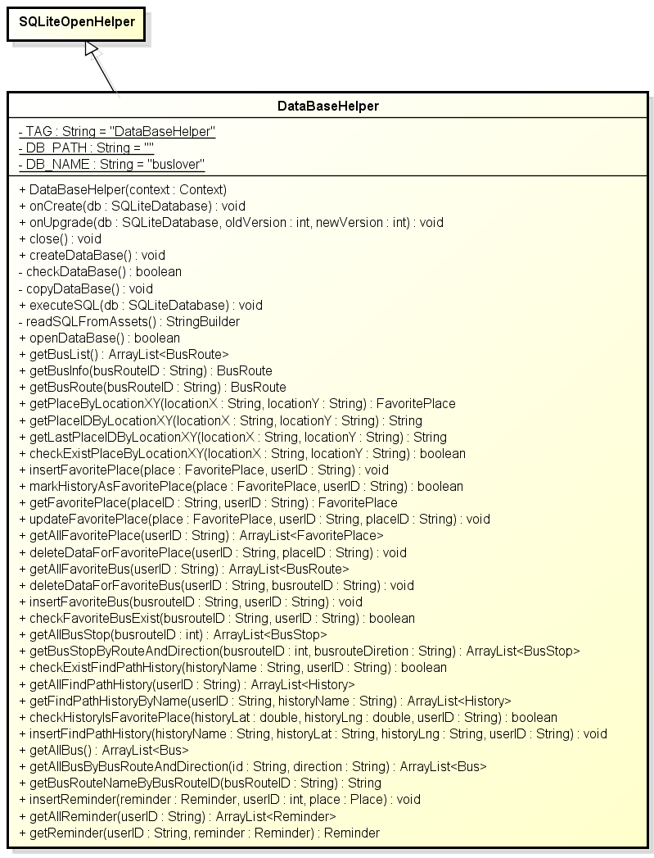

***Figure 4: Class diagram dao package***

|  |  |  |
| --- | --- | --- |
| No | Class Name | Description |
| 1 | DataBaseHelper | Include method interact with database |

### DataBaseHelper

#### **Attributes**

|  |  |  |  |  |  |
| --- | --- | --- | --- | --- | --- |
| **No** | **Attribute** | **Type** | **Default** | **Note** | **Description** |
| 1 | TAG | String | DataBaseHelper | private |  |
| 2 | DB_PATH | String | “” | private |  |
| 3 | DB_NAME | String | buslover | private |  |

#### **Methods**

|  |
| --- |
| DataBaseHelper() |
| * Return: * Visibility: public * Purpose: |

|  |  |  |  |
| --- | --- | --- | --- |
| onCreate() | | | |
| * Return: void * Visibility: public * Purpose: | | | |
| Parameters | | | |
| No. | Parameter | Type | Description |
| 1 | db | SQLiteDatabase |  |

|  |  |  |  |
| --- | --- | --- | --- |
| onUpgrade() | | | |
| * Return: void * Visibility: public * Purpose: | | | |
| Parameters | | | |
| No. | Parameter | Type | Description |
| 1 | db | SQLiteDatabase |  |
| 2 | oldVersion | int |  |
| 3 | newVersion | int |  |

|  |
| --- |
| close() |
| * Return: void * Visibility: public * Purpose: |

|  |
| --- |
| createDataBase() |
| * Return: void * Visibility: public * Purpose: |

|  |
| --- |
| checkDataBase() |
| * Return: boolean * Visibility: private * Purpose: |

|  |
| --- |
| copyDataBase() |
| * Return: void * Visibility: private * Purpose: |

|  |  |  |  |
| --- | --- | --- | --- |
| executeSQL() | | | |
| * Return: void * Visibility: public * Purpose: | | | |
| Parameters | | | |
| No. | Parameter | Type | Description |
| 1 | db | SQLiteDatabase |  |

|  |
| --- |
| readSQLFromAssets() |
| * Return: StringBuilder * Visibility: private * Purpose: |

|  |
| --- |
| openDataBase() |
| * Return: boolean * Visibility: public * Purpose: |

|  |
| --- |
| **getBusList()** |
| * **Return:** ArrayList<BusRoute> * **Visibility:** public * **Purpose:** |

|  |  |  |  |
| --- | --- | --- | --- |
| getBusInfo() | | | |
| * Return: BusRoute * Visibility: public * Purpose: | | | |
| Parameters | | | |
| No. | Parameter | Type | Description |
| 1 | busRouteID | String |  |

|  |  |  |  |
| --- | --- | --- | --- |
| getBusRoute() | | | |
| * Return: BusRoute * Visibility: public * Purpose: | | | |
| Parameters | | | |
| No. | Parameter | Type | Description |
| 1 | busRouteID | String |  |

|  |  |  |  |
| --- | --- | --- | --- |
| getPlaceByLocationXY() | | | |
| * Return: FavoritePlace * Visibility: public * Purpose: | | | |
| Parameters | | | |
| No. | Parameter | Type | Description |
| 1 | locationX | String |  |
| 2 | locationY | String |  |

|  |  |  |  |
| --- | --- | --- | --- |
| getPlaceIDByLocationXY() | | | |
| * Return: String * Visibility: public * Purpose: | | | |
| Parameters | | | |
| No. | Parameter | Type | Description |
| 1 | locationX | String |  |
| 2 | locationY | String |  |

|  |  |  |  |
| --- | --- | --- | --- |
| getLastPlaceIDByLocationXY() | | | |
| * Return: String * Visibility: public * Purpose: | | | |
| Parameters | | | |
| No. | Parameter | Type | Description |
| 1 | locationX | String |  |
| 2 | locationY | String |  |

|  |  |  |  |
| --- | --- | --- | --- |
| checkExistPlaceByLocationXY() | | | |
| * Return: boolean * Visibility: public * Purpose: | | | |
| Parameters | | | |
| No. | Parameter | Type | Description |
| 1 | locationX | String |  |
| 2 | locationY | String |  |

|  |  |  |  |
| --- | --- | --- | --- |
| insertFavoritePlace() | | | |
| * Return: void * Visibility: public * Purpose: | | | |
| Parameters | | | |
| No. | Parameter | Type | Description |
| 1 | place | FavoritePlace |  |
| 2 | userID | String |  |

|  |  |  |  |
| --- | --- | --- | --- |
| markHistoryAsFavoritePlace() | | | |
| * Return: void * Visibility: public * Purpose: | | | |
| Parameters | | | |
| No. | Parameter | Type | Description |
| 1 | place | FavoritePlace |  |
| 2 | userID | String |  |

|  |  |  |  |
| --- | --- | --- | --- |
| getFavoritePlace() | | | |
| * Return: FavoritePlace * Visibility: public * Purpose: | | | |
| Parameters | | | |
| No. | Parameter | Type | Description |
| 1 | place | FavoritePlace |  |
| 2 | userID | String |  |

|  |  |  |  |
| --- | --- | --- | --- |
| updateFavoritePlace() | | | |
| * Return: void * Visibility: public * Purpose: | | | |
| Parameters | | | |
| No. | Parameter | Type | Description |
| 1 | place | FavoritePlace |  |
| 2 | userID | String |  |
| 3 | placeID | String |  |

|  |  |  |  |
| --- | --- | --- | --- |
| getAllFavoritePlace() | | | |
| * Return: ArrayList<FavoritePlace> * Visibility: public * Purpose: | | | |
| Parameters | | | |
| No. | Parameter | Type | Description |
| 1 | userID | String |  |

|  |  |  |  |
| --- | --- | --- | --- |
| deleteDataForFavoritePlace() | | | |
| * Return: void * Visibility: public * Purpose: | | | |
| Parameters | | | |
| No. | Parameter | Type | Description |
| 1 | userID | String |  |
| 2 | placeID | String |  |

|  |  |  |  |
| --- | --- | --- | --- |
| getAllFavoriteBus() | | | |
| * Return: ArrayList<BusRoute> * Visibility: public * Purpose: | | | |
| Parameters | | | |
| No. | Parameter | Type | Description |
| 1 | userID | String |  |

|  |  |  |  |
| --- | --- | --- | --- |
| deleteDataForFavoriteBus() | | | |
| * Return: void * Visibility: public * Purpose: | | | |
| Parameters | | | |
| No. | Parameter | Type | Description |
| 1 | userID | String |  |
| 2 | busrouteID | String |  |

|  |  |  |  |
| --- | --- | --- | --- |
| insertFavoriteBus() | | | |
| * Return: void * Visibility: public * Purpose: | | | |
| Parameters | | | |
| No. | Parameter | Type | Description |
| 1 | busrouteID | String |  |
| 2 | userID | String |  |

|  |  |  |  |
| --- | --- | --- | --- |
| checkFavoriteBusExist() | | | |
| * Return: void * Visibility: public * Purpose: | | | |
| Parameters | | | |
| No. | Parameter | Type | Description |
| 1 | busrouteID | String |  |
| 2 | userID | String |  |

|  |  |  |  |
| --- | --- | --- | --- |
| getAllBusStop() | | | |
| * Return: ArrayList<BusStop> * Visibility: public * Purpose: | | | |
| Parameters | | | |
| No. | Parameter | Type | Description |
| 1 | busrouteID | int |  |

|  |  |  |  |
| --- | --- | --- | --- |
| getBusStopByRouteAndDirection() | | | |
| * Return: ArrayList<BusStop> * Visibility: public * Purpose: | | | |
| Parameters | | | |
| No. | Parameter | Type | Description |
| 1 | busrouteID | int |  |
| 2 | busrouteDiretion | String |  |

|  |  |  |  |
| --- | --- | --- | --- |
| checkExistFindPathHistory() | | | |
| * Return: boolean * Visibility: public * Purpose: | | | |
| Parameters | | | |
| No. | Parameter | Type | Description |
| 1 | historyName | String |  |
| 2 | userID | String |  |

|  |  |  |  |
| --- | --- | --- | --- |
| getAllFindPathHistory() | | | |
| * Return: ArrayList<History> * Visibility: public * Purpose: | | | |
| Parameters | | | |
| No. | Parameter | Type | Description |
| 1 | userID | String |  |

|  |  |  |  |
| --- | --- | --- | --- |
| getFindPathHistoryByName() | | | |
| * Return: ArrayList<History> * Visibility: public * Purpose: | | | |
| Parameters | | | |
| No. | Parameter | Type | Description |
| 1 | userID | String |  |
| 2 | historyName | String |  |

|  |  |  |  |
| --- | --- | --- | --- |
| checkHistorylsFavoritePlace() | | | |
| * Return: boolean * Visibility: public * Purpose: | | | |
| Parameters | | | |
| No. | Parameter | Type | Description |
| 1 | historyLat | double |  |
| 2 | historyLng | double |  |
| 3 | userID | String |  |

|  |  |  |  |
| --- | --- | --- | --- |
| insertFindPathHistory() | | | |
| * Return: void * Visibility: public * Purpose: | | | |
| Parameters | | | |
| No. | Parameter | Type | Description |
| 1 | historyName | String |  |
| 2 | historyLat | String |  |
| 3 | historyLng | String |  |
| 4 | userID | String |  |

|  |
| --- |
| getAllBus() |
| * Return: ArrayList<Bus> * Visibility: public * Purpose: |

|  |  |  |  |
| --- | --- | --- | --- |
| getAllBusByBusRouteAndDirection() | | | |
| * Return: ArrayList<Bus> * Visibility: public * Purpose: | | | |
| Parameters | | | |
| No. | Parameter | Type | Description |
| 1 | id | String |  |
| 2 | direction | String |  |

|  |  |  |  |
| --- | --- | --- | --- |
| getBusRouteNameByBusRouteID() | | | |
| * Return: String * Visibility: public * Purpose: | | | |
| Parameters | | | |
| No. | Parameter | Type | Description |
| 1 | busRouteID | String |  |

|  |  |  |  |
| --- | --- | --- | --- |
| insertReminder() | | | |
| * Return: void * Visibility: public * Purpose: | | | |
| Parameters | | | |
| No. | Parameter | Type | Description |
| 1 | reminder | Reminder |  |
| 2 | userID | int |  |
| 3 | place | Place |  |

|  |  |  |  |
| --- | --- | --- | --- |
| getAllReminder() | | | |
| * Return: ArrayList<Reminder> * Visibility: public * Purpose: | | | |
| Parameters | | | |
| No. | Parameter | Type | Description |
| 1 | userID | String |  |

|  |  |  |  |
| --- | --- | --- | --- |
| getReminder() | | | |
| * Return: Reminder * Visibility: public * Purpose: | | | |
| Parameters | | | |
| No. | Parameter | Type | Description |
| 1 | userID | String |  |
| 2 | reminder | Reminder |  |

## wsclient Package

### Class diagram

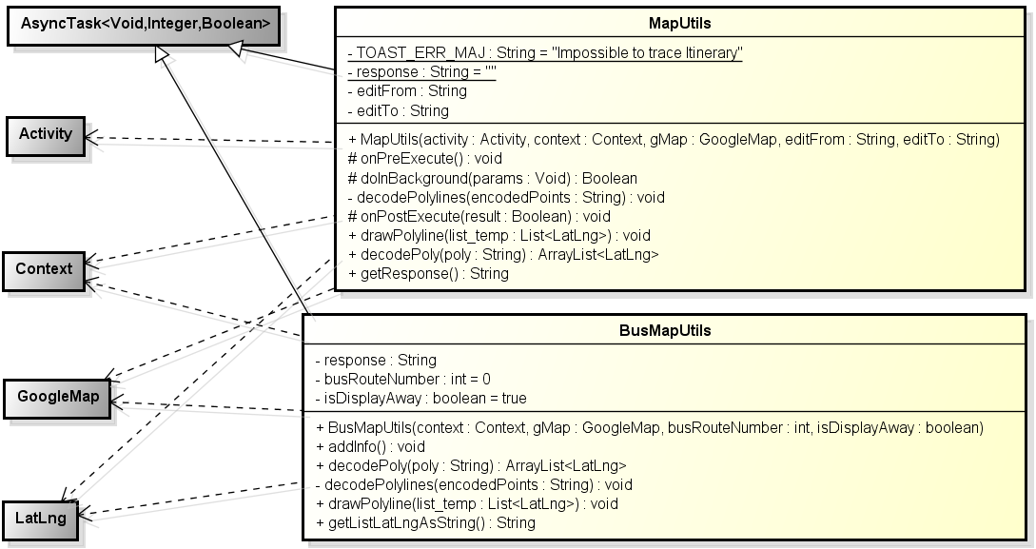

**Figure 5: Class diagram wsclient package**

### BusMapUtils

#### **Attributes**

|  |  |  |  |  |  |
| --- | --- | --- | --- | --- | --- |
| **No** | **Attribute** | **Type** | **Default** | **Note** | **Description** |
| 1 | response | String |  | private |  |
| 2 | busRouteNumber | int |  | private |  |
| 3 | isDisplayAway | boolean |  | private |  |

#### **Methods**

|  |  |  |  |
| --- | --- | --- | --- |
| BusMapUtils() | | | |
| * Return: * Visibility: public * Purpose: | | | |
| Parameters | | | |
| No. | Parameter | Type | Description |
| 1 | gMap | GoogleMap |  |
| 2 | busRouteNumber | int |  |
| 3 | isDisplayAway | boolean |  |

|  |
| --- |
| addInfo () |
| * Return: void * Visibility: public * Purpose: |

|  |  |  |  |
| --- | --- | --- | --- |
| decodePoly() | | | |
| * Return: ArrayList<LatLng> * Visibility: public * Purpose: | | | |
| Parameters | | | |
| No. | Parameter | Type | Description |
| 1 | poly | String |  |

|  |  |  |  |
| --- | --- | --- | --- |
| decodePolyline() | | | |
| * Return: void * Visibility: private * Purpose: | | | |
| Parameters | | | |
| No. | Parameter | Type | Description |
| 1 | encodedPoints | String |  |

|  |  |  |  |
| --- | --- | --- | --- |
| drawPolyline() | | | |
| * Return: void * Visibility: public * Purpose: | | | |
| Parameters | | | |
| No. | Parameter | Type | Description |
| 1 | list | List<LatLng> |  |

|  |
| --- |
| getListLatLngAsString () |
| * Return: String * Visibility: public * Purpose: |

### MapUtils

#### **Attributes**

|  |  |  |  |  |  |
| --- | --- | --- | --- | --- | --- |
| **No** | **Attribute** | **Type** | **Default** | **Note** | **Description** |
| 1 | TOAST_ERR_MAJ | String | Impossible to trace Itinerary | private |  |
| 2 | response | String | "" | private |  |
| 3 | editFrom | String |  | private |  |
| 4 | editTo | String |  | private |  |

#### **Methods**

|  |  |  |  |
| --- | --- | --- | --- |
| MapUtils() | | | |
| * Return: * Visibility: public * Purpose: | | | |
| Parameters | | | |
| No. | Parameter | Type | Description |
| 1 | context | Context |  |
| 2 | gMap | GoogleMap |  |
| 3 | editFrom | String |  |
| 4 | editTo | String |  |

|  |
| --- |
| onPreExecute () |
| * Return: void * Visibility: protected * Purpose: |

|  |  |  |  |
| --- | --- | --- | --- |
| doInBackgound() | | | |
| * Return: Boolean * Visibility: protected * Purpose: | | | |
| Parameters | | | |
| No. | Parameter | Type | Description |
| 1 | params | Void |  |

|  |  |  |  |
| --- | --- | --- | --- |
| decodePolyline() | | | |
| * Return: void * Visibility: private * Purpose: | | | |
| Parameters | | | |
| No. | Parameter | Type | Description |
| 1 | encodedPoints | String |  |

|  |  |  |  |
| --- | --- | --- | --- |
| onPostExecute() | | | |
| * Return: void * Visibility: protected * Purpose: | | | |
| Parameters | | | |
| No. | Parameter | Type | Description |
| 1 | result | Boolean |  |

|  |  |  |  |
| --- | --- | --- | --- |
| drawPolyline() | | | |
| * Return: void * Visibility: public * Purpose: | | | |
| Parameters | | | |
| No. | Parameter | Type | Description |
| 1 | list_temp | List<LatLng> |  |

|  |  |  |  |
| --- | --- | --- | --- |
| drawPoly() | | | |
| * Return: ArrayList<LatLng> * Visibility: public * Purpose: | | | |
| Parameters | | | |
| No. | Parameter | Type | Description |
| 1 | poly | String |  |

|  |
| --- |
| getResponse () |
| * Return: String * Visibility: public * Purpose: |

# Functions

## Bus function group

### Class diagram

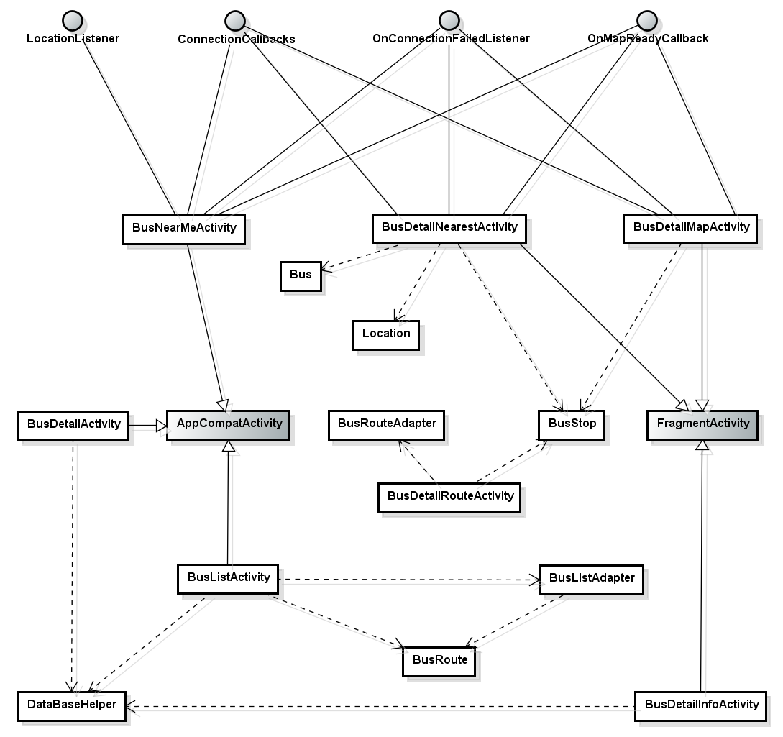

### Sequence diagram

#### Search Bus List Sequence

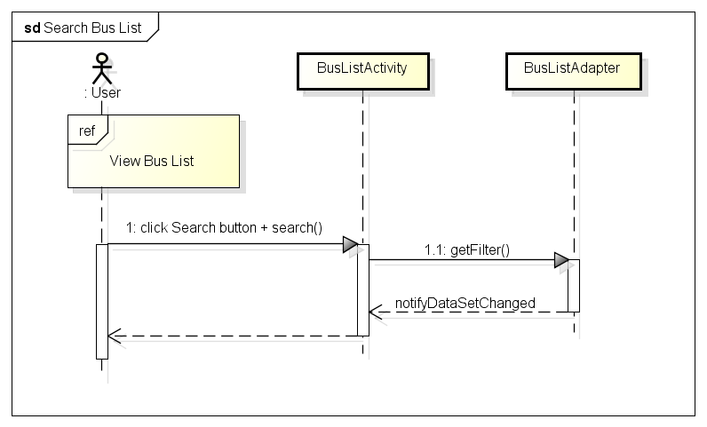

#### View Bus List Sequence

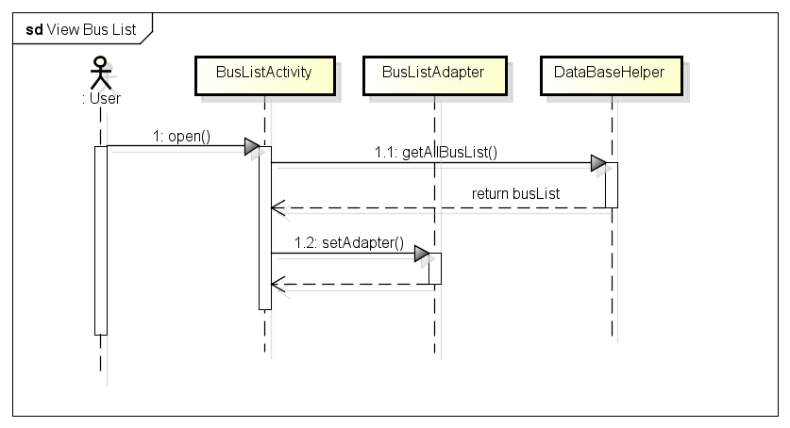

#### View Bus Info Sequence

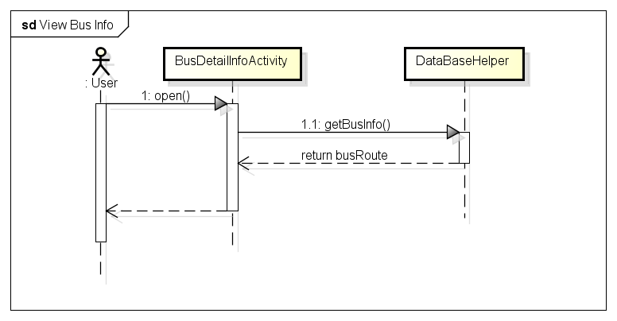

#### View Bus Route Sequence

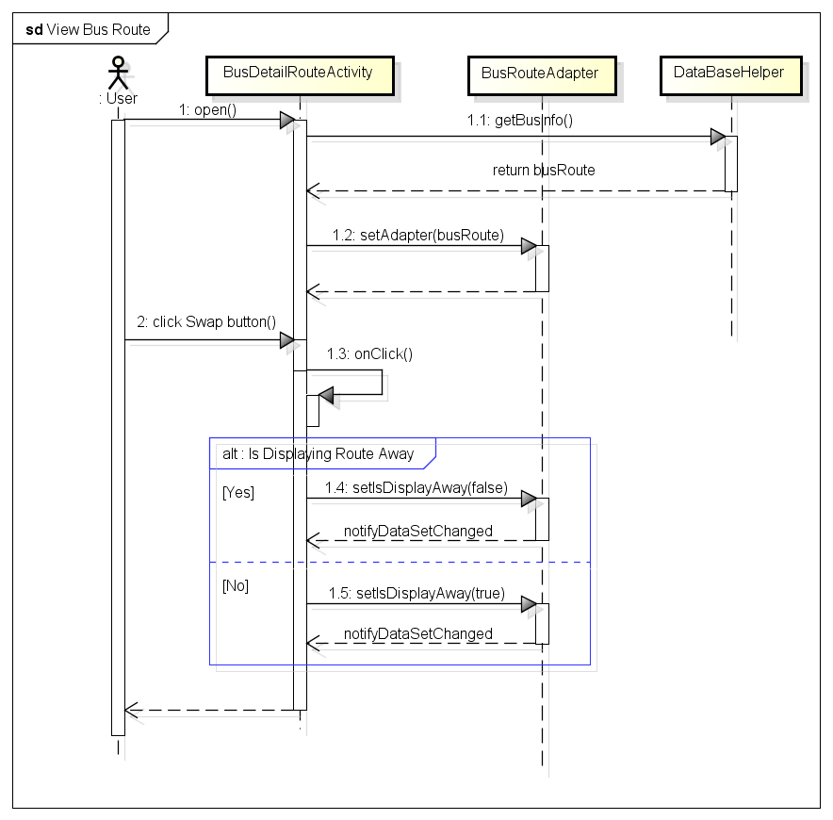

#### View Bus Nearest Sequence

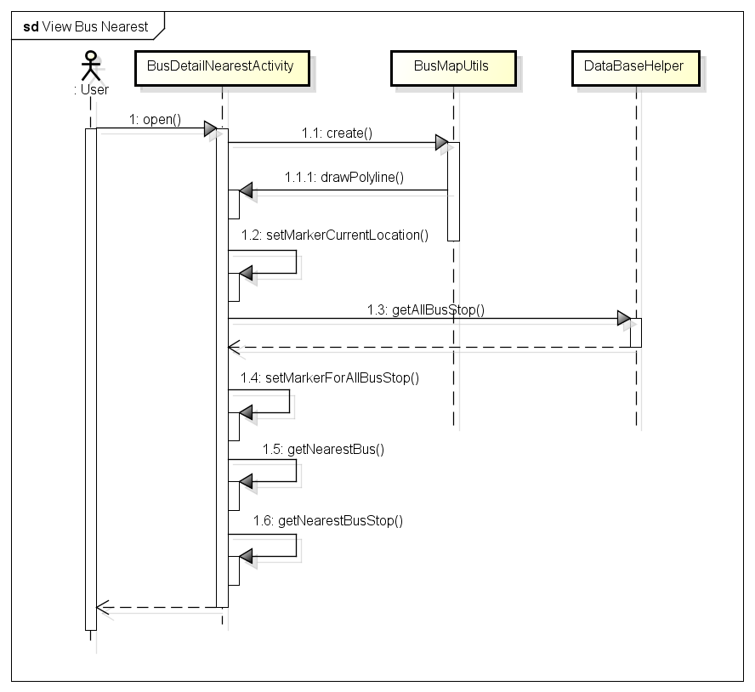

#### View Bus Map Sequence

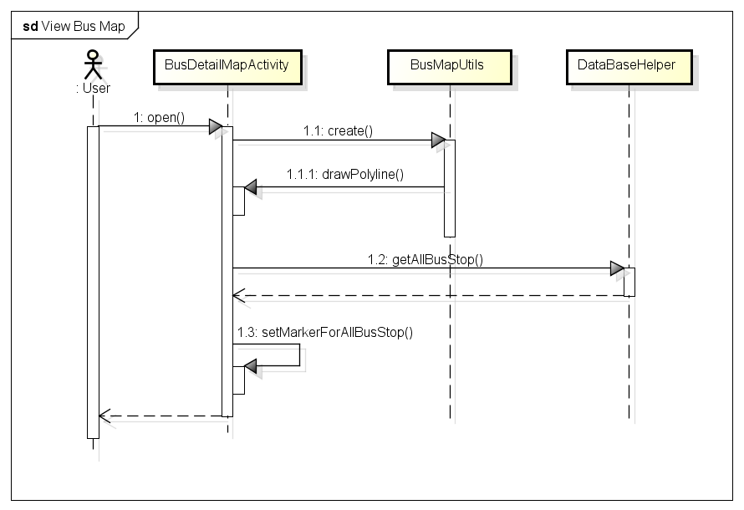

#### View Bus Near Me Sequence

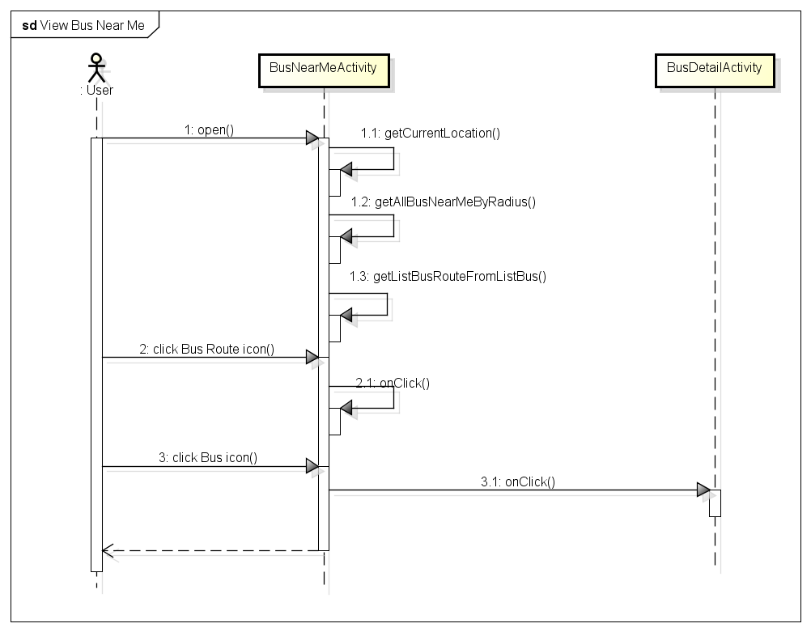

## Path function group

### Class diagram

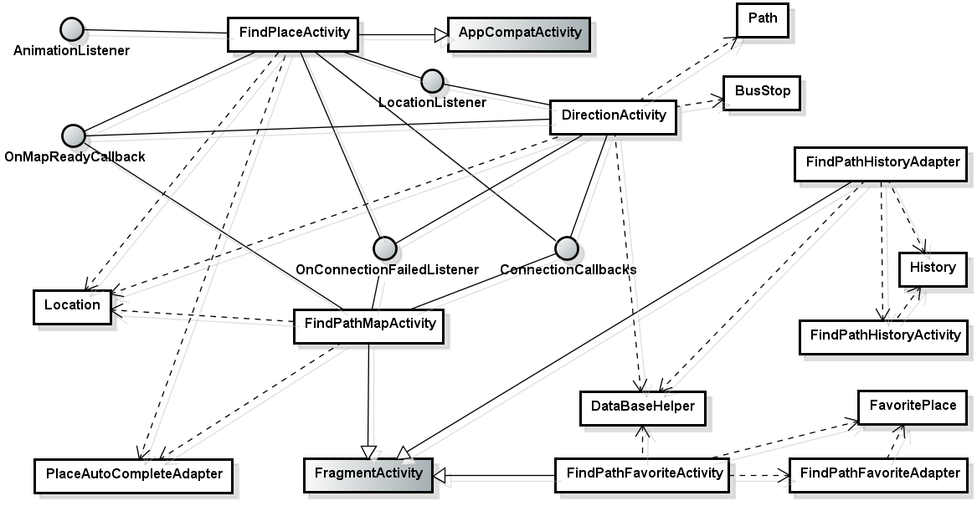

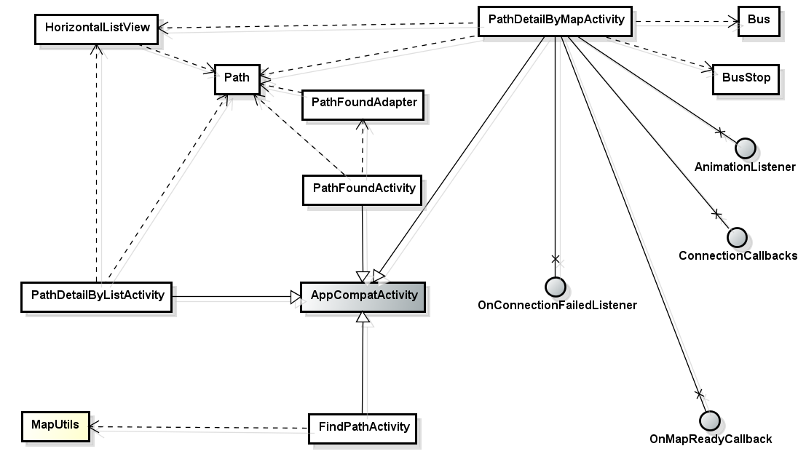

### Sequence diagram

#### Find Path on Map tab Sequence

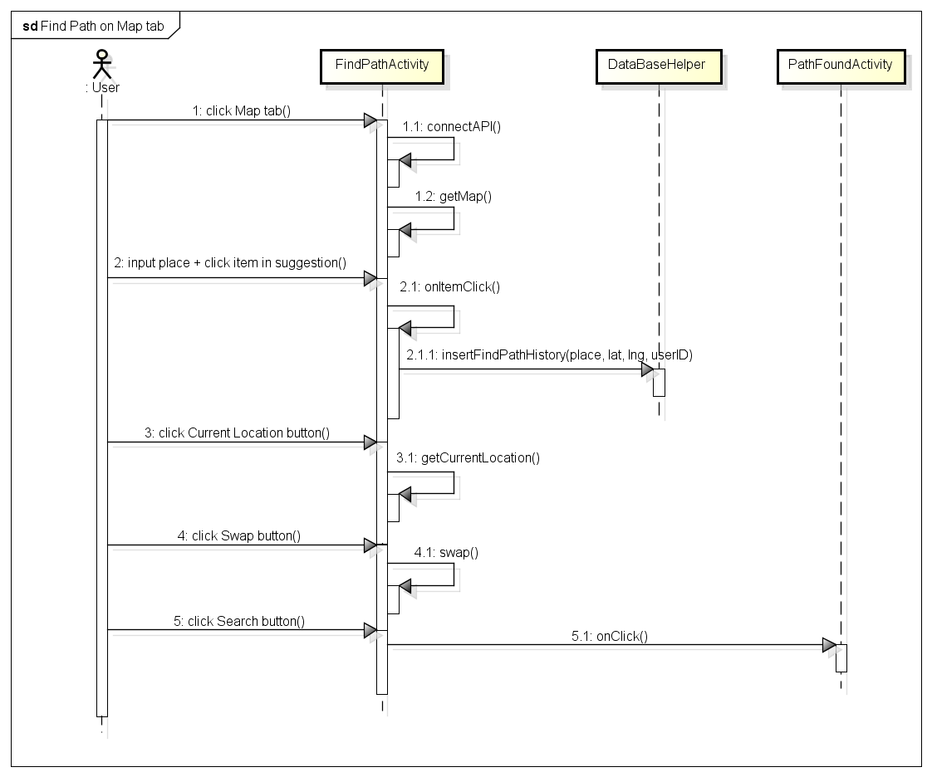

#### Find Path on History tab Sequence

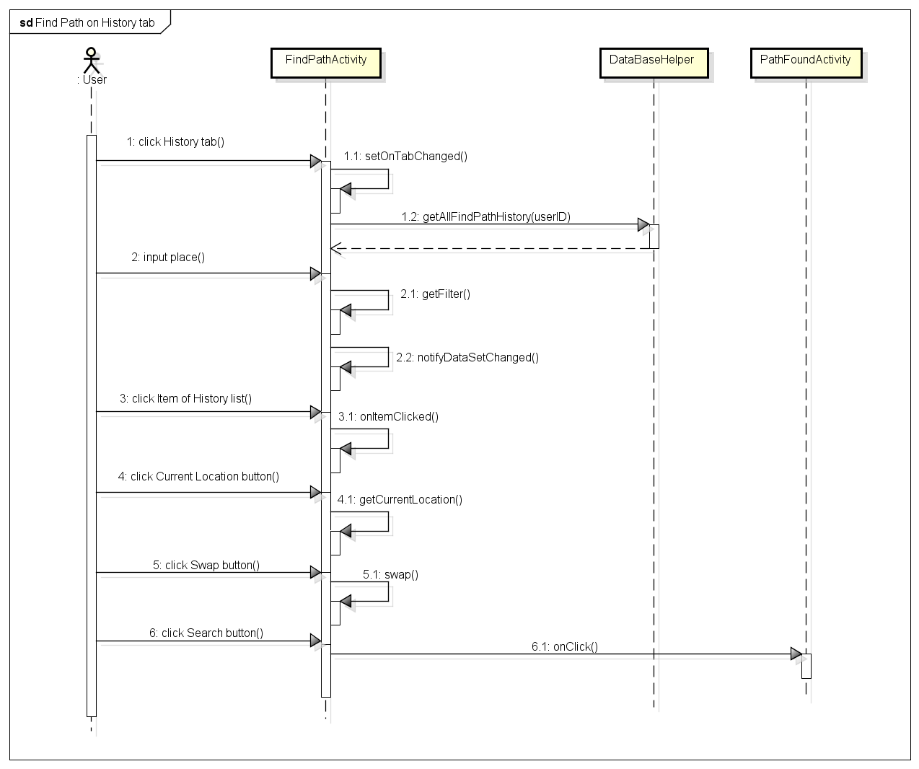

#### Find Path on Favorite tab Sequence

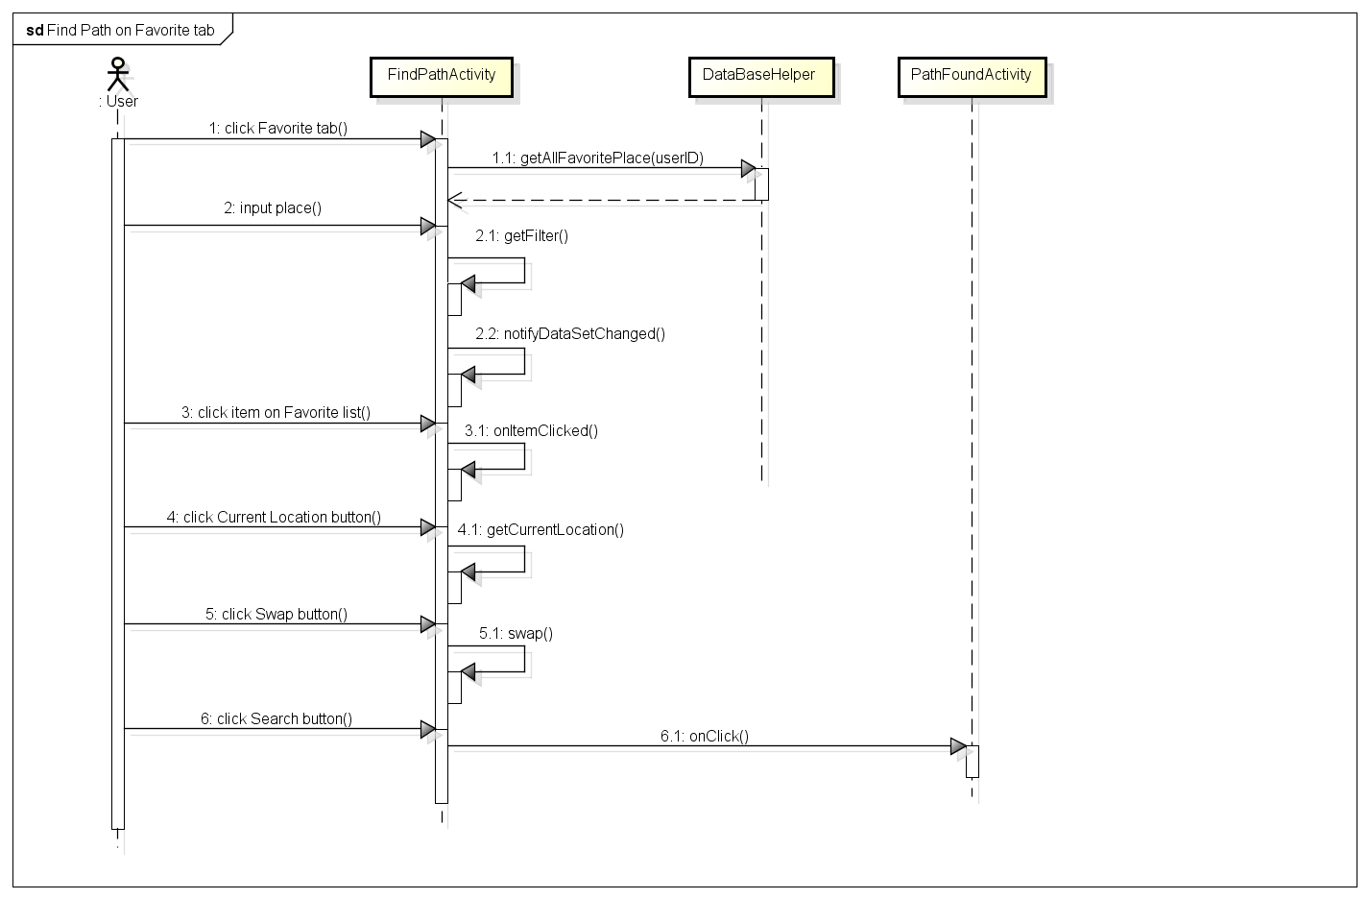

#### View Path Found Sequence

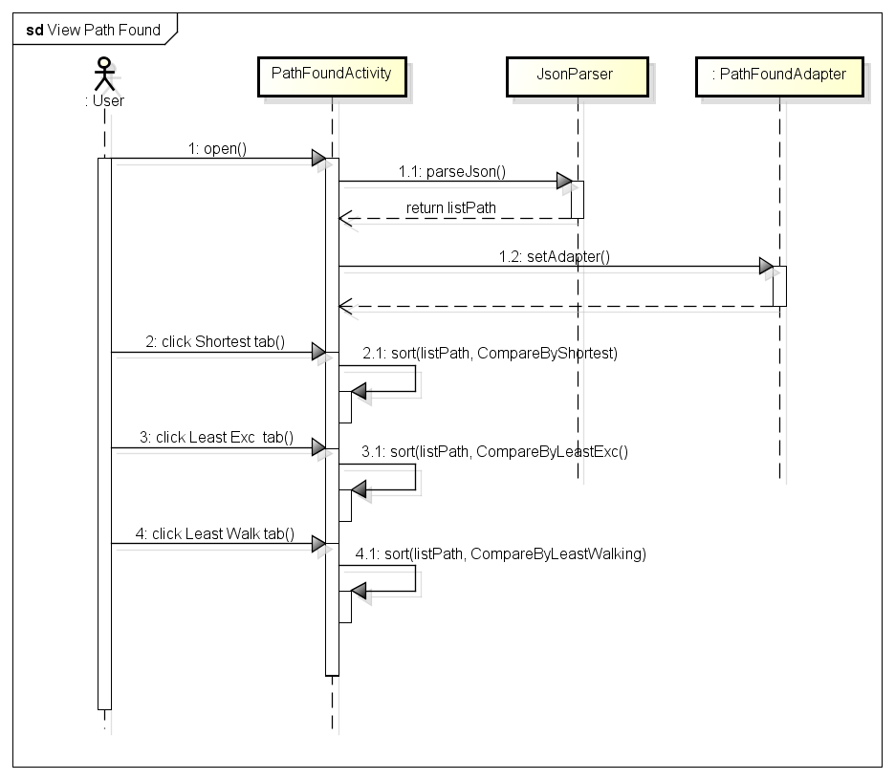

#### View Path Detail Sequence

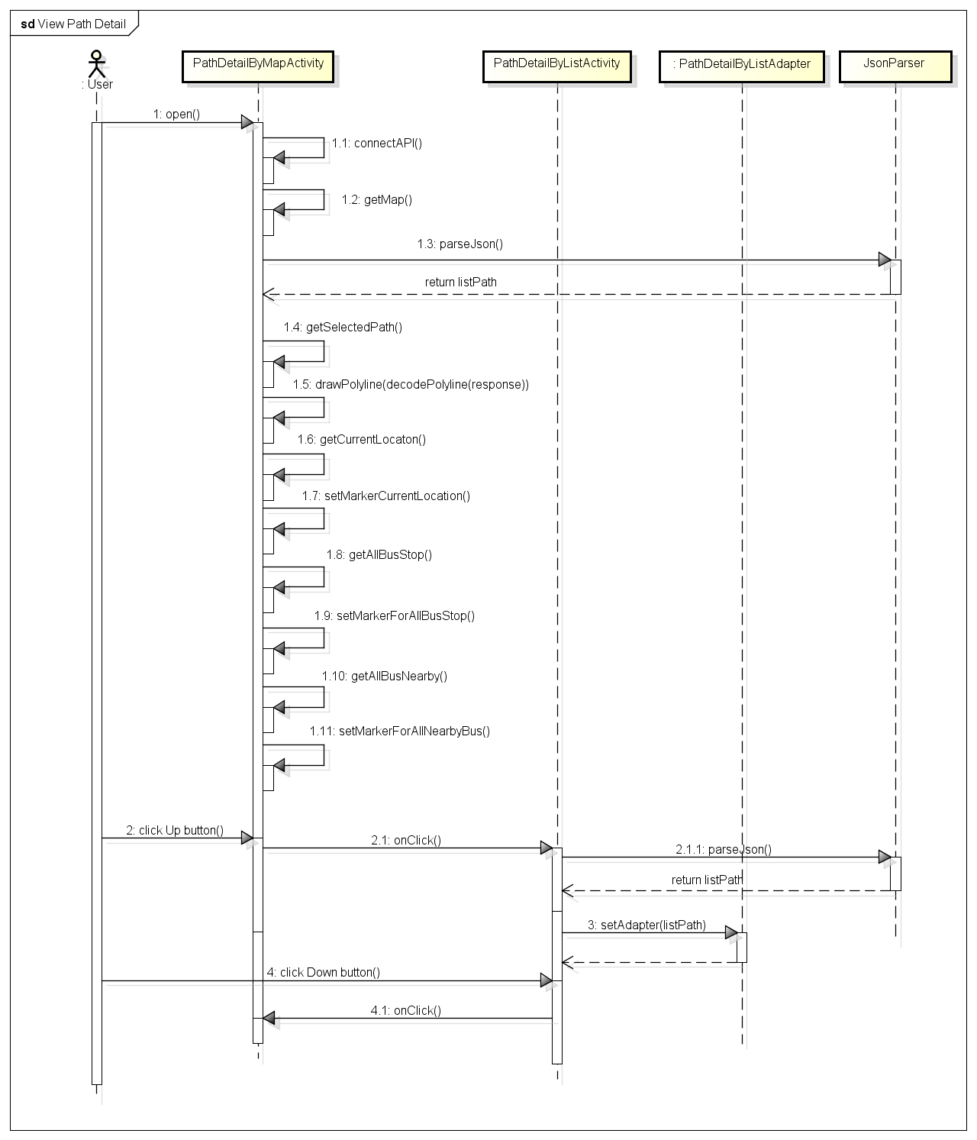

#### View Direction Sequence

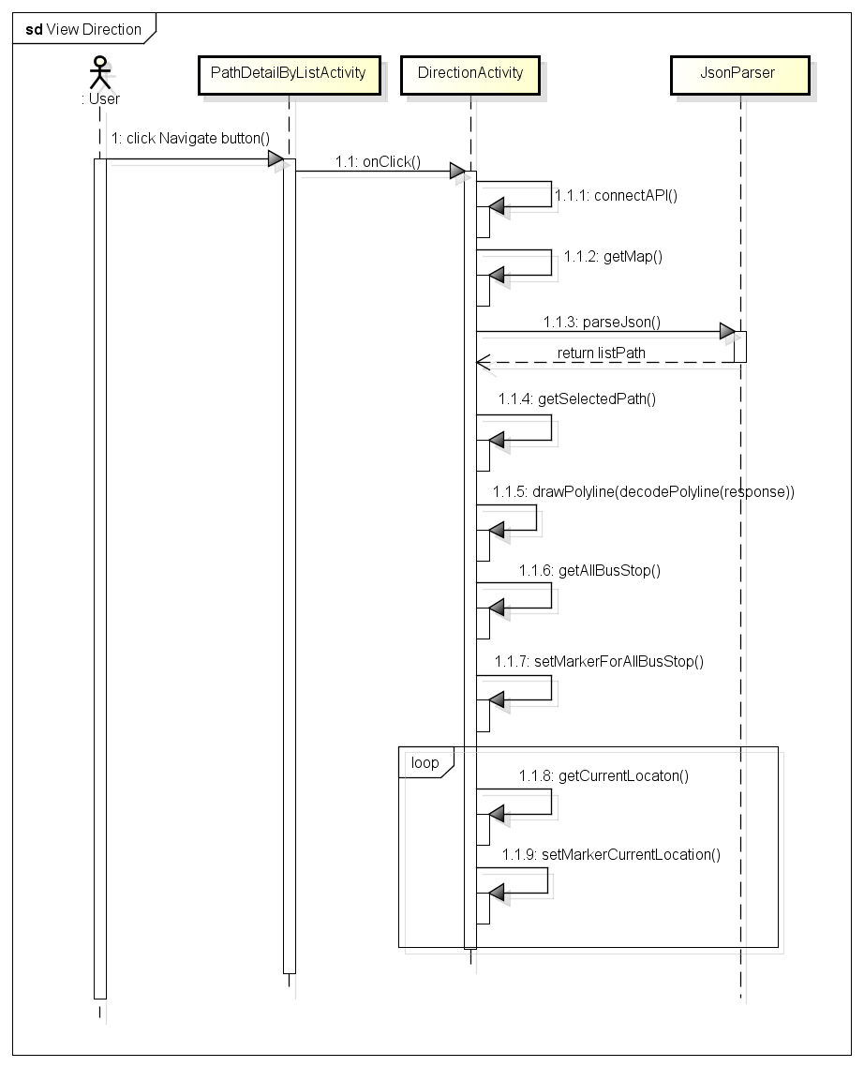

## Favorites function group

### Class diagram

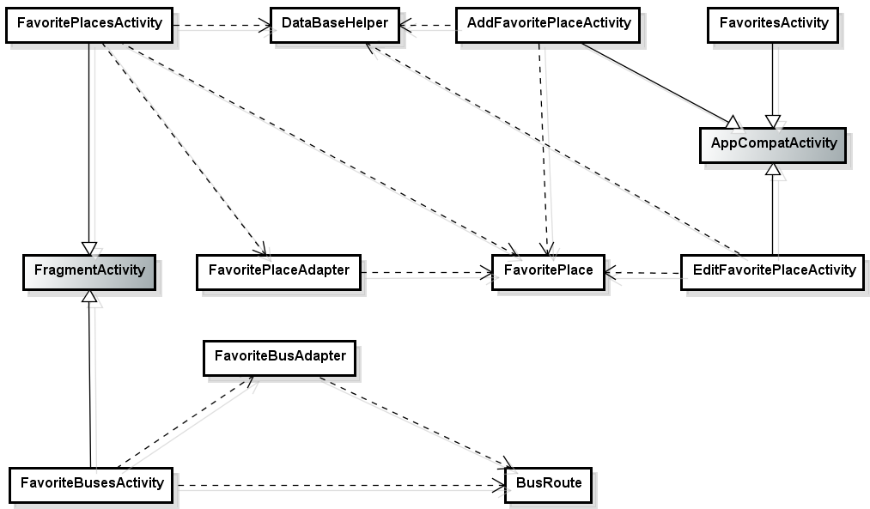

### Sequence diagram

#### View Favorite Places Sequence

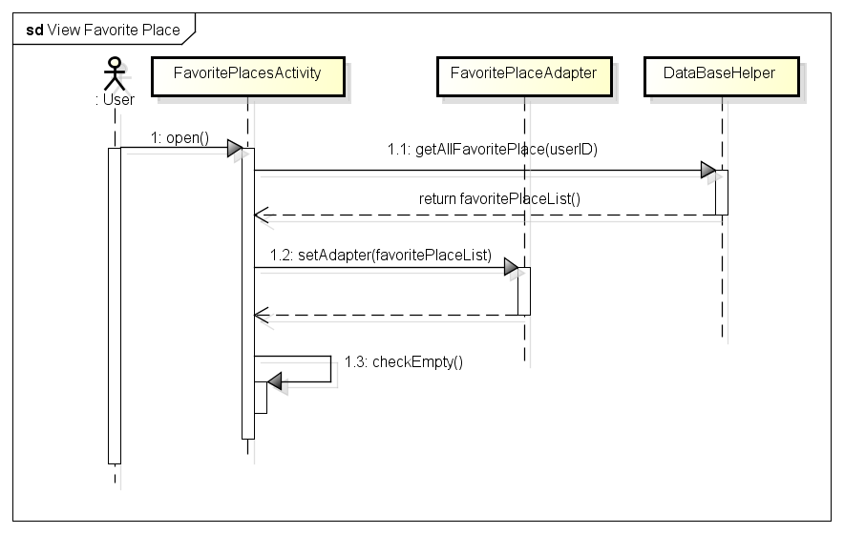

#### Add Favorite Place Sequence

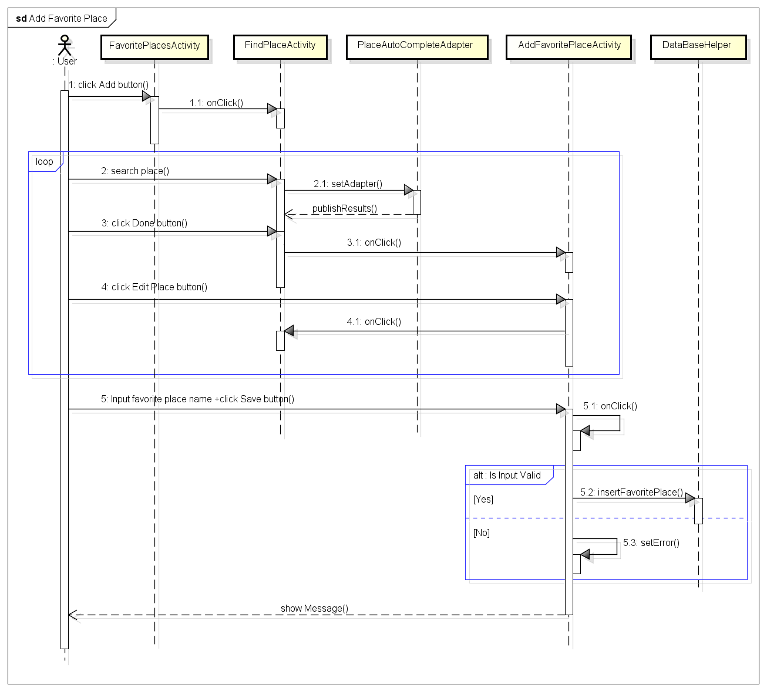

#### Edit Favorite Place Sequence

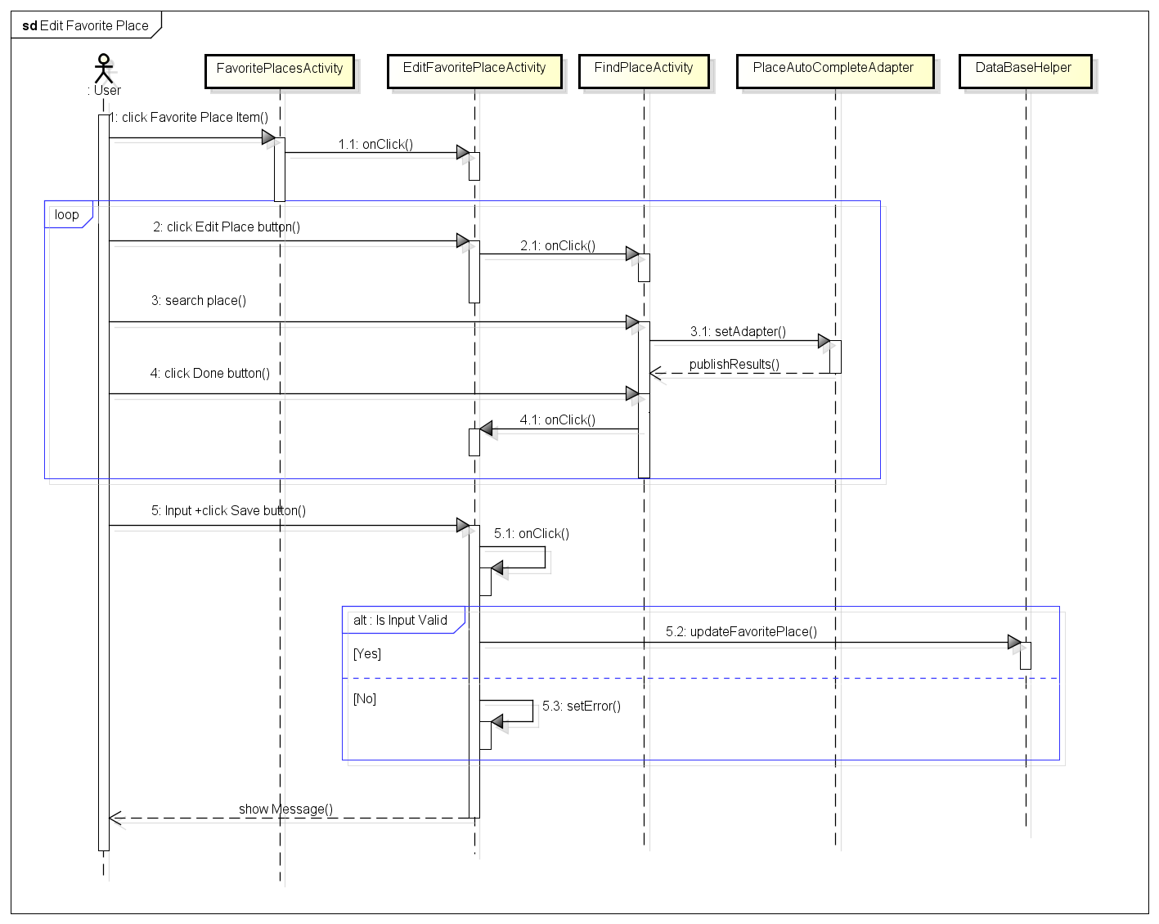

#### Delete Favorite Place Sequence

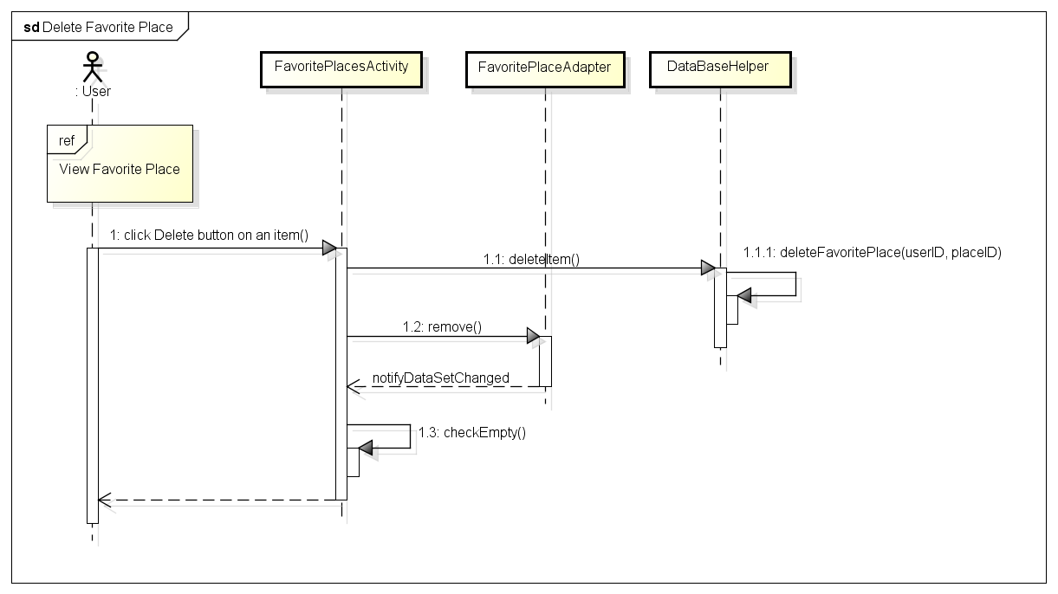

#### Search Favorite Place Sequence

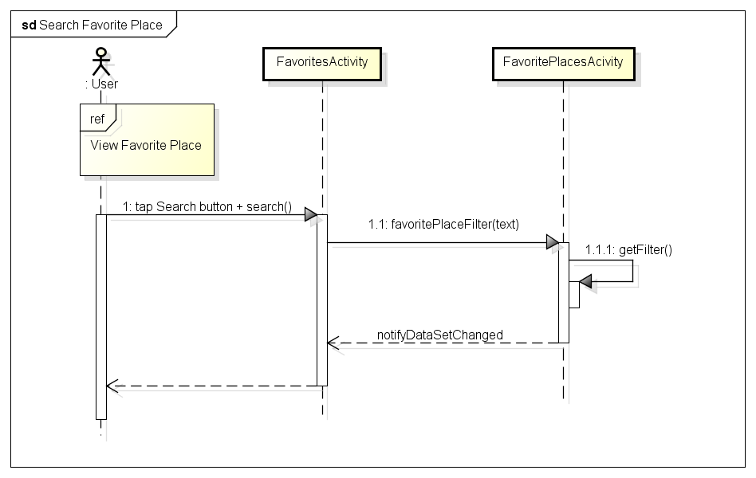

#### View Favorite Buses Sequence

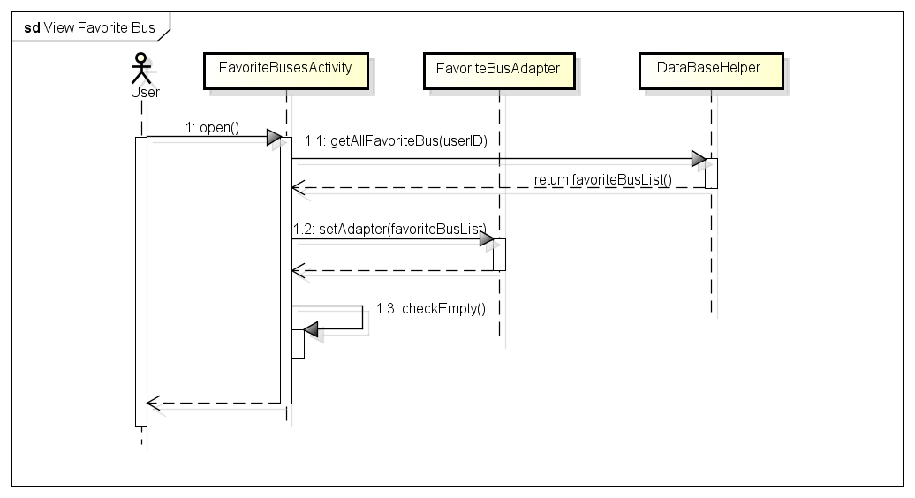

#### Add Favorite Bus Sequence

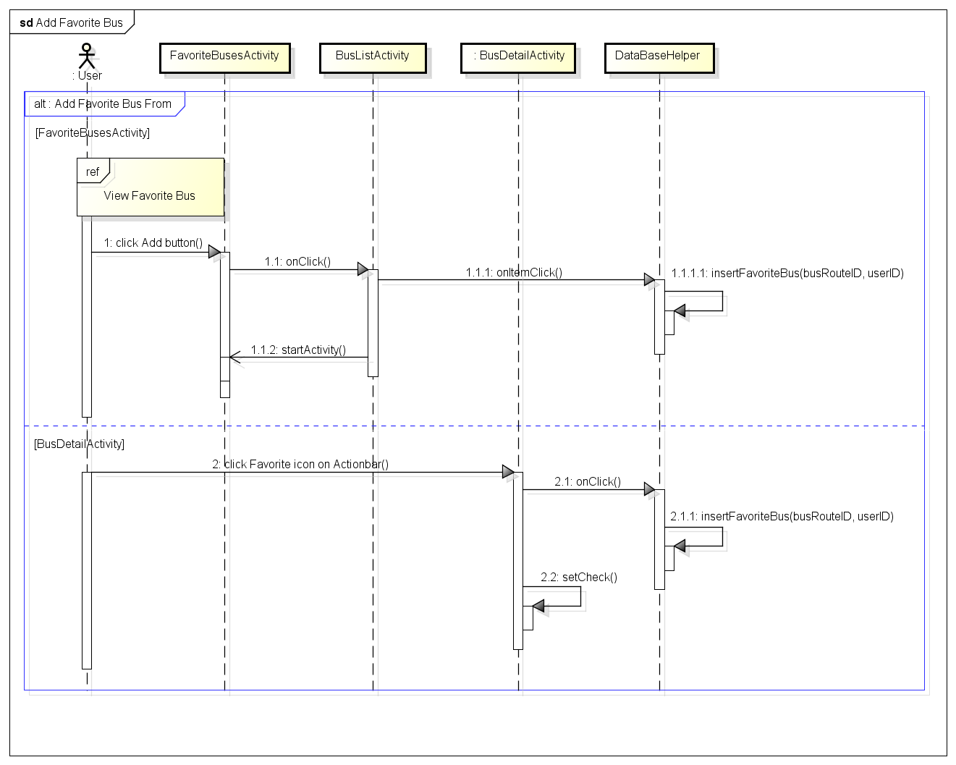

#### Delete Favorite Bus Sequence

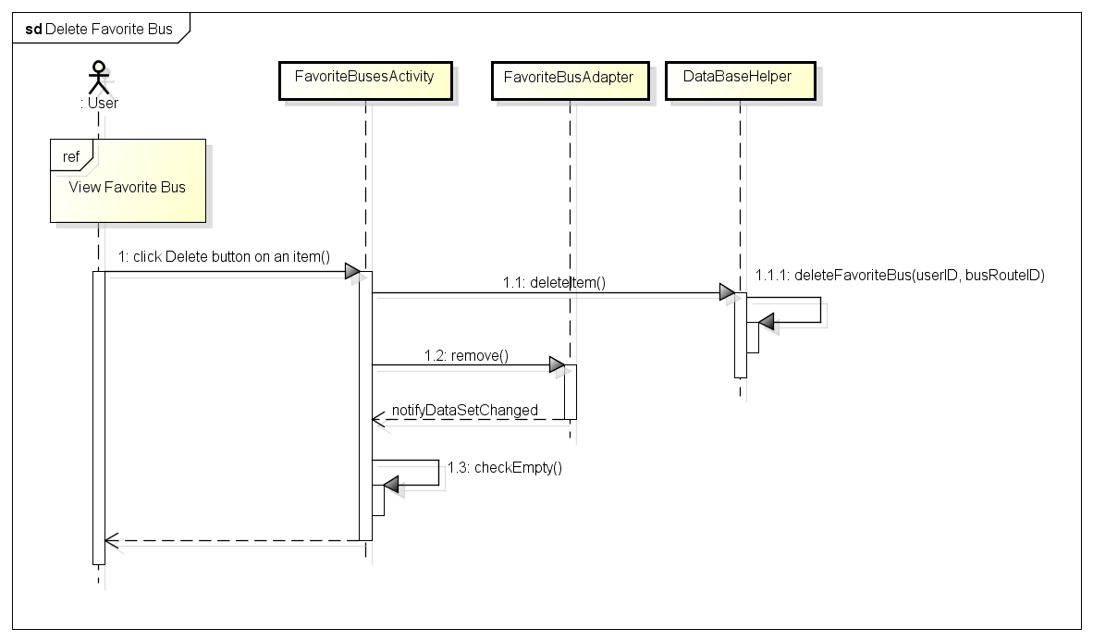

#### Search Favorite Bus Sequence

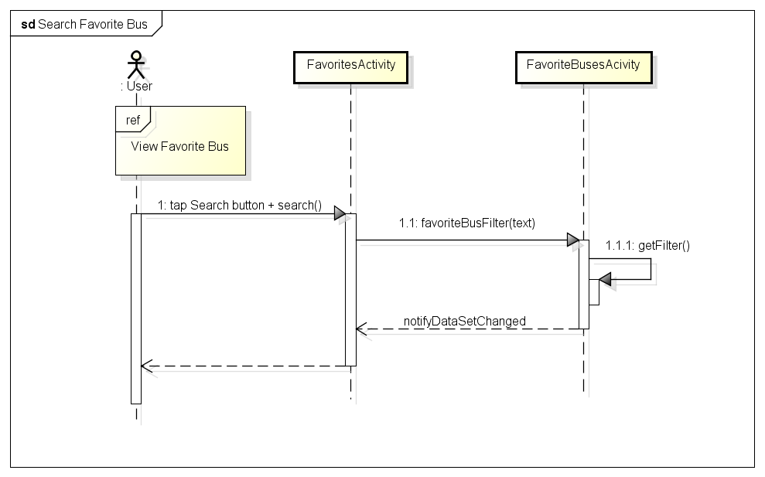

## Reminder function group

### Class diagram

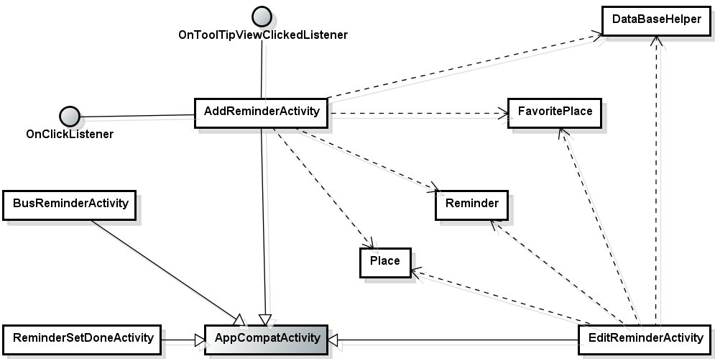

### Sequence diagram

#### View Bus Reminders Sequence

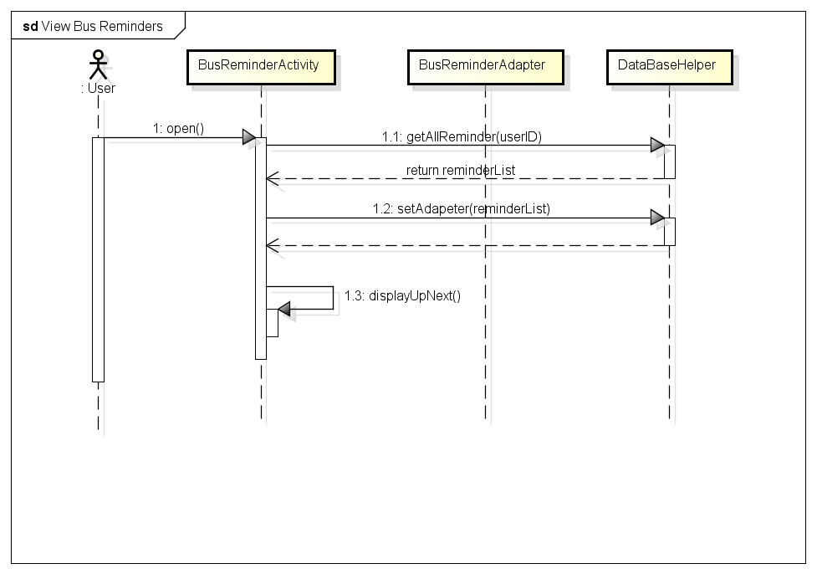

#### Add Reminder Sequence

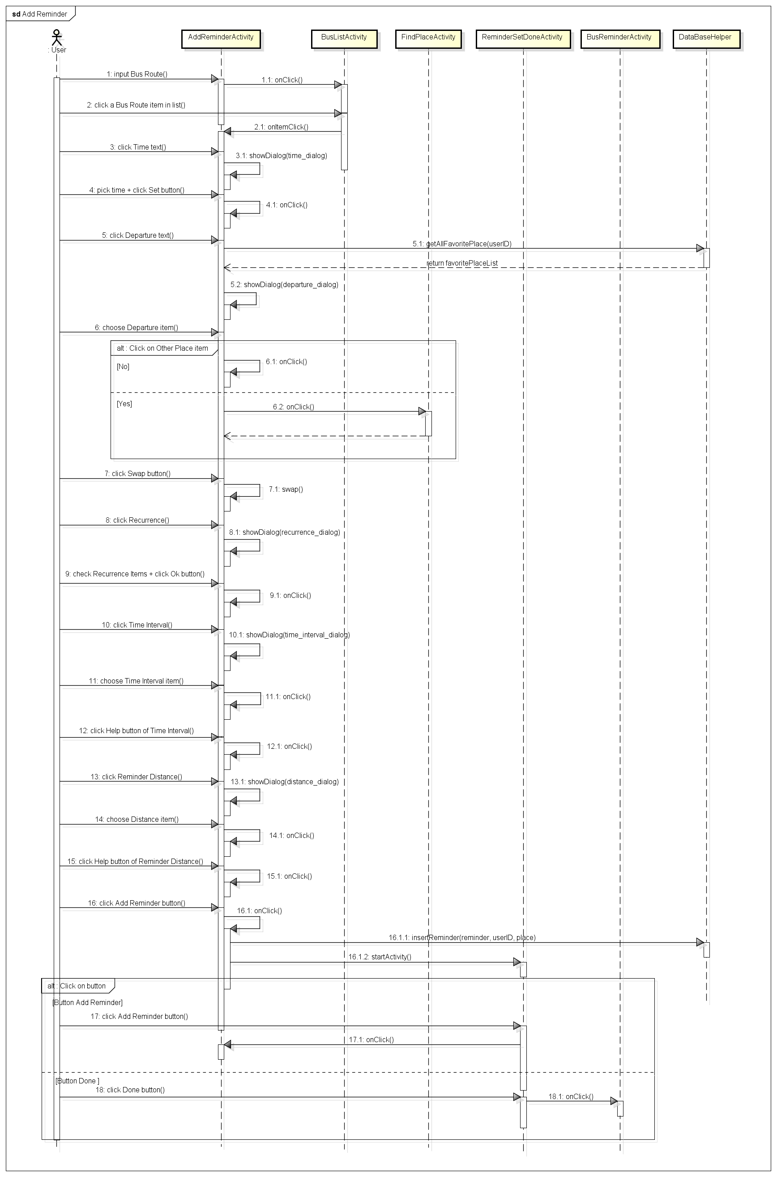

#### Edit Reminder Sequence

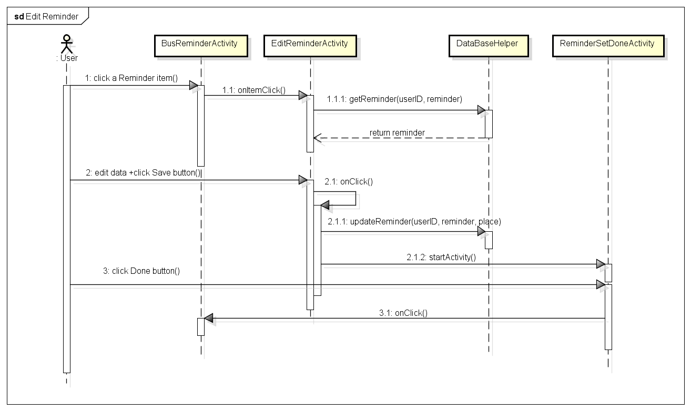

#### Delete Reminder Sequence

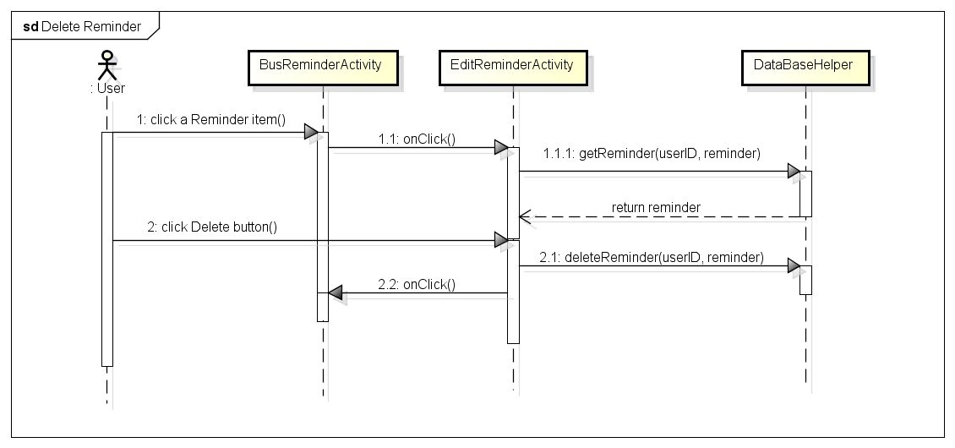

#### Suspend/ cancel suspend a reminder Sequence

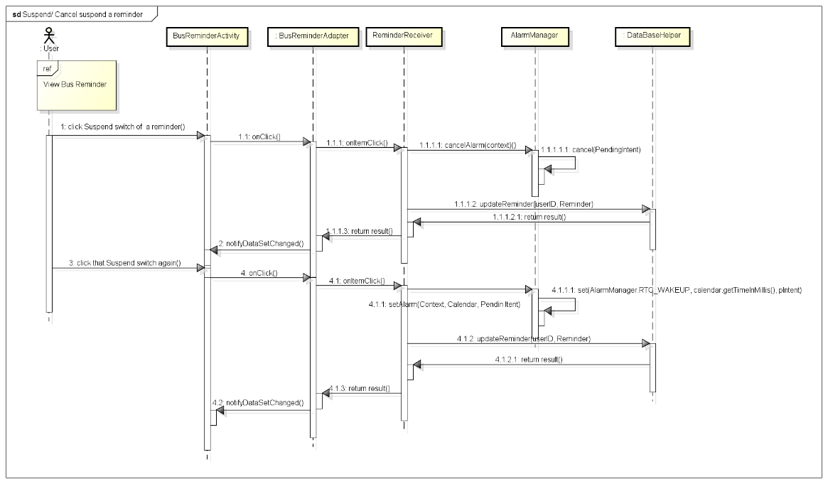

## Other function

### Class diagram

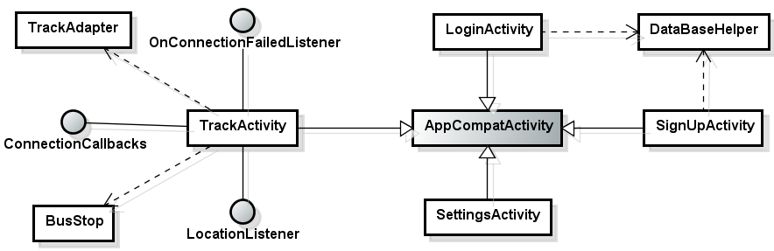

### Sequence diagram

#### Login Sequence

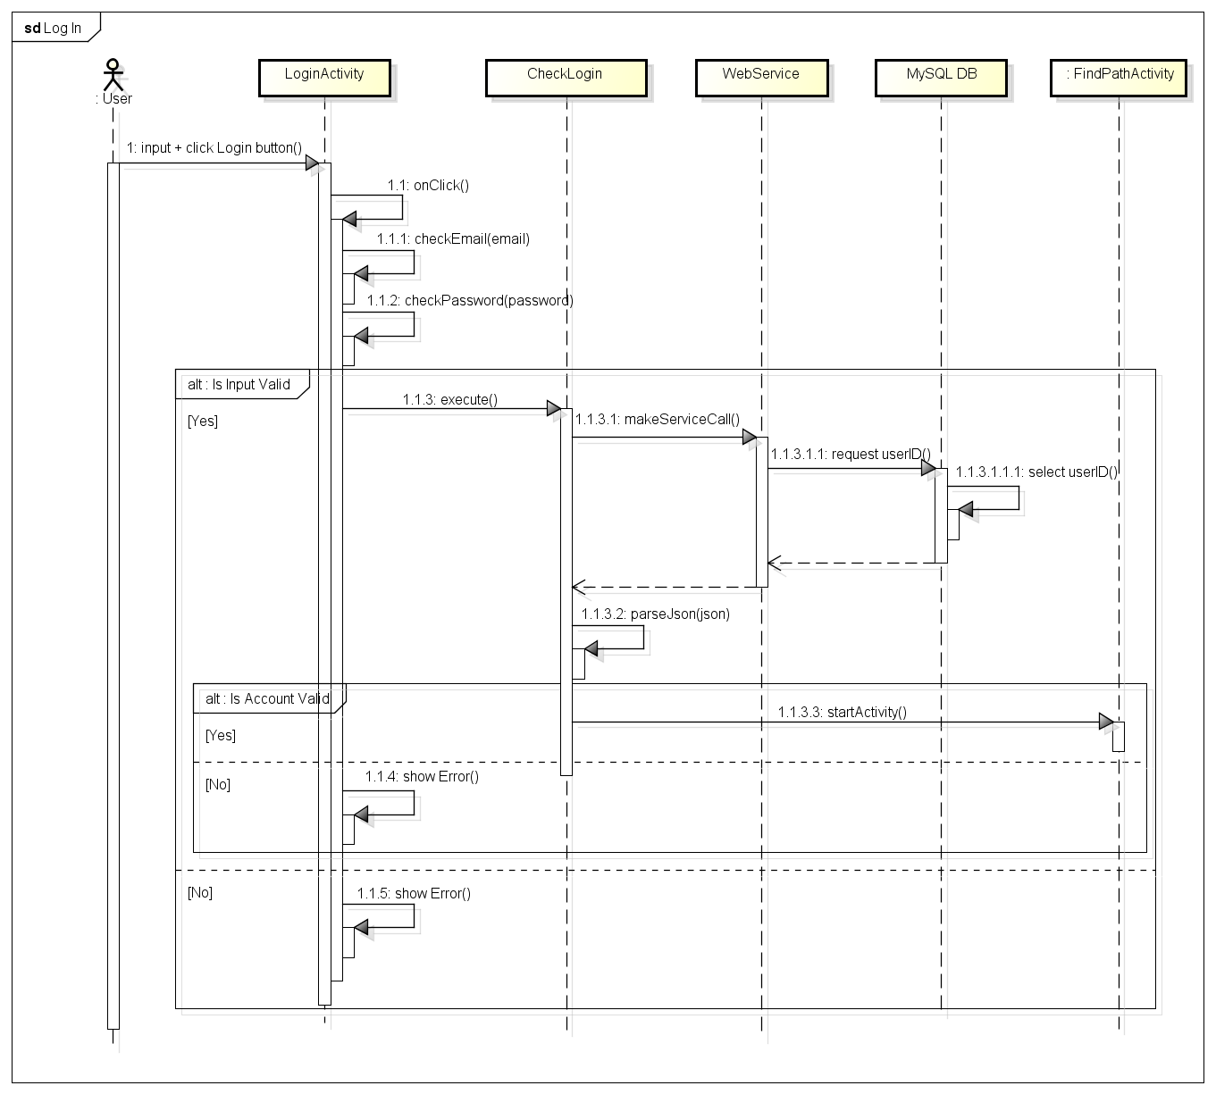

#### Log out Sequence

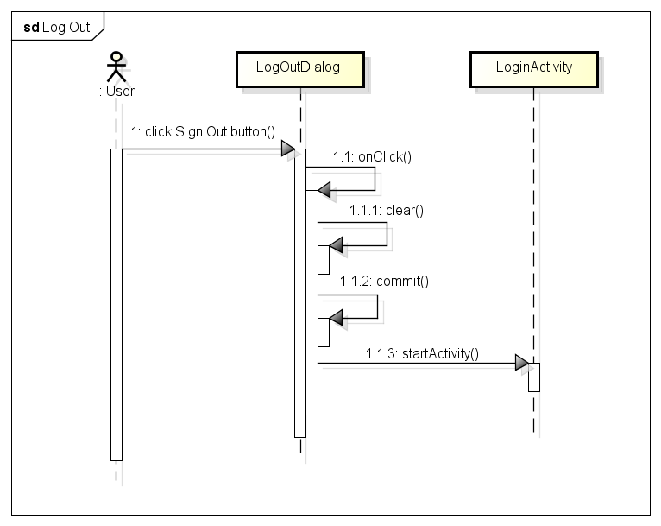

#### Signup Sequence

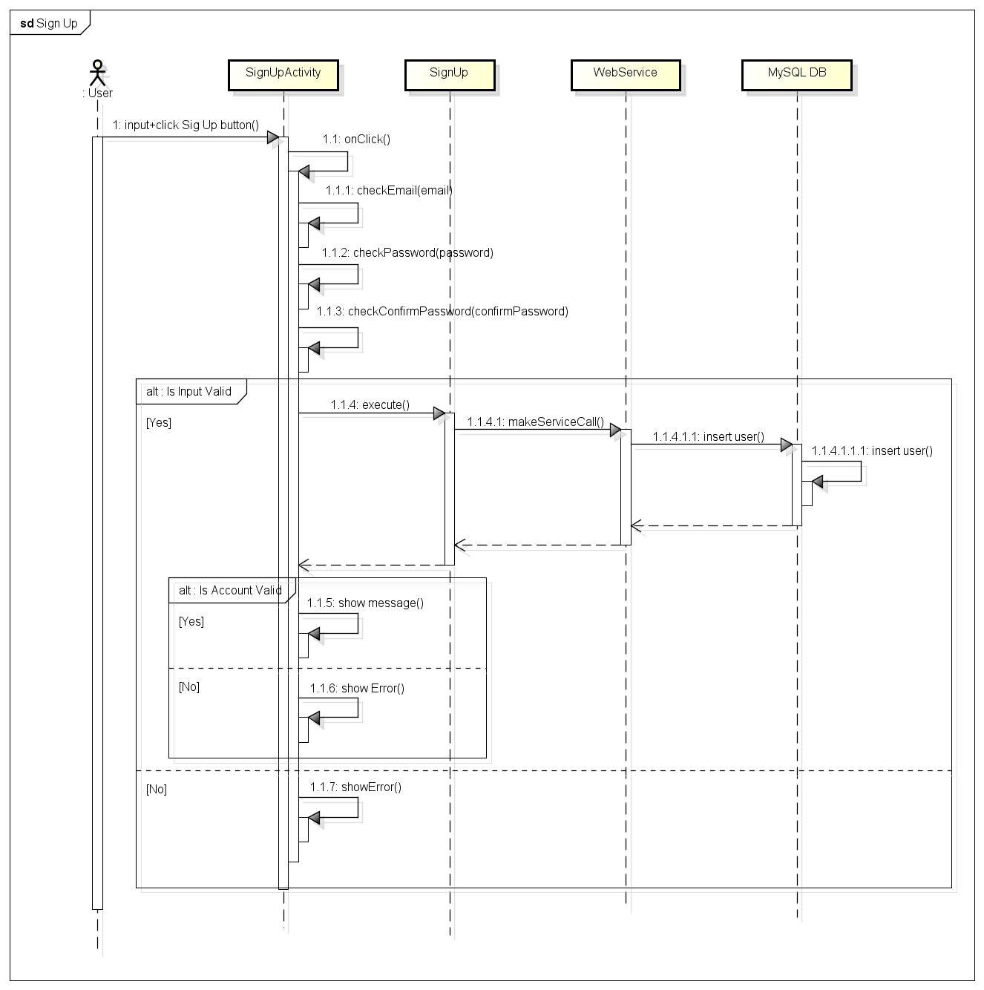

#### Forgot password Sequence

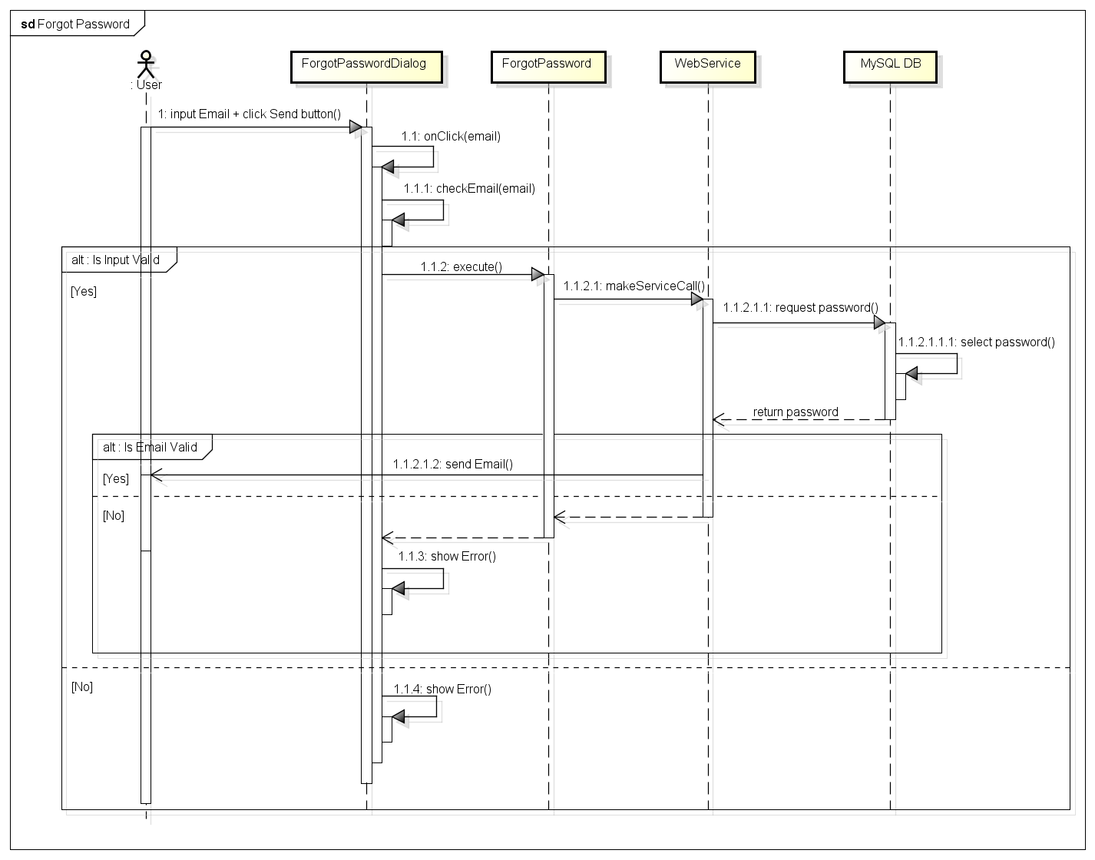

#### Change password Sequence

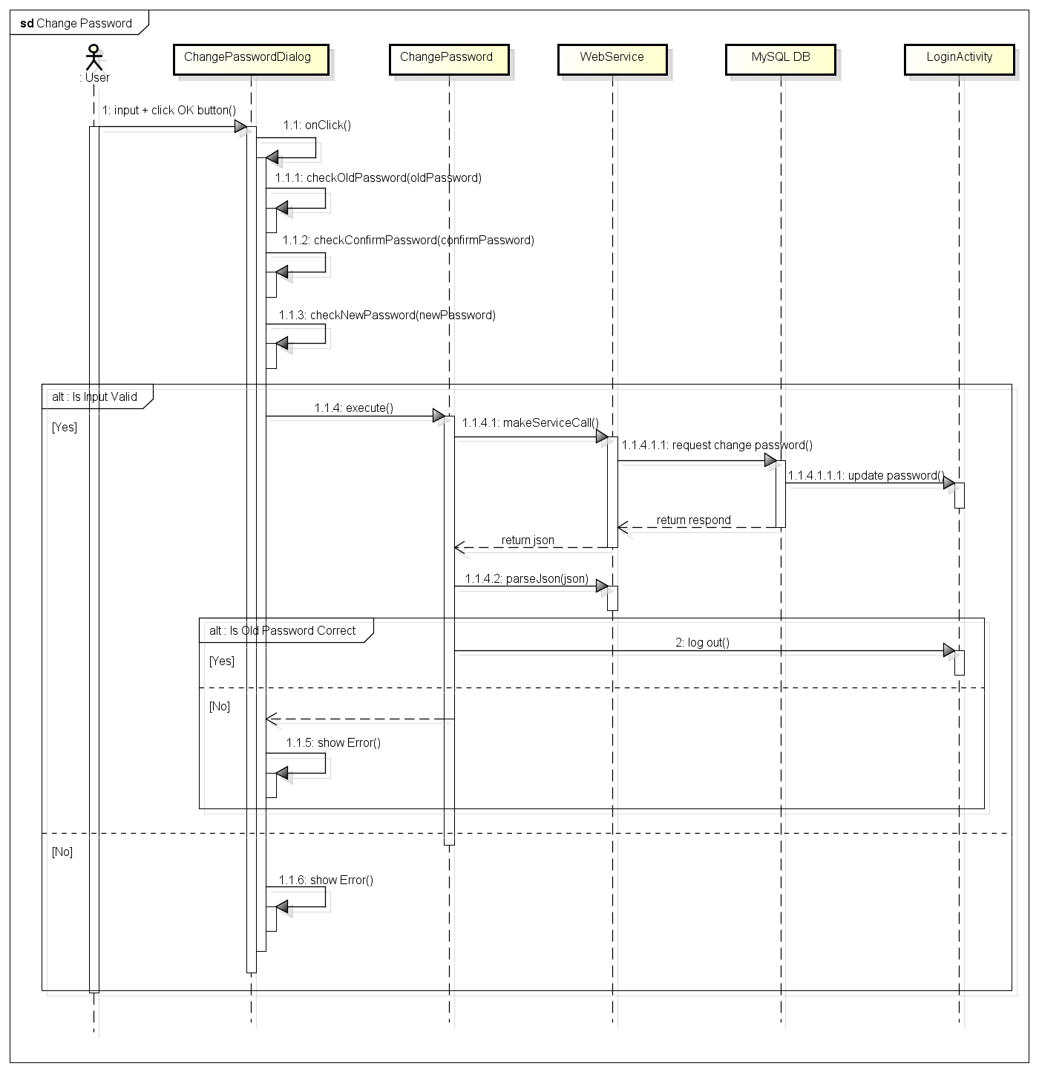

#### Set Track from Bus Detail Sequence

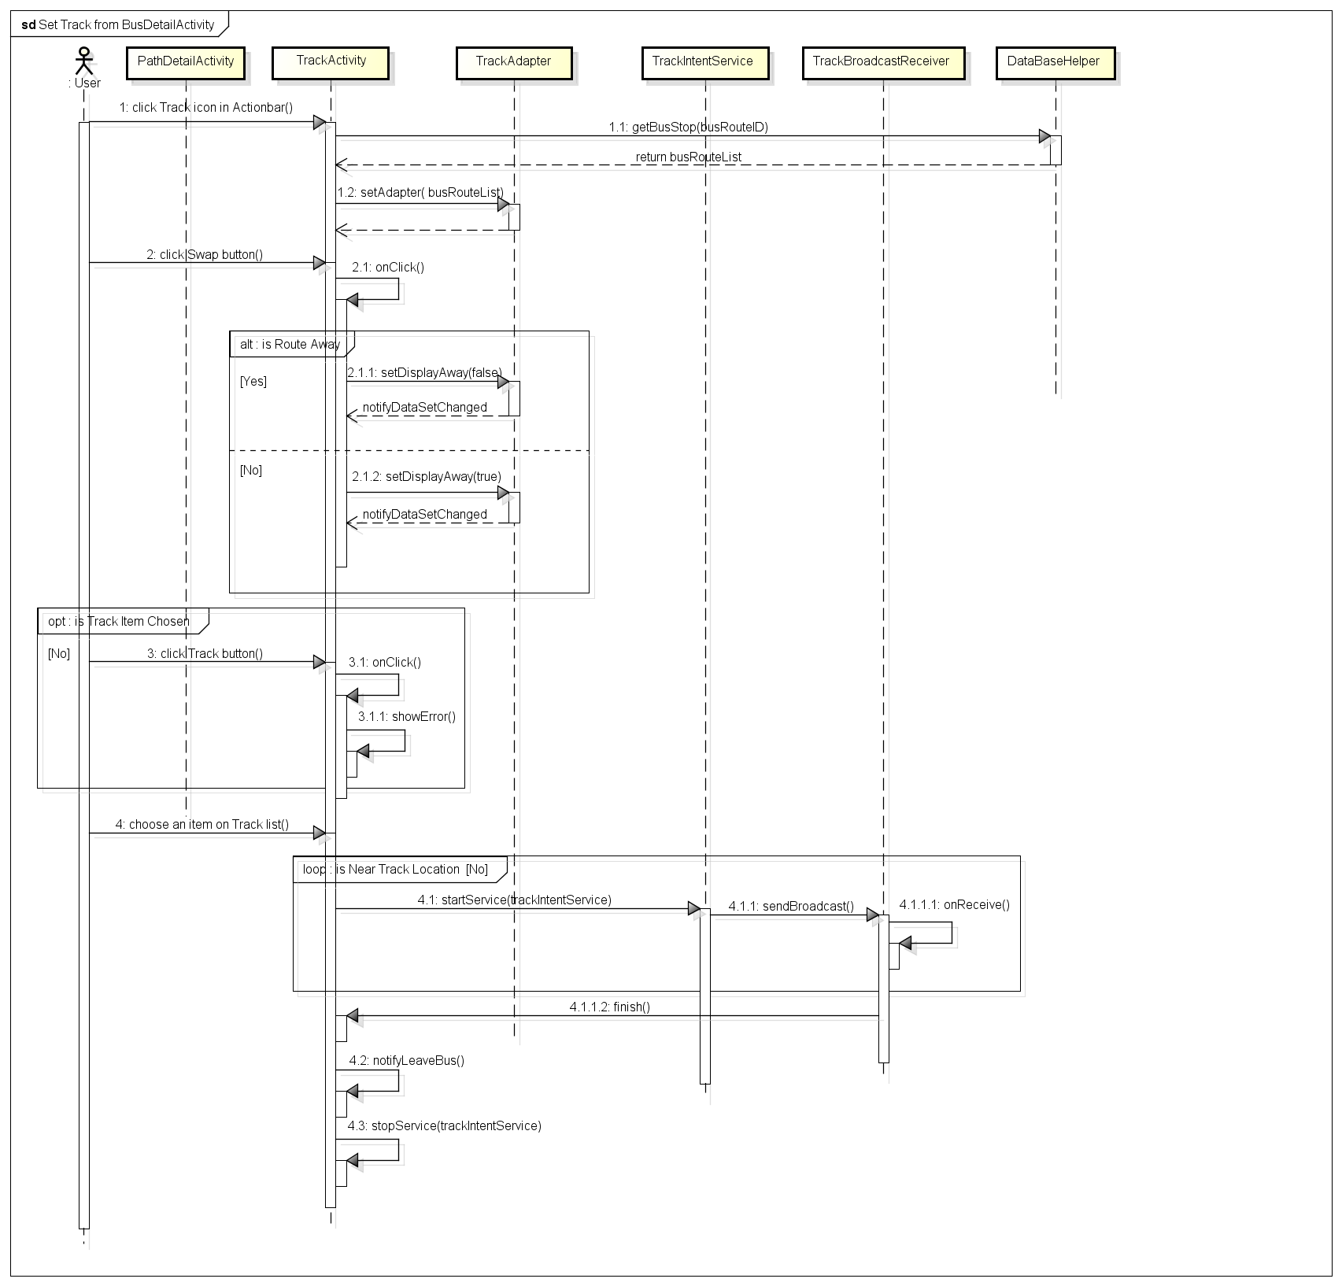

#### Set Track from Path Detail Sequence

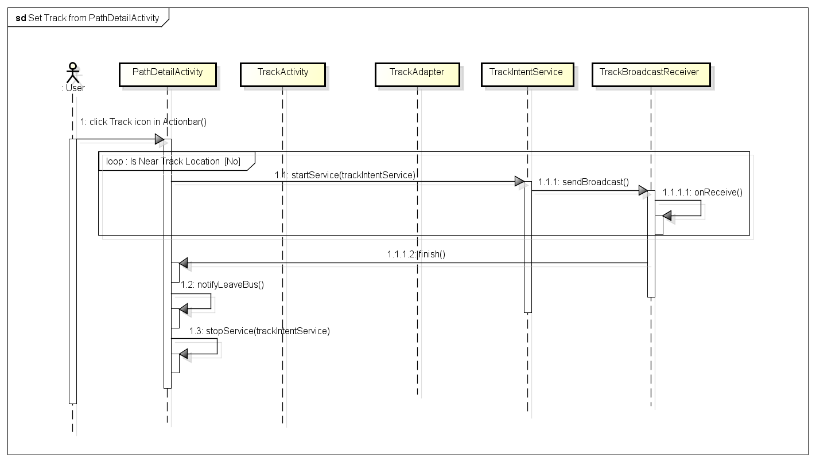

#### Change app settings Sequence

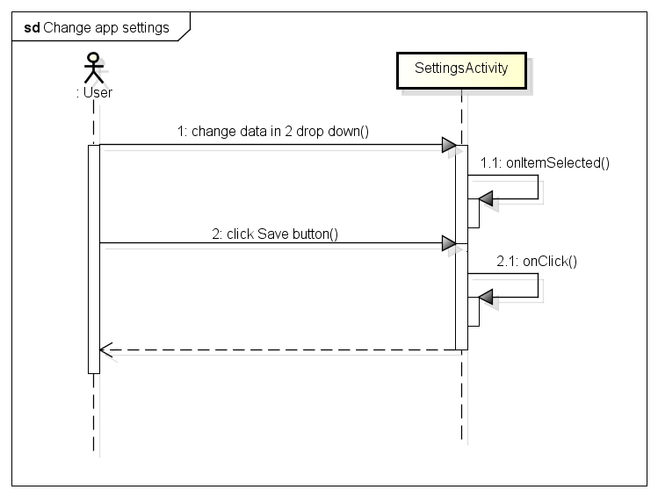

#### Cancel Track Sequence

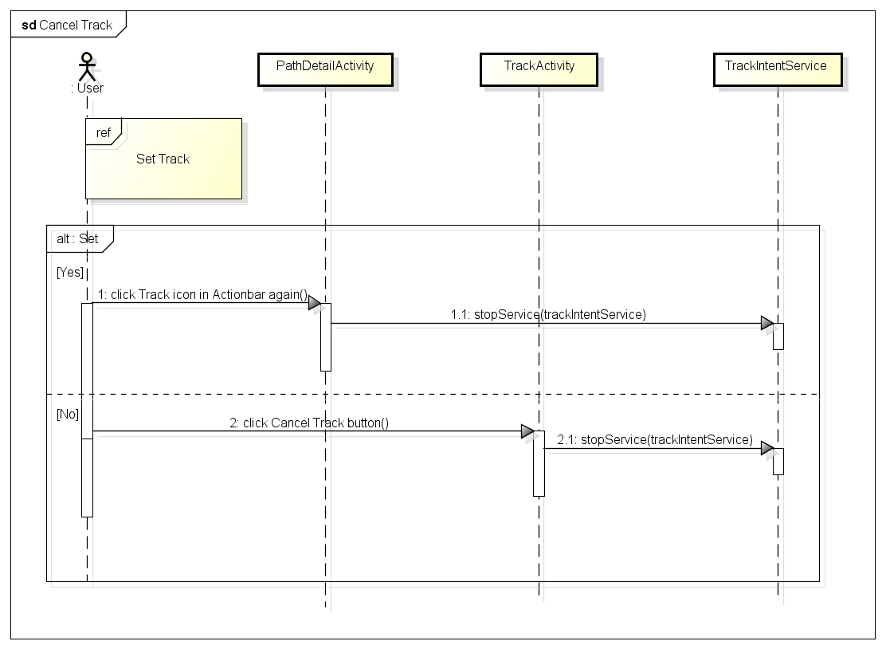

# Layer architecture pattern

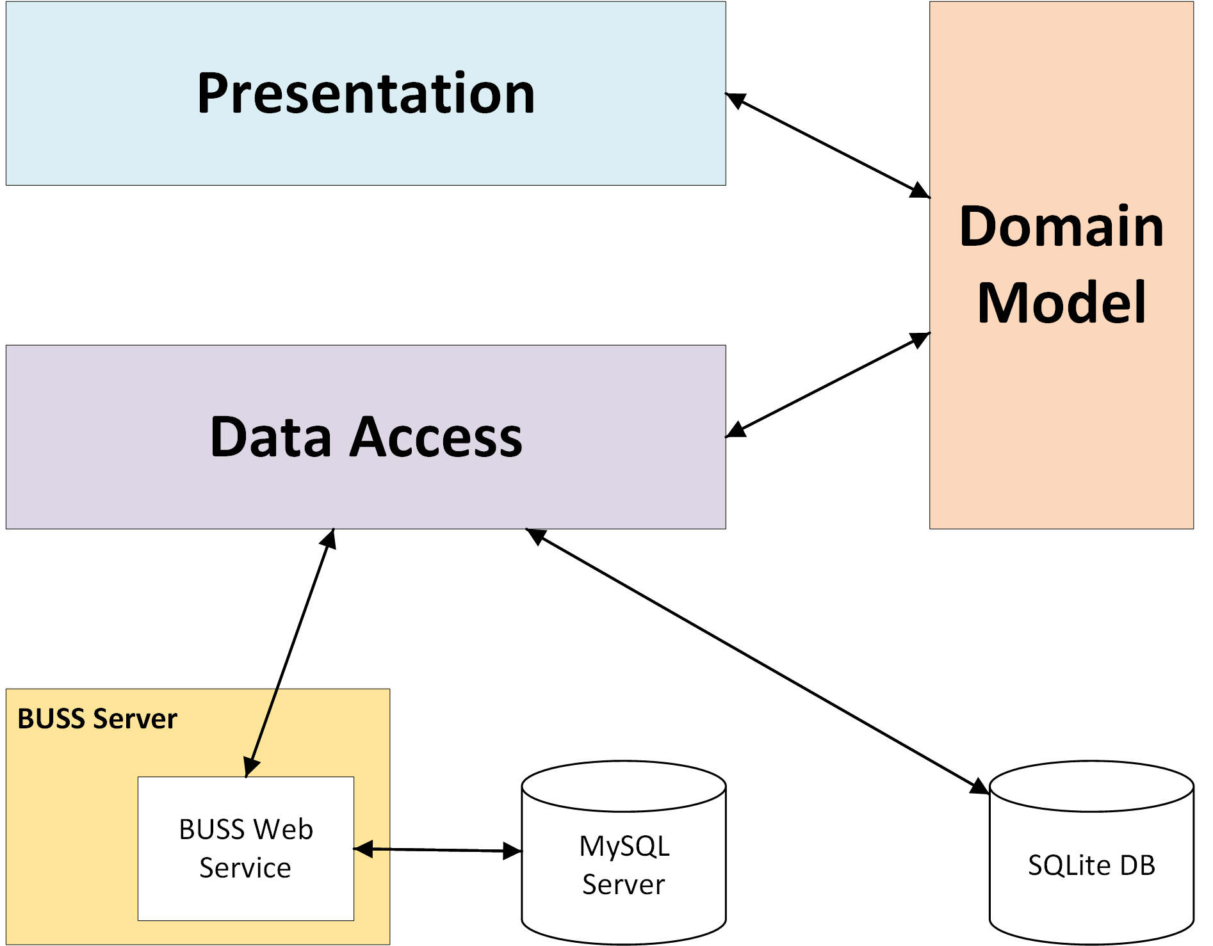

***Figure 6: Layer architecture pattern***